# NETWORK ARCHITECTURE DESIGN AND AN ON-PREMISE UNIVERSAL FILE ACCESS AND SYNC PLATFORM WITH ACL AND SERVER ENCRYPTION AT STA. RITA ELEMENTARY SCHOOL

A Capstone Project Presented to the Faculty of

College of Informatics and Computing Sciences BATANGAS STATE UNIVERSITY

The National Engineering University Batangas City

In Partial Fulfillment

of the Requirements for the Degree

**Bachelor of Science in Information Technology**

**Major in Network Technology**

LEWIS MINCH D. BAUAL JOMARK L. CORNEJO ABEGAIL P. DRIZ

CYCERILLE JANE R. LORZANO

LLOYD H. MACATANGAY, MSCS

Adviser

December 2022

# APPROVAL SHEET

This capstone project entitled **NETWORK ARCHITECTURE DESIGN AND AN ON-PREMISE UNIVERSAL FILE ACCESS AND SYNC PLATFORM WITH ACL AND SERVER ENCRYPTION AT STA. RITA**

**ELEMENTARY SCHOOL** prepared and submitted by LEWIS MINCH D. BAUAL, JOMARK L. CORNEJO, ABEGAIL P. DRIZ, CYCERILLE JANE R.

LORZANO in partial fulfillment of the requirements for the degree **Bachelor of Science in Information Technology major in Network Technology**, has been examined and is recommended for acceptance and approval for oral examination.



**LLOYD H. MACATANGAY, MSCS**

Adviser

Approved by the Committee on Oral Examination with a grade of .

**PANEL OF EXAMINERS**

**RYNDEL V. AMORADO, DIT**

Chairperson

|  |  |
| --- | --- |
| **JEROME M. FABREGAR** | **RAYMOND KIT M. RODRIGUEZ, MSCS** |
| Member | Member |

Accepted and approved in partial fulfillment of the requirements for the degree Bachelor of Science in Information Technology major in Network Technology.

|  |  |
| --- | --- |
|  | **PRINCESS MARIE B. MELO, DIT** |
| Date | Dean, CICS |

# ABSTRACT

|  |  |
| --- | --- |
| **Title:** | NETWORK ARCHITECTURE DESIGN AND AN ON- PREMISE UNIVERSAL FILE ACCESS AND SYNC PLATFORM WITH ACL AND SERVER ENCRYPTION AT STA. RITA ELEMENTARY SCHOOL |
| **Researchers:** | Lewis Minch D. Baual Jomark L. Cornejo Abegail P. Driz  Cycerille Jane R. Lorzano |
| **Degree:** | Bachelor of Science in Information Technology |
| **Year:** | 2022 |
| **Adviser:** | LLOYD M. MACATANGAY, MSCS |

Organizations that keep their network and devices up-to-date and make use of a server or platform that allows them to securely store, manage, and share files, and promotes a more collaborative and productive environment. There are various reasons that hinder and negatively affect an organization’s workplace, like the Sta. Rita Elementary School, which experienced slow and unreliable internet connection loss that frequently occurs, due to the existing LAN possessing. That is why negatively impacted faculty staff’s work, the teacher’s way of teaching, and the student's learning. The teachers and faculty staff also experienced difficulties managing files and submitting their work on time due to the lack of a server or a platform where the teachers can centrally organize, access, and share files. The study’s main objective is to create network architecture designs and implement on- premise universal file access and sync platform at Sta. Rita Elementary School that resolved some of the school problems.

The project was implemented to help the school to upgrade of their existing LAN and to provide them with a platform to centrally store, manage, access, and share files. Three network architecture designs were created that were comprised of different network devices. Each network architecture design with its network devices and software was compared with each other and in contrast with the existing LAN in terms of the overall estimated cost, the design itself, speed, performance, and security. This in turn can help the school decide on which design was the most economical and suitable for the upgrade of their existing LAN. The implemented file access and sync platform served as the server that allowed the teachers and staff to easily store, manage, access, and share files, but not only that as it was also a collaborative platform that enabled to do much more such as had their own exclusive video meetings, chats, scheduled meetings, and more.

The PPDIOO methodology was used in the study. In the preparation phase, the researchers conducted a gap analysis, SWOT analysis, and analysis of the existing LAN. The hardware, software, and network requirements were identified and gathered in the planning phase. The three network architecture designs were created using Cisco Packet Tracer and were thoroughly discussed and compared

with each other in contrast with the existing LAN in the design phase. Various hardware and software were used in the implementation phase including an internal HDD and RAM, Nextcloud was used as the file access and sync platform with the help of Docker desktop and Portainer, and then Cloudflare was configured for the security measures of the platform. Proper server maintenance was comprehensively discussed step-by-step in the operate phase to ensure that the server properly maximized its resources and reduces its potential risks and problems. A network risk management plan was developed in the optimize phase to tackle the different risks and issues that occured within the network as well as the server. The appropriate mitigation plan was also extensively discussed according to each risk.

The speed and performance of each network architecture design were simulated and measured with ping tests using packet tracer, while vulnerability scanning and DoS attack were performed to test the security of the server. In conclusion, the three network architecture designs and the universal file access and sync platform were acknowledged and well-received by the Sta. Rita Elementary School as it presented various options to upgrade their existing LAN, and provided them with a secure platform to store, manage, access, and share files that also improved their collaboration and productivity.

# ACKNOWLEDGEMENT

First and foremost, the researchers want to extend their deepest gratitude to the following persons who helped them accomplish this study.

To their instructor and adviser, **Dr. Princess Marie B. Melo** and **Mr. Lloyd**

**H. Macatangay** who guided and gave them the best advice that made this study feasible, who gave them their utmost support and encouragement to finish this study.

To their client representative, **Mr. Darrel C. Enriquez** for sharing his knowledge and giving his trust, support, and coordination to help complete the implementation of the project.

To their friend, **Lance Michael A. Delariarte** for sharing his knowledge, expertise, guidance, and utmost support for the implementation of the project.

To their **parents** who always guide and remind them of the importance of education in one's life and give moral advice with their undying love and never- ending support.

To their **friends** and **classmates** who help and inspired them to do their best and finish every work.

And above all, to the **Almighty God**, for guidance, blessings, enough knowledge, and strength that made this study possible.

Lewis Minch Baual Jomark Cornejo Abegail Driz

Cycerille Jane Lorzano

# DEDICATION

This study is dedicated to our beloved parents, who served as an inspiration and who have never failed to give us their continual guidance, moral, and financial

support to complete this study.

To our Dear Professors who have worked tirelessly to share their knowledge with guidance and supervision to help us face all the challenges during

the development of this study.

To our friends, classmates, and the whole project team – Lewis, Jomark,

Abby, and Cy for a memorable time spent together during the development of the project and made this journey fun and enjoyable.

And lastly, we dedicate this study to the Almighty God, thank you for giving us the strength and courage to face all the challenges to complete this

project. Thank you, God bless us all.

L. M. B.

J. C.

A. D.

C. J. L.

# TABLE OF CONTENTS

TITLE PAGE 1

APPROVAL SHEET 2

ABSTRACT 3

ACKNOWLEDGEMENT 6

DEDICATION 7

TABLE OF CONTENTS 8

LIST OF FIGURES 13

LIST OF TABLES 15

CHAPTER I INTRODUCTION

INTRODUCTION 17

Background of the Study 17

Objectives of the Study 22

Significance of the Study 23

Scope and Limitations 24

Definition of Terms 24

CHAPTER II REVIEW OF RELATED SYSTEMS AND STUDIES

Technical Background 27

Research Literature and Related studies 39

Local Related Studies 39

Foreign Related Studies 44

Synthesis 58

Theoretical Paradigm (Conceptual Framework) 62

CHAPTER III DESIGN AND METHODOLOGY

Prepare Phase 65

Analysis of the existing LAN 67

Functional and Non-Functional Requirements 68

Plan Phase 69

Hardware Requirements 69

Software Requirements 71

Network Requirements 72

Constraints 76

Cost Constraints 76

Security Constraints 80

Trade-Offs 82

Design Phase 83

Network Design 1 85

Network Design 2 86

Network Design 3 88

Software Constraints 89

Network Design Summary and Comparison 92

Implement Phase 97

Server Static Configuration 98

Software Configuration 100

Operate Phase 111

Server Maintenance 111

Optimize Phase 113

Network Risk Management Plan 113

Network Disaster Recovery Plan 115

CHAPTER IV RESULTS AND DISCUSSIONS

3 Network Architecture Designs 118

Cost 123

Design 124

Speed and Performance 125

Security 129

Universal File Access and Sync Platform 130

Security Measures 136

Security Test 141

CHAPTER V SUMMARY, CONCLUSIONS, RECOMMENDATIONS

Summary of Findings 149

Conclusions 153

Recommendations 163

BIBLIOGRAPHY 165

APPENDICES 173

APPENDIX A 173

SCHEDULE AND TIMELINE 173

APPENDIX B 175

PROJECT TEAMS AND RESPONSIBILITIES 175

APPENDIX C 176

BUDGET COST AND MANAGEMENT PLAN 176

APPENDIX D 177

SERVER CONFIGURATION 177

APPENDIX E 182

DoS ATTACK MAIN SCRIPT 182

APPENDIX F 182

USER MANUAL 182

APPENDIX G 196

GRAMMARIAN’S CERTIFICATION 196

APPENDIX H 197

CURRICULUM VITAE 197

# LIST OF FIGURES

|  |  |  |
| --- | --- | --- |
| **TABLE NO.** | **TITLE** | **PAGE** |

|  |  |  |
| --- | --- | --- |
| Figure 1. | Conceptual Framework | 62 |
| Figure 2. | PPDIOO Life Cycle Phases | 64 |
| Figure 3. | Analysis of existing LAN | 67 |
| Figure 4. | ISO/IEC 27001 | 75 |
| Figure 5. | Vicinity Map | 84 |
| Figure 6. | Network Design 1 | 85 |
| Figure 7. | Network Design 2 | 87 |
| Figure 8. | Network Design 3 | 88 |
| Figure 9. | Network Architecture Design | 96 |
| Figure 10. | Server Static Configuration | 99 |
| Figure 11. | Ping Test | 100 |
| Figure 12. | Virtualization | 102 |
| Figure 13. | Programs and Features | 103 |
| Figure 14. | Docker | 104 |
| Figure 15. | Cloudflare login | 105 |
| Figure 16. | Cloudflare Tunnel | 106 |
| Figure 17. | Cloudflare Tunnel Name | 107 |
| Figure 18. | Cloudflare Tunnel Environment | 107 |
| Figure 19. | Cloudflare Unique Command | 108 |
| Figure 20. | Portainer Command | 109 |

|  |  |  |
| --- | --- | --- |
| Figure 21. | Portainer | 109 |
| Figure 22. | Nextcloud Docker Compose Configuration | 110 |
| Figure 23. | Portainer Stack | 111 |
| Figure 24. | Existing LAN | 117 |
| Figure 25. | Network Architecture Design 1 | 119 |
| Figure 26. | Network Architecture Design 2 | 120 |
| Figure 27. | Network Architecture Design 3 | 122 |
| Figure 28. | Network Architecture Design Cost | 123 |
| Figure 29. | Speed and Performance of the Existing LAN | 126 |
| Figure 30. | Speed and Performance of Designs 1, 2, and 3 | 128 |
| Figure 31. | Accessing the workspace.staritaes.com | 131 |
| Figure 32. | Files and Talk Feature | 133 |
| Figure 33. | Access and Sync | 135 |
| Figure 34. | Access Control of Users | 137 |
| Figure 35. | Server-side Encryption | 139 |
| Figure 36. | Cloudflare Security | 140 |
| Figure 37. | Vulnerability Scan | 143 |
| Figure 38. | 1st Trial DoS Attack | 145 |
| Figure 39. | 2nd Trial DoS Attack | 147 |

# LIST OF TABLES

|  |  |  |
| --- | --- | --- |
| **TABLE NO.** | **TITLE** | **PAGE** |

Table 1 Key Features of Cisco Packet Tracer 30

Table 2Nextcloud Features 32

Table 3Docker Desktop Advantages 34

Table 4 Cloudflare Features 36

Table 5ACL Advantages 38

Table 6Network Gap Analysis 65

Table 7SWOT Analysis66

Table 8Functional and Non-functional Requirements 68

Table 9Server Implementation Hardware Requirements 69

Table 10End User Hardware Requirements 70

Table 11ServerImplementationSoftwareRequirements 71

Table 12End User Software Requirements 72

Table 13Network Requirements 73

Table 14 Hardware Cost and Specifications 73

Table 15Software Cost and Specifications 74

Table 16Access Point 76

Table 17Switches 77

Table 18Storage 78

Table 19RAM 79

Table 20Access Point Security Constraints 80

Table 21Longevity of Network Designs and its devices 81

Table 22Number of Users for each Network Design 82

Table 23 Software Constraints 90

Table 24Network Design Summary 93

Table 25Steps to maintaining a server 112

Table 26Likelihood 113

Table 27Risk Management Plan 114

Table 28Network Disaster Recovery Plan 115

Table 29Access Point Security 129

Table 30 DoS Attack Details 147

# CHAPTER I

# INTRODUCTION

# Background of the Study

Local Area Network (LAN) is a popularly known and widely used computer network that enables diverse end-users to connect and share the standard communication infrastructure inside a single organization within a specific geographical area (Samir et al., 2018). LAN is a group of devices including desktops, laptops, servers, smartphones, and other equipment linked in one physical location, including school buildings, homes, or corporate offices. Devices connected to LAN can use a single internet connection, print to shared printers, share files, and even access and control one another. A network administrator accomplishes the management of all aspects and functions of LAN.

The physical layer of the infrastructure makes the sharing of resources such as printers or network storage attainable. Also, it increases the information exchange between different end-users and departments in a single organization. Reduced cost is one of the benefits of having a LAN through the sharing of information and databases, resources, and network services. According to Samir et al., (2018), data traffic is growing and the number of connections to a computer LAN is increasing, thus, the need for the improvement of old LANs is an utmost priority for all kinds of organizations or institutions in order to grow and survive in the current world of technology.

Windows 10 is the most popularly used operating system today that features many programs and processes for managing computer hardware and software (Ðuranec et al., 2019). Specifically, it was decided to use Windows 10 for the project as more people are familiar with operating and navigating it. Windows 10 is one of the most powerful operating systems that Microsoft has ever made for organizations, institutions, and their employees. It provides a seamless user experience and has enterprise-class security, information, and identity protection features, which is necessary for most businesses to reduce complications and address modern needs. It is equipped with a wide variety of new and enhanced features including virtual desktops, universal apps, and improved desktop and security.

The benefits of utilizing Windows 10 on the premises of an organization or institution include advanced security and management, great compatibility with numerous applications, improved device management, and more that help the productivity of businesses to grow and move forward. According to Softic & Vejzovic (2022), Windows 10 is made based on Windows NT technology, enabling users to easily engage with the OS in both corporate and personal computing environments.

With the use of computer networks growing exponentially, there’s also an increase in the challenges and difficulties in maintaining network security. Networks and systems that have access to the internet are exposed daily to cyber threats. According to Thai-Nichi Institute of Technology Faculty of Information

Technology (2019), the number of cyber-attacks, specifically targeting hosts in LANs are increasing in recent years, and implementing the appropriate kind of security in LANs has never been more important. Consequently, maintaining continuous network monitoring and enabling security measures for vulnerable activities/exploits has become a serious issue and a major concern in ensuring network security. Various risks involved in network security can affect users’ lives, and work, and may even cause property or financial losses (Ge & Xu, 2020). The technology that cyber-criminals use is also improving and may cause loopholes to destroy the network, which may result in data destruction, information leakage, and other issues that can cause losses to individuals or institutions, and organizations (L. Liu, 2020).

Unauthorized access is also a big threat as it is involved in illegally accessing important and confidential files, which may result in the loss of important information and compromises the security of the network (Ge & Xu, 2020). In handling huge amounts of data, it is critical to ensure the safety of storing, transmitting, and using information, as well as maintaining the security and stability of the entire network (L. Liu, 2020). In that regard, configuring Access Control List (ACL) and performing server encryption on a network or LAN is a highly relevant task and is a step towards the right path in ensuring network security.

To protect and secure highly important and sensitive information of an institution or organization, it is important to properly configure access controls as numerous data breach incidents happen due to poorly configured access controls

(Pongsrisomchai & Ngamsuriyaroj, 2019). An Access Control List (ACL) is a list of permissions configured on a network that authorizes access to certain types of users (X. Liu et al., 2018). Each ACL rule contains packet matching rules and actions that are performed during matching. Misconfiguration of ACL can lead to security risks such as incorrect blocking and wrong permission that may result in business unavailability and intrusion attack (Chen et al., 2020).

In addition, configuration mistakes can also lead to network outages, and degradation in performance, and produce security vulnerabilities in the network (X. Liu et al., 2018). Currently, a substantial amount of sensitive data exists in the form of files, and the loss of secret files has become a significant threat to electronic data security (Tong et al., 2021). Encryption settings for sensitive information and files can help to limit the risk of data being stolen and modified (L. Liu, 2020). On that note, properly configuring the ACL to give access and authority to the right individuals is a highly significant task that ensures the safety of the network, and encrypting the server gives that added layer of protection to better secure data and files from leakage, destruction, and modification.

In this modern day, most businesses, organizations, schools, and the like need a private local area network in some of their offices or premises for the sole purpose of sharing and storing important files in a fast, secure, efficient, and reliable way. This study is associated with Sustainable Development Goals (SDG) 9: Industry, Innovation, and Infrastructure which aimed to build resilient infrastructure, promote inclusive and sustainable industrialization, that foster

innovation. An effective local network design provides innovation and reliable infrastructure that can provide increased profitability, and improve the flow of communication and productivity within a business organization or institution. An interview was conducted with the principal and administrative officer of the Sta. Rita elementary school to identify the total number of students, teachers, and offices who use computers and determine the specific network problems present within the school and what to improve in the current existing LAN.

The Sta. Rita elementary school has a total of 1,797 students which are ALS, kinder, and grade 1 - 6 students. They have a staff consisting of 1 Principal, 60 Teachers, 2 Administrative Assistants, 2 Admin Aides, 1 Administrative Officer, and 1 Security Guard. There are 5 offices, the Information Communication Technologies (ICT) room, Homeroom (HR), Guidance room, Registrar’s office, and the office of the principal that use computers and other devices such as printers, projectors, etc. The school also provides 60 laptops for teaching and non-teaching and 250 tablets for grade 4-6 students.

The school has an existing LAN that uses a wired connection and comprises 2 routers, 3 switches, and numerous network devices such as desktops, laptops, and tablets. Specifically, the office of the principal has 16 computers, the registrar’s office has 13 computers, the ICT room has 10 computers, and both the HR and guidance room has only 1 computer.

However, the current existing LAN in Sta. Rita elementary school poses many problems such as some of their equipment and network devices being outdated, thus, causing slow and unreliable internet connection where the loss of internet connectivity of devices frequently occurs this is heavily emphasized by the teachers and the principal as one of their major concerns as it negatively affects the teacher’s way of teaching and the students learning during online classes. The school only makes use of the Google drive storage, thus, lacks a dedicated centralized database such as a file server with at least 1TB of storage for storing important files. Consequently if a file server is to be implemented it needs security and protection from threats such as unauthorized file access and malicious behaviors. The school allocated a budget of Php 3,000 for the procurement of hardware devices and the improvement of their existing LAN or network.

# Objectives of the Study

The main objective of this study is to create network architecture designs and implement on-premise universal file access and sync platform configured with ACL and server encryption using Nextcloud, Cloudflare, and device encryption at Sta. Rita Elementary School.

Specifically, this study aimed to:

1. Create 3 network architecture designs by adding and upgrading network hardware devices and compare them with the existing LAN in terms of:
   1. Cost
   2. Design
   3. Performance
   4. Security
   5. Speed
2. Implement on-premise universal file access and sync platform for data storage management and organization.
3. Implement security measures in the LAN and the on-premise universal file access and sync platform using:
4. Access Control List (ACL)
5. Encryption
6. Firewall

# Significance of the Study

The purpose of the study is to create 3 network architecture designs and implement on-premise universal file access and sync platform configured with ACL and server encryption at Sta. Rita Elementary School.

The study is beneficial to the Sta. Rita Elementary School as they obtained 3 network designs to consider for the future upgrade of their network that if implemented can help ensure the productivity, efficiency, and security of the Sta. Rita elementary school.

The teachers, faculty staff, and students benefit from the outcome of the study as it enables them to share files with one another, print to shared printers, and access connected computers. Having a centralized database allows the faculty and

the staff to speed up communication and easily store, manage, and access relevant data. They also have a more secure and reliable network.

The study benefits future researchers by providing reliable and relevant information that they can use as a reference for their future related studies.

# Scope and Limitations

This study only focuses on creating 3 network architecture designs and implementing on-premise universal file access and sync platform for data storage management and organization in Sta. Rita Elementary School. Consequently, ACL configuration and server encryption is implemented for the security of the sync platform from threats and firewalls are also implemented for network security. This study only covers the above-mentioned objectives for the implementation.

This study is limited only to the Sta. Rita Elementary School and its teachers and faculty staff. This study does not cover the bridging of routers and off-site data storage due to limited time, knowledge, and budget for the implementation.

# Definition of Terms

The following terms used in the study are defined.

**Access Control List.** An access control list is a list of permissions or rights of a user for a file, folder, or other objects. It specifies which users and groups are permitted to access the item and what operations they are permitted to do such as read, write, and execute (Christensson, 2022).

**Encryption.** The process of turning data into an unrecognizable or "encrypted" form is known as encryption. It is widely used to keep sensitive

information secure so that only authorized individuals may see it. This includes data sent across wireless networks and the Internet, as well as files and storage devices (Christensson, 2022).

**File server.** A file server is a centralized computer system that organizes and stores data files so that other computers and devices on the same network can access them. Users can communicate information through a network without physically moving files (Wright, 2021).

**Firewall.** An example of a computer network security tool is a firewall, which regulates internet traffic going into, out of, and inside a private network. (Kaspersky, 2021).

**Local Area Network (LAN).** A local area network is a collection of connected devices in a single physical location, such as a house, office, or building. LAN can range in size from a small home network for a single user to a large enterprise network in a workplace or institution with numerous users and devices.

**Router.** A router is a device that interconnects the internet and the internet-enabled devices in an organization or institution. It routes communication and data between devices and the internet. (Johansen, 2022).

**Server.** Servers are powerful computers that store, process, and manage data, devices, and systems through a network. Servers are the power houses of internet companies by giving appropriate resources to network devices and systems (Ingalls, 2021).

**Storage.** Storage is the process of using computing technology to save digital data within a data storage device. Storage is a method that allows a computer to store data indefinitely or temporarily (Techopedia, 2020).

**Switch.** A network switch connects the various components of a network, including computers, printers, and wireless access points, and enables data packet communication between them. Switches can be both hardware and software-based virtual devices that govern physical networks (Burke, 2020).

# CHAPTER II

**REVIEW OF RELATED SYSTEMS AND STUDIES**

The related systems and studies cited in this chapter address the different concepts, ideas, understanding, conclusions, and other developments related to the present study that assist and guide the researchers in its development.

# Technical Background

This part gathered and discussed all the necessary software, hardware requirements, and specific technology used in the implementation of the project.

**Network Devices**

The current existing LAN in Sta. Rita elementary school consists of some old or already outdated network devices and lacks a dedicated centralized database such as a server. With this, the researchers provided 3 enhanced network designs, each having its own advantages and features that address the problems on the premises of the school, mainly in the principal’s office, guidance office, and admin office. Specifically, the hardware requirements needed to enhance the existing LAN includes a Cat6 UTP cable that helps in connecting computers or work stations in the offices. It consists of four pairs of copper wires which are utilized for data transfer and can provide a bandwidth of 250MHz speed up to 10Gbps. Mikrotik Rj- 45 was used in conjunction with the UTP cable as a socket and can be used for crossover cabling if the devices are the same or straight-through cabling if the devices are different from each other.

A system unit with at least an Intel core i5 10th gen processor is the minimum specification needed to maximize the capacity of transporting and moving files seamlessly. Takei et al., (2021), noted that in large networks, a router can be overwhelmed by the bloated number of entries, surpassing the upper limit of the specified number of entries. Meaning, a router that can deliver a strong WI-FI signal, provide reliable connection, and is capable of bandwidth-sensitive tasks is ideal for large networks usually in an organization or institution such as a school. Therefore, in Network Design 1 which is the recommended design, TP-Link TL- WR844N AP is used for the connection of the ISP's modem to the access point and then to the system unit.

Also as studied by Institute of Electrical and Electronics Engineers, (2017), a router is able to determine if a packet experiences congestion or not by calculating the average queue length at an interface over a given time period and comparing this with predefined thresholds. If thresholds are exceeded, packets may be dropped or dropped later. Choosing the appropriate router or switch is critical in improving the school’s existing LAN. Thus TP-Link LS1005G 5-Port which provides reliable data transfer and increases the speed of the network is used in Network Design 1 to connect the computers in the LAN to eliminate network congestion and bottlenecks. A Kingston HyperX Fury DDR4 2400MHz 8GB RAM is also used and lastly, Barracuda with 1TB of storage provides sufficient storage for the school’s files.

**Cisco Packet Tracer**

Cisco Packet Tracer was used for creating and simulating the 3 network architecture designs for the Sta. Rita Elementary School. It is a powerful tool for creating simple and complicated networks and for visualizing how they work. Various protocols can be configured and simulated on different types of networks, including simple to complex networks. The simulation results and statistics can be further analyzed and studied to determine if the configured protocols are appropriate for the network to properly maximize its potential.

This Cisco Packet Tracer provides a comprehensive hands-on experience on various network devices such as switches, hubs, cisco routers, and end devices such as servers, PCs, laptops, tablets, and many more. According to Srikanth Reddy et al., (2020), Cisco Packet Tracer is a network simulation tool built to create and evaluate network architecture. The study conducted by Demeter et al., (2019), mentioned that learning the basic and advanced concepts of networks is one of the numerous advantages of utilizing the Cisco Packet Tracer.

**Key Features of Cisco Packet Tracer**

Table 1 shows the significant features of utilizing the Cisco Packet Tracer for creating network architecture designs and simulating networks.

Table 1

*Key Features of Cisco Packet Tracer*

|  |  |
| --- | --- |
| **Feature** | **Description** |
| Cross Platform Compatibility | Enables the creation and simulation of networks in multiple operating systems and environments. |
| Visualization of Networks | Allows a comprehensive layout of small to large and complex networks. |
| Interactive Environment | Provides a number of features that allows a comprehensive and effective hands-on learning experience. |
| Majority of Networking Protocols are Supported | Enable the configuration and simulation of various networking protocols such as OSPF, EIGRP, RIP, and many more. |
| Real-Time Mode and Simulation Mode | Allow networks to either run in real-time or in simulation mode to slow or fast forward time. |
| Customize Single/Multi-user Activities | Provides customization of single and multi-user activities. |

Table 1 summarizes the key features of the Cisco Packet Tracer which provides a powerful and broad network simulation tool for students, teachers, engineers, and all kinds of people to learn, design, test, and simulate networks. It contains all the necessary features in order to create, customize, and configure a network and other projects including IoT and Cybersecurity. It ensures that the user experiences a comprehensive yet simple tool to mainly learn and gain hands-on experience on networks.

**Nextcloud**

Nextcloud is used as the universal file access and sync platform in Sta. Rita Elementary School. Nextcloud is a self-hosted, open-source, file-sharing, and communication platform. Its universal file access feature provides a common file access layer, maintaining data in its location and preserving the management and regulation mechanisms used by IT to manage risk (Kariyattin et al., 2018). Nextcloud can be the most widely used collaborative cloud that can be configured and used on-site. Facing the world with new technologies Nextcloud is the answer where a person can be an organization without the help of the external collaborative tool. Nextcloud is widely used now because of its security technology and secure communications over external networks.

It is the industry-leading, fully open-source, and on-premises content collaboration platform. Its features include client-side encryption, brute force protection, advanced server-integrated end-to-end, and a variety of security hardenings are all examples of a novel and innovative security solution. Nextcloud enables all kinds of files to be stored such as documents, presentations, videos, and photos, and also provides support for mobile devices, MAC, and Windows operating systems (Singh et al., 2021).

**Features of Nextcloud**

Table 2 shows the significant features of using Nextcloud as universal file access, storage, and sync platform for the Sta. Rita Elementary School and other institutions.

Table 2

*Nextcloud Features*

|  |  |
| --- | --- |
| **Feature** | **Description** |
| Calendar, Contacts, and Mail | Users can store, sync, and share their schedules and contacts using the Nextcloud Calendar and Contacts apps, and sync the calendar or contacts with multiple devices and access them from anywhere, share with individuals or groups on a server, or both. |
| Secure Audio and Video Calls | Users can run a private audio/video communication service where family, friends, and workmates can collaborate in a group through secure, end-to-end encrypted audio and video communication. |
| Activity App | Allows the tracking of file changes. It shows the modification of files, and downloaded shares, and also shows any changes to any comments or tags. |
| External Storage and Encryption | Provide access to data wherever it is stored. Data saved on networks other than your server can be secured using the encryption app, which can encrypt data at rest for both local and remote storage. |
| Security | Nextcloud follows the industry’s best security practices and incorporates unique end-to-end encryption methods that are server-side, client-side, and in-transit. |

Nextcloud provides users with greater connectivity which has a user-friendly online interface and allows users to access data from anywhere and anytime through desktops and mobile devices. It also provides maximum security through the use of end-to-end encryption of data and only users who are actively communicating can view the data and the messages. It features real-time notifications on all devices, allows collaboration with ease, and has a wide variety of productivity apps to manage schedules, appointments, and emails. With Nextcloud, system administrators can direct and regulate the data flow between users based on several criteria, including geographic regions, tags, user groups, request types, file ownership, and much more.

**Docker Desktop**

Docker Desktop is used for the project to containerize the Nextcloud

application and allow it to run efficiently and reliably. It is a well-known open- source tool that offers software programs in a uniform and portable execution environment. It employs containers as separate remote user space environments that perform at the operating system level and share a file system and resources. A typical server or virtual machine uses much more resources than containerization. In the study of Kim et al., (2022), Docker is the best-known lightweight virtualization technology for container platforms.

Docker is the best-known lightweight virtualization technology for container platforms. It offers a straightforward interface that lets manage containers, programs, and images directly from the computer without having to resort to the CLI for basic operations. Docker Desktop with the development tools and language of choosing, gives access to a sizable collection of approved image-s and templates in Docker Hub. This gives development teams the opportunity to expand their environment so that they can quickly auto-build, continually integrate, and interact while using a secure repository.

**Advantages of using Docker Desktop**

Table 3 shows the advantages of using Docker Desktop for containerizing, deploying, and running applications and software.

Table 3

*Docker Desktop Advantages*

|  |  |
| --- | --- |
| **Advantages** | **Description** |
| Continuous Integration | Docker works well with various tools such as Jenkins, Travis, Wrecker, and more to help create Docker images. |
| Rapid Deployment | Deployment time can be reduced to seconds and containers can be established for each process even without booting an operating system. |
| Security | Docker provides full control over traffic flow and administration and ensures that applications that are executing on containers are totally segregated and isolated from one another. |
| Simplicity and Faster Configurations | Docker simplifies and allows faster configurations by providing users the freedom to take their own configuration, include it in the  code, and then deploy it further without encountering any issues. |

Docker ensures that applications can function in any environment; the benefit is due to the integration of all programs and all of the dependencies into a single Docker execution container. It is widely used in the cloud as Docker containers are more versatile and efficient. The flexibility of numerous deployment options is greatly enhanced by the ability of various programs to run on a single operating system instance. The significant benefit of Docker containers is the ability to separate apps from their underlying systems as well as from one another.

**Portainer**

Portainer is used in the project in conjunction with Docker Desktop to easily manage and secure containers. It functions as a web graphical user interface to show the size of the RAM, the number of processors, and other specific information about

Docker such as images, volumes, containers, and more to easily manage and operate containers. According to the study of Kithulwatta et al., (2022), Portainer is an open- source tool that makes it easier to work with various container-oriented infrastructures such as Docker, Kubernetes, Azure ACI, etc. by acting as a bridge between users and infrastructures. Portainer provides time efficiency by deploying applications quickly and by compacting and centralizing the management of containers. It also reduces risks by rapidly organizing and securing clusters. Using Portainer allows users to deploy, view the status of individual containers, restart them when necessary, and debug them without having to use the command line.

**Cloudflare**

Cloudflare is used in the project to provide the Staritaes website with thorough, extensive, and diverse security features to ensure reliability, strong security, and improved performance of websites, applications, and devices connected to the internet. One main advantage of using Cloudflare is that it offers a free plan of core features such as multiple security, improved performance, increased speed, and extra protection of websites. With Cloudflare, users can efficiently and securely access websites that are also protected from hackers and other threats (Dewi et al., 2019).

**Features of Cloudflare**

Cloudflare provides a free plan containing the core features to secure, protect, speed up, and improve the performance of websites and applications online.

Table 4

*Cloudflare Features*

|  |  |
| --- | --- |
| ***Feature*** | ***Description*** |
| Zero Trust Services | Stops data loss, prevents malware and phishing, and provides safe and secure internet browsing. |
| Performance | Provides CDN, DNS, and Load Balancing to speed up and optimize websites and deliver them efficiently to users. |
| Security | Monitors malicious behavior and threats and offers web application firewall, DDoS protection, and Bot management to secure and protect websites and applications from DDoS attacks and bots. |
| Network Security and Performance | Reduces cost and complexity by providing solutions to secure and accelerate network connection. |

Cloudflare has absolute protection against DDoS attacks and ensures secure communications by allowing users to create a safe tunnel between host servers and data centers. Cloudflare’s CDN spreads globally with great load management to efficiently balance traffic load and ensure the fast delivery, security, and reliability of websites and applications to users. It also has the ability to cache web pages to minimize latency issues and offers intelligence systems that can analyze, learn, and understand attack attempts on websites to come up with a solution to defend against them.

**Access Control List (ACL)**

An access control list consists of rules or permissions that grant or deny access to certain types of users or specific types of traffic. Each ACL makes use of packet matching rules and actions to execute during the matching process. The

action indicated in the first matched rule is used to determine whether to grant or deny permission (Wakabayashi et al., 2020). Multidimensional attributes are used in packet-matching rules to specify the set of packet-matching features (Chen et al., 2020).

There is a set of values for each attribute and there is order priority in rule matching. When the pattern of header information indicated in the rule matches the header information of the packet, the rule is considered to match (Wakabayashi et al., 2020). Proper configuration of ACLs ensures that unauthorized access to the system and files are eliminated and that the right permissions are configured to the right persons. Generally, there are two types of ACL, one works in systems that involve users, and the other is used for the network that involves network devices such as routers and switches.

**Two Types of ACL:**

* **Filesystem ACLs –** Thisprovides operating systems information about the types of users who can use the system and the permissions that are available to them. Access to files and directories is filtered by filesystem ACLs.
* **Networking ACLs –** It informs routers and switches what specific traffic can reach the network and what activities are permitted. Networking ACLs control network access within an organization or institution.

**Advantages of ACL**

Table 5 summarizes the benefits of configuring ACL to a network.

Table 5

*ACL Advantages*

|  |  |
| --- | --- |
| **Advantage** | **Description** |
| Traffic Flow Control | Capable of controlling the flow of traffic by specifying which type of traffic is granted or denied access to different routes. |
| Restricts Network Traffic | Provides better network performance by restricting network traffic and eliminating suspicious traffic or packets. |
| Network Access Security | Provides a level of network security by configuring and specifying which users can and cannot access certain areas of a server, network, or service. |
| Granular Monitoring | Capable of providing highly detailed monitoring of traffic that is  going in and out of the system. |

Table 5 outlines some of the advantages of ACL when properly configured and implemented. ACL is capable of providing traffic flow control to a network by specifying permissions to different types of packets. It is also capable of improving network performance by restricting network traffic and not allowing suspicious traffic to access the network or system. ACL also provides security in accessing the network by specifying which certain types of users are granted access to different areas of a network, server, or service and what they are allowed to do. Detailed monitoring of traffic is also provided when ACL is configured.

**Encryption**

Encryption is commonly used to keep critical and sensitive information such as data being sent across wireless networks, as well as files and storage devices secure and protected so that only authorized users can access it. With the

advancement and widespread adoption of information technology, more and more data are being saved in digital form on disk storage devices (W. Liu & Li, 2019). The data files kept on computer terminals are managed and audited to avoid the leakage of sensitive information. Having the ability to share important and sensitive data amongst other uses is vital in any workplace (Khashan, 2020).

Moreover, protecting important data by means of encryption and storage provides higher security and prevents data leakage. Even if some files or data are somehow obtained by an unauthorized user the plaintext of the data cannot be retrieved (W. Liu & Li, 2019). Finding and developing ways to protect data and maintain its confidentiality, integrity, and availability is of great importance, especially in the current digital age. On that note, device encryption technology is used to protect the data of the Sta. Rita elementary school from unauthorized access and other malicious behaviors.

# Research Literature and Related studies

# Local Related Studies

The study produced by Canja et al., (2020), created a local area network that gave users the ability to collaborate on projects, opens up the possibility of expanding information resources, speeds up communication between each computer, and posed no security risk when sharing data via a flash drive. An affordable LAN was created as a result of the low-cost computers and the requirement to exchange data and hardware resources in an office setting.

In the study of Osias et al., (2020), local area network which is extremely important and popular in today's world, is mostly used for global communication. It appears that the teachers were very busy with a lot of tasks, including keeping track of grades and planning classes. In the findings of this study, creating a local area network in the ICT Faculty assists ICT lecturers in reducing workload, improving data transfer, and securing data. De Leon et al., (2020), stated that the proper configuration of a PC must be a step-by-step process for computers to operate, and to avoid misconfiguration, the ports must be put in their respective places in order to connect personal computers to a switch hub. The study focuses on the basic configuration of a switch hub and the proper arrangement of ports to have an internet connection.

Servers make storing, securing, and sharing files in an organization easy and convenient. In a study of Bernal et al., (2020), Information and Communication Technology ICT students perform a lot of activities in the computer laboratory. A server for the computer lab makes it easier for the facilitator to administer and maintain the security of the client’s machines, including monitoring apps, appropriate file sharing, and data archiving. The researchers also interviewed and surveyed the ICT facilitator and teachers to gather qualitative data. Ayuban et al., (2020) added that a server is faster than the clients when sharing files and provides privacy for shared files.

To protect the files, the researcher's client set up a client-server system and kept track of the user's activities. The server employed in the study had a more powerful central CPU, more memory, and bigger disk drives than the client devices had. The study's goal is to set up a client-server setup at Bryan John Computer Shop in Bagong Silang, Caloocan City. In addition, Jayoma et al., (2020) mentioned that the Department of Social Worker and Development in Caraga constantly produces data every day. However, because of their traditional records management approach, they have trouble storing and retrieving records' locations.

As a result, DSWD Caraga moved forward with record digitalization for its administration to assure the preservation of durable and important papers, safeguarded and available for future reference as required by the organization of many offices based on current norms and regulations in records management. The open-source Python-Tesseract (PyTesseract) package, a wrapper for Google's Tesseract-OCR Engine, was utilized in the study to automate data classification. Starting with the conversion of paper-based documents into digital format (scanning), the PyTesseract library is used to detect and extract the text.

Network security allows to keep the network and data safe from viruses, unauthorized users, and other threats. A study conducted by Blancaflor et al., (2020), aimed to distinguish and improve the design infrastructure of a business focusing on the security and fault tolerance of network architecture characteristics. The case site is a recruitment agency in the Philippines, categorized as a mid-sized company that needs improvement in its network design and the main requirement is to link all offices with the headquarters office for more secure file sharing and application sharing. However, due to enormous cyberattacks, the design also considers the use of modern network security tools.

The study used DNS Servers, FTP and Internal Web Server, Simple wall Firewall and NAS Setup, Cobian Backup & DMZ, which allows secure file sharing between the headquarter office to the other five branches in the Philippines. Another study made by Matel et al., (2019), mentioned that the online environment is growing at an unimaginable rate and scale, as it provides convenience personal life but on the other hand, exposes to threats and danger in terms of network intrusion that eventually leads to invasion of privacy and other network security issues. Moreover, Cadiente et al., (2020) stated that, in the year 2017, Journey Tech Inc. faced a significant problem when their network was maliciously targeted by an unknown hacker.

As a result of the lack of knowledge of network security and expertise in threat control, the company was not able to prevent the event from happening and was also not able to undertake counter measures and reactions to the aforementioned attack. Their systems and databases, as well as critical data needed for their business operations (e.g. GPS data), were compromised. As a result, the company had to spend some time recovering after having all configurations reset to default. As a result, the researchers made the decision to implement a Vulnerability Management approach for the company, and did Vulnerability Assessment and Penetration Testing to identify what security faults and vulnerabilities exist in the company's current network (VAPT). With this, the company is given an in-depth view of the potential threats on its network.

The study conducted by Angelbert Dulay & Kate Manuel, (2021), mentioned that last October 2020 in the Philippines, begins the cancellation of face-to-face teaching classes including laboratories and other learning experiences, as a mitigation step against the risk caused by the Coronavirus. Therefore, The Department of Education addresses the challenges in the basic education program during the covid-19 pandemic through its Learning Continuity Plan (LCP). This unexpected change in teaching methodology is commonly known as Emergency Remote Teaching (ERT), a shift of delivering lessons due to crisis. This phenomenological qualitative research aimed to determine the experiences of STEM Research teachers in Pangasinan Philippines during the Emergency Remote Teaching.

Rey et al., (2022), stated that a secure and scalable end-to-end private network connection between head office and branches is an essential requirement for modern-day businesses and other institutions nowadays. The study aimed to connect three remote offices in an advertising firm in the Philippines with the headquarters office for more protected file and application sharing. The network design enables secure file and application sharing through overlay tunnels between the headquarters and the other three provincial branches and remote users.

# Foreign Related Studies

As studied by Balogh et al., (2018), the most widespread form of computer network is the local area network (LAN) that interconnects personal computers, workstations, peripherals, servers, and terminals. This provides a practical way of sharing resources between end users. The study aimed to analyze and provide security for local computer networks, and the analysis is to create a compact overview of the information that is important for understanding the potential risks and threats in computer networks.

T. Liu et al., (2020), mentioned that when the numerous users of a wireless access point exceed the limit that its own hardware can carry, causes new users to be unable to access it, and can even lead to the collapse of the entire wireless network. The study designed an active wireless network access management model to solve this problem. The test results show that this model can significantly reduce the load of wireless access points, and enable wireless access points with weaker performance to support the data transmission needs of a large number of users.

Increasing the wave lengths is an easy and affordable approach to enhancing bandwidth (Azamuddin et al., 2020). In addition, it recommends that two internet service providers merge with another operator to provide best-efforts services. Telco networks distinguish services based on the classes between premium data service and best-effort subscribers as applications that use QoS as their performance indicator. After increasing the wavelength, is possible to work at ease without thinking of any problem in connection. The only disadvantage of increasing wavelengths is the increase in the electric bill. Access points that have customized wavelengths of the range consumes more power to give more signals in all workstations. The study by Al-Khaleefa et al., (2019) enhance real-time traffic performance on a network with limited capacity. Token bucket (TB) has the best ability to receive packets smoothly among the queuing disciplines of round robin (RR), priority-based, and, and RR displayed superior performance than the other techniques.

According to Srikanth Reddy et al., (2020), Cisco Packet Tracer (CPT) is a network training simulation tool created to construct and evaluate a network architecture. It is a platform where students can learn to create and configure networks, discover protocols, and practice troubleshooting network. A study conducted by Demeter et al., (2019), stated that with the help of the potent network simulation tool Cisco Packet Tracer, students may construct networks, set up devices, and simulate various Ethernet protocols. It provides enough features, available devices, and protocols, and has a simple user interface for users to easily grasp the platform to create and simulate simple to complex networks.

In the study of Mufadhol et al., (2019), a packet tracer application can be used to simulate data communication to obtain information about the status of the computer connection inside the network and to find accurate solutions to problems as they arise. The Cisco Packet Tracer enables users to have a suitable and reliable network architecture design, analysis, and monitoring that helps in dealing with collision problems in the network. The visualization, authoring, evaluation, and

collaboration features of the Cisco Packet Tracer simulation tool make it easier to teach, learn, and understand intricate technological ideas (Demeter et al., 2019). In the study of Mufadhol et al., (2019), the Cisco Packet Tracer program can be used to construct and analyze simulation data and network traffic. It can also be used to gather information about the status of computer connections within networks, making it possible to quickly, easily, and affordably identify network damage.

According to Arai et al., (2021), a file stored in cloud storage equipment must be accessible via the Internet. As a result, data transfer is slowed, and the access speed is decreased. In addition, the users can store and maintain files in cloud storage or local storage but filing files inside the cloud may decrease the speed of the internet connection in all workstations. With that result, the speed of packets may decrease due to the use of the internet and file transferring among other stations. With that result, it is recommended using local file storage or a centralized server to store all necessary and important documents. Data sharing is an essential step to maximize the workloads of an employee (Naz et al., 2019)

Windows operating system is one of the most popularly used operating systems along with windows servers in various industries and institutions. According to Softic & Vejzovic, (2022), Windows 10 is widely used by businesses and individuals, making it more vulnerable to online threats. According to the study of Ðuranec et al., (2019), Windows 10, has a number of tools and processes for controlling and managing computer hardware and software. The study by Clark & Rantala, (2020), stated that security automation that uses configuration management

tools are an old and common thing in today's modern world. These tools can be used in numerous ways. One of the most common functionalities of configuration management tools is to keep system settings consistent across systems.

Generally, the focus is not more on security, but on other general host or node configurations. The aim of this study was to automate the security on Windows 10 hosts and to see if Ansible, a configuration management tool, is an applicable tool for security automation on Windows 10 hosts. The study by Negi & Kar (2020), mentioned that all devices need an operating system to manage the computer's memory, and processes for them to work properly. To manage those resources, hardware devices ranging from digital clocks to laptops need different kinds of operating systems. Considering the huge number of devices, people also need privacy and security, and to achieve that, reliable security features on hardware and software are necessary.

In order to determine which operating system is best for security requirements, the study also made observations about compatibility with hardware, installation procedures, and other aspects. Another study conducted by Softic & Vejzovic, (2022), indicates that malicious software is intrusive software that aimed to produce harm or damage to computer systems or people. However, a developer can use malicious software to test system vulnerability during penetration testing, an authorized simulated attack to perform an attack on a computer system to evaluate its security. It is also a form of ethical hacking, as part of the

operating system (OS) patching procedure. The purpose of this study was to uncover weak areas in newly installed Windows 10 utilizing both paid and free, open-source tools to understand possible attack scenarios better and to show that the default protection and settings of Windows 10 cannot fully protect against cyber-attacks. This study examined several versions of Windows 10 and Kali Linux tools like mfsvenum, Metasploit framework, Nmap, and Netcat to exploit the system's vulnerabilities.

Nextcloud is a well-known open-source solution for file synchronization and collaboration, that offers the most extensive selection of built-in capabilities and user interfaces currently accessible (Farooq et al., 2022). According to the study conducted by Kariyattin et al., (2018), the science gateways community allows analysts from broad communities to access and monitor advanced computing and storage resources. The study analyzed large amounts of data using the compute resources and the generated results, usually, files are saved in the storage. However, if a researcher has to input large data files of historically run experiments on an external server and if the researcher wants to move the data to the gateway storage, then, the only way to do is through data transfer, which is inconvenient and time- consuming.

The study focused on integrating Nextcloud with Airavata which helped to solve the problem of providing a unified file transfer API across all the Airavata clients. As Nextcloud supports various external storage, its integration with Airavata also enable the data ingestion and importing of large data from

different storage sources to Airavata. Another study made by Singh et al., (2021), mentioned that cloud storage services such as Google Cloud and Nextcloud have gained popularity in the internet, organizations, and businesses. Even though there are numerous encrypted file cloud systems in use today for a variety of uses, cloud technology still has some uncertainties regarding its usability, security, and performance.

This study focuses on the comparison of Nextcloud with composite end-to-end solutions using both an encrypted and an unencrypted cloud storage solution. To fully assess the efficacy of Nextcloud and Google Cloud, the study examined the network utilization, file output size, and calculation time of specific workloads for two separate services. According to Asenov et al., (2019), modern education involves the use of modern, interactive, and innovative technologies such as cloud technologies. Engineering students at the University of Plovdiv Paisii Hilendarski, Bulgaria need to acquire skills to work with cloud technologies during their training.

Cloud technologies provide an opportunity for better organization of the learning process in higher education. The paper shows the results of the cloud technology introduced in the process of training students and the faculty of physics and technology at the University of Plovdiv Paisii Hilendarski. The students familiarize the theoretical approaches to the implementation of cloud technology and acquire practical skills in its implementation. On the other hand, cloud technology itself is used in the organization of the learning process. The study used

the Nextcloud platform in which the activities of the consumer groups were created, designed, and organized. In addition, Nurdin et al., (2019) mentioned in their study that Ceph is one of the most popular open-source software-defined storage implemented and use by the enterprise to build a data storage infrastructure due to guaranteed reliability, ease of management and provides unified storage services: object, block, and file storage.

However, an enterprise needs a particular file storage platform in order to operate and consolidate all of the data. Nextcloud as a file storage platform can run on a private cloud storage infrastructure by utilizing Ceph as its data storage back end. This paper aimed to develop NextCeph, a Nextcloud App that can support administrators to configure a Ceph cluster using a PHP Based Web application framework. When lecturers or teachers use their own laptops to access the internet, data and important documents are often disregarded in terms of storage, and there are times were files, certificates, and teaching modules are damaged due to viruses and ransomware, and some are being stolen without the knowledge of the owner.

Theft, fire, flooding, an unexpectedly damaged laptop, unreadable external storage or laptop hard drive, forgetting to backup to Google Drive, forgetting the Google Drive password, not having access to the data locally, and experiencing significant problems with where the data is when it's needed is some additional issues. An alternative to the issues mentioned with the Nextcloud-based Infrastructure as A Service (IAAS) concept is to build a centralized data backup in each university. Nextcloud is not a provider of online cloud storage, but it does

provide free software for downloading and installing a cloud storage service on the user's own server. Using a home network server for cloud storage is much faster, and it also enables encryption and ensures that the information never leaves the home network, making it far safer. It is a computer and storage architecture that collects and manages large data sets while allowing for real-time data analytics. As technology advances, so does the amount of data available (Kamalakannan et al., 2019).

The study by Luan et al., (2018), stated that due to the development of virtualization technology, desktop virtualization is becoming more sophisticated. According to the study of Luan et al., (2018), Docker is used to separating the communication, network, and storage between virtual desktop processes. Desktop virtualization can effectively isolate the use of users and the management of the system, but in the access to virtual desktops, its security has become a key factor that can't be ignored. The study introduces a set of technologies that enhance the security of virtual desktops from multiple levels.

Docker desktop technology is used to isolate the communication, storage, and network between the virtual desktop processes. The study isolated the virtual desktop client from GUI Level based on the X server mechanism. The probing results have shown the effects from different aspects, as well as the differences in performance with the original client. (Haque et al., 2020), Docker technology has been mostly used by developers in a great number of projects. This expanding interest is because docker technology is an open-source containerization platform that supports a more suitable process for developing and building containers, promotes stronger cooperation between developers and operation teams, and supports continuous software delivery.

The Study by Whitton (2021), mentioned that there’s a great challenge seen in the workforce in terms of real-world experience. Higher learning equips students with the knowledge to accomplish great things but rarely prepares them for the professional working environment. The goal of the study is to produce an environment for dynamic learning and to expand the university’s current educational capacity by means of adding some new flexible, highly specific, and robust Linux-based environments that utilize Docker to manage and deploy various services. Moreover, Kim et al., (2022), stated that in today's world of digitalization, many multinational businesses are creating enterprise-wide hybrid cloud platforms to hasten their digital transformation.

Additionally, a number of businesses are using container virtualization technologies to fully utilize the cloud move and its advantages. However, the complexity of IT services and surges in network traffic are creating inefficiencies that continually increase costs. Manufacturing companies are considering moving to a public cloud as an alternative for efficient server management and adapting to the rapidly changing manufacturing IT infrastructure. To overcome such issues and enhance competitiveness, organizations are preparing for a new leap into digital transformation. The goal of this study is to present a Docker Container application architecture, which is a specialized machine-learning model for small and mid-sized manufacturers for the AWS cloud environment that is built on containers to inspect defects. A datalog-based container monitoring system was constructed to enable real-time anomaly detection, and the development was enhanced by interfacing with open-source software.

Portainer is a container orchestration, managing, and governing tool over the traditional command-line tool. The deployment and management of containerized applications and services may be done more quickly and easily using it, a universal container management solution that can be used with both Docker and Kubernetes (Kithulwatta et al., 2022). Portainer is an open-source technology that helps to work with different container-oriented infrastructures including Docker, Kubernetes, Azure ACI, Docker Swarm, etc. The Portainer architecture consists of two elements, the Portainer Server and Portainer Agent and on a containerized system, both operate as small containers.

Each node in a cluster has the Portainer Agent installed and set up to communicate with the Portainer Server container. Multiple clusters can be managed from a single centralized interface thanks to a single Portainer Server's capacity to accept connections from any number of Portainer Agents. According to Kithulwatta et al., (2022), a web-based GUI was provided for the Portainer-based technique, and

any kind of manual installation on the Docker containers were to be carried out using a dedicated embedded command-line interface. The Portainer gateway gave users access to a number of functionalities. Full ownership of managing, orchestrating, and governing the Docker containerized infrastructure was provided to Docker's command line on the host’s computer file system. Abstractly speaking, Docker container-based solutions could only access the specialized Docker file path and were governed to deliver a variety of early, core activities and functions using the Portainer container-based method.

The study by Pongsrisomchai & Ngamsuriyaroj, (2019), stated that access control should be focused on, as it is the main concern of security breaches that are mostly caused by insiders or internal people. The insiders include administrators, third-party vendors, or terminated employees who have privileged access or rights. The study by Kalaskar & Barkade, (2018), found that most users or employees in an organization are overprivileged, having greater permissions and access to the organization’s network and resources than necessary to accomplish their work or tasks. These kinds of threats can result in data leakage or misuse.

In addition, the possible targets for attacks are servers as sensitive data are usually stored in them. Therefore, the customers and other critical and confidential information should be the major concern for most organizations and institutions. Operating system auditing should be configured with utmost care to ensure the confidentiality, integrity, and availability of business systems and data (Pongsrisomchai & Ngamsuriyaroj, 2019). Chen et al., (2020), explained that

finding errors in access control strategies is vital and necessary for access control list management as it can help the effectiveness and efficiency of using access control lists. The relevant study by X. Liu et al., (2018), stated that mistakes in the configuration process of ACLs can result in the degradation of network performance, network outages, and security vulnerabilities. (Pongsrisomchai & Ngamsuriyaroj, 2019), mentioned that if access controls are properly configured on an operating system, it can be an effective way to aid companies in reducing the risk of cyberattacks. Wakabayashi et al., (2020), stated that ACLs are configured in advance by a network administrator, and the decision to permit or deny a packet is dependent on the input rule lists.

According to Cao & Ai (2022), Access Control List (ACL) is a vital packet- filtering firewall technology that provides network security and access control strategy management for various campus and enterprise networks. An access control list is a way to permit or revoke the rights of a user to access certain data or accomplish some task (Alhamdani, 2017). According to X. Liu et al., (2018), access control lists normally accept or prohibit packets based on the source address, destination address, packet type, or any combination of these criteria.

Another study Wakabayashi et al., (2020), stated that an access control list handles the permission of communication by a packet filtering method that is used to determine permit, deny, or other control based on a pre-set rule list for each packet that a router passes. A packet is permitted or denied based on the action specified in the first matched rule. This can help prevent any unknown users from obtaining

access to the network and mitigating the cases of malicious activity in the network. Chen et al., (2020), found that ACL control rules can be utilized to quickly verify the result of access control of a given network data packet which can help reduce errors.

Cao & Ai (2022), expressed that the network manager configures ACLs relative to the network security requirements includes filtering data flow, security in the input and output of data, registering network access control, improving the overall performance of the network and other processes that ensure network security. The study by Maakoul et al., (2020), stated that in order to secure access and guarantee the confidentiality of sensitive and important data, access control mechanisms must be used and implemented.

Currently, a huge amount of sensitive data is stored in files, and the loss of confidential files has become a major concealed threat to electronic data security (Tong et al., 2021). According to W. Liu & Li, (2019), a file system is the most valuable resource in a computer system, and encryption is an effective way to safeguard it. A study conducted by Khashan (2020), stated that it is vital to have the ability to securely share sensitive data between users and employees in the workplace of institutions and organizations. Critical data can be protected by means of encryption and storage that provides a high level of security and is able to prevent data leakage that may be accessed by unauthorized users. The study by W. Liu & Li, (2019), found that encryption of data is broadly used by various institutions and organizations to effectively protect data.

Firewalls were designed with the goal of permitting or blocking outside access to specific network resources for a company (Aswal et al., 2021). Firewalls may now enforce network security regulations, log internet traffic, and protect an organization's vulnerability to external threats. The attack vectors are being updated to evade traditional firewalls as artificial intelligence grows in popularity. In another study conducted by da Costa Júnior et al., (2018), distributed firewall systems emerged with the proposal of protecting individual hosts against attacks originating from inside the network. In these systems, firewall rules are centrally created, then distributed and enforced on all servers that compose the firewall, restricting which services will be available.

However, this approach lacks protection against software vulnerabilities that can make network services vulnerable to attacks, since firewalls usually do not scan application protocols. In addition to that, a firewall is a set of components that operates between two networks and filters traffic according to a set of security policies. Traditional firewalls filter traffic based on network topology requirements. Furthermore, one crucial assumption in this approach is that everyone on the protected networks is trustworthy, internal traffic cannot be filtered because it is not visible by the firewall, if this is not the case, internal firewalls must be implemented in the internal network.

According to the study of Biswas et al., (2019), the first line of security against DDoS attacks, hacker attacks, and other threats is Cloudflare. Once Cloudflare is implemented every website visit must first pass via Cloudflare and the

delivery of webpage data is automatically optimized by Cloudflare to improve speed and performance. It is capable of restricting bots, reducing spam, and blocking various threats.

# Synthesis

This part discusses the similarities, differences, and unique features among the related literature and studies.

In view of the above-mentioned studies, establishing an effective LAN along with the right software, hardware, and appropriate security is extremely important and relevant for the organizations and institutions, as it can yield great benefits such as increased profit, improved productivity, efficiency, and better communication. Studies conducted by Canja et al., (2020) and Balogh et al., (2018) found that having a LAN in some office or institution creates opportunities to speed up transactions, and provides a useful way to share resources and information between end users and computers. The use of low-cost but effective hardware such as computers and other network devices can result in the development of an economical LAN.

According to the study of T. Liu et al., (2020), when the number of users exceeds the limit a wireless router or wireless access point can handle, and can cause the users to abruptly disconnect or be unable to access the network and can even lead to the failure of a network. Which is greatly similar to the problems that the Sta. Rita elementary school is currently experiencing, such as unreliable internet and frequent disconnection of users from the network; shows how

important it is to replace or upgrade obsolete network devices that are still present in a LAN.

Several studies including Pongsrisomchai & Ngamsuriyaroj, (2019) and Ðuranec et al., (2019), acknowledged that Windows 10 operating system is one of the most popularly used operating systems in numerous industries. The study by Softic & Vejzovic, (2022), concluded that Windows 10 problems can only be found through publicly accessible technology, which suggests that computers and systems are open to unauthorized use by third-party software. Using a common and widely used operating system and software lessens or eliminates mistakes or human errors that can cause problems to a network.

The studies of both Demeter et al., (2019) and Mufadhol et al., (2019) mentioned that the Cisco Packet Tracer is equipped with numerous features that allow users to create and simulate network architecture designs. It also has a simple and easy-to-understand interface that users can easily comprehend. Cisco Packet Tracer is a platform for students alike to learn, discover, and understand simple and complex networks and other areas such as IoT and cybersecurity. The study by Farooq et al., (2022), concluded that Nextcloud offers a wide variety of features that lets people within an organization or institution collaborate more effectively and efficiently.

Nextcloud provides users access to consolidated data coming from cloud storage, Windows network drives, and legacy data storage in a single, simple interface where users can share, access, and sync files on any device from anywhere.

It is also managed, encrypted, and regulated by IT (Kariyattin et al., 2018), which is suitable and relevant to a work environment such as the Sta. Rita elementary school where teachers need to collaborate effectively and efficiently with each other. Docker provides an easy procedure for constructing and creating containers and encourages close collaboration between development and operations teams which results in continuous software delivery (Haque et al., 2020). The use of Docker significantly helps in the containerization and deployment of Nextcloud for the Sta. Rita elementary school.

Pongsrisomchai & Ngamsuriyaroj, (2019), explained that having an audit checklist and developing an automated audit tool can eliminate manual tasks for auditing and reduce the resources and time used, and can result in the improvement of productivity and quality of security in windows security access controls. This can be helpful in the researcher’s study to maximize the potential of using access control lists. The study of X. Liu et al., (2018), developed EASYACL to reduce the time consumed during configuration and eliminate configuration mistakes and errors that would otherwise produce poor network performance, security vulnerabilities, and network outages. This study provides network administrators with an easy way to implement and configure ACLs on systems and networks.

The study conducted by Rochim et al., (2021), implemented the use of an algorithm named Dynamic Access Control List that is capable of mitigating network attacks such as DDoS attacks which can be considered for the future improvement of the study. Both the study of Idar et al., (2018) and Maakoul et al., (2020) made

use of ACLs to strengthen the security and privacy protection of data in a Hadoop environment or platform. Wakabayashi et al., (2020), created a way to reconstruct an ACL rule list by using a decision tree that was derived from a data set and was able to produce a new ACL rule list that was efficient and essential.

Tong et al., (2021), explained how an attribute-based data encryption scheme can accomplish a secure storage and access control of important files. It is easy to implement and has been proven to be reliable during operation. The process is described as when a user is granted access to a file, the client and server collaborate to decode the encrypted file using the user's attribute private keys' user- side secret shares and server-side secret shares. The study conducted by W. Liu & Li, (2019), made use of a transparent encryption technology for file protection that was able to provide users with a more flexible and safer operating environment, and it protects the security of critical data in the organization using custom working software.

# Theoretical Paradigm (Conceptual Framework)

Theoretical Paradigm or Conceptual Framework is a philosophical framework that provides a framework of assumptions and comprehensions upon which the theories and methods of the research study might be based.

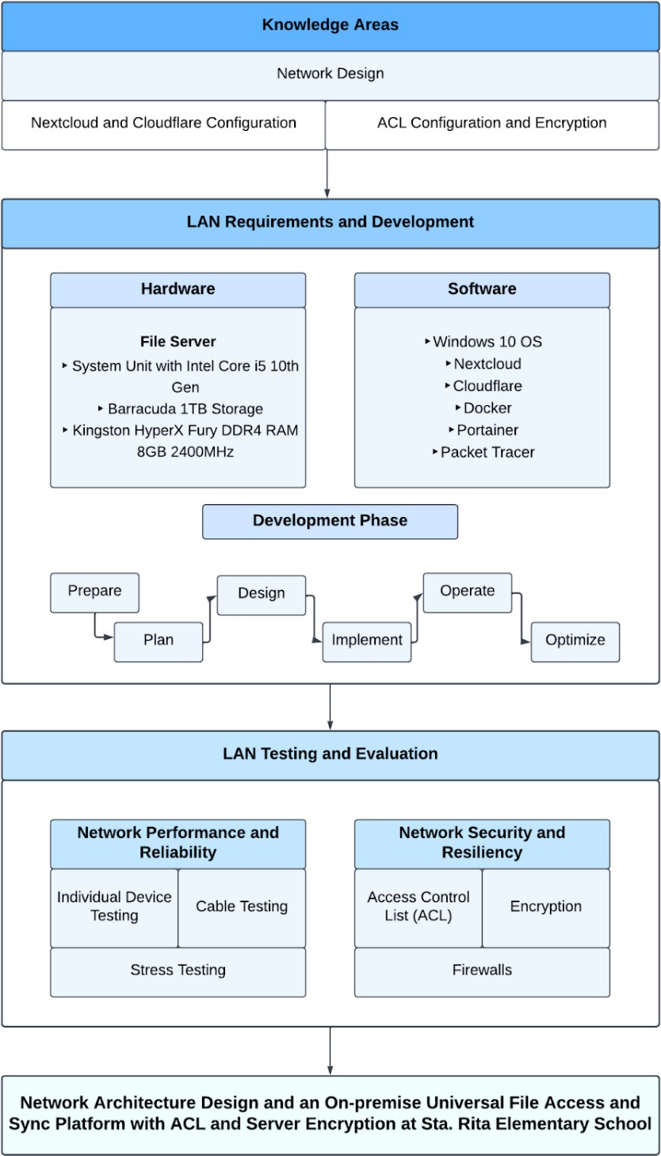

**Figure 1.** *Conceptual Framework*

The first part of the conceptual framework indicates the knowledge in designing a network, configuring Nextcloud for the universal file access and sync platform and Cloudflare for the security of the website, and have knowledge in configuring ACL and server encryption for the security of the network and the server. The necessary hardware requirements to implement a file server in Sta. Rita elementary school comprises a System Unit with an Intel core i5 10th gen processor to maximize the capacity of transporting and moving files seamlessly; a Barracuda 1TB Storage provides sufficient storage for storing user’s files, and 2 Kingston HyperX Fury DDR4 2400MHz 8GB RAM to make the server’s RAM 16GB and provide a smooth connection for users.

The necessary software requirements for the implementation include the Windows 10 operating system, Nextcloud, Cloudflare, Docker Desktop, Portainer, and Cisco Packet Tracer are used for network design and simulation. The development phase of the project consists of preparing, planning, designing, implementing, operating, and optimizing the network. The last part of the project involves the LAN testing and evaluation that tests the network’s performance and reliability by testing the devices and cables that are connected and used in the network. The network’s security and resiliency are also tested to identify threats by using security testing tools and implementing ACLs, encryption, and firewalls.

# CHAPTER III

**DESIGN AND METHODOLOGY**

The development of the project is based on the Prepare, Plan, Design, Implement, Operate, Optimize (PPDIOO) methodology. This ensures the effectiveness of the designed network and manages the problems that could exist in the implemented network design.

**Network Design Methodology**

Figure 2 shows the PPDIOO methodology diagram that is used in the project.

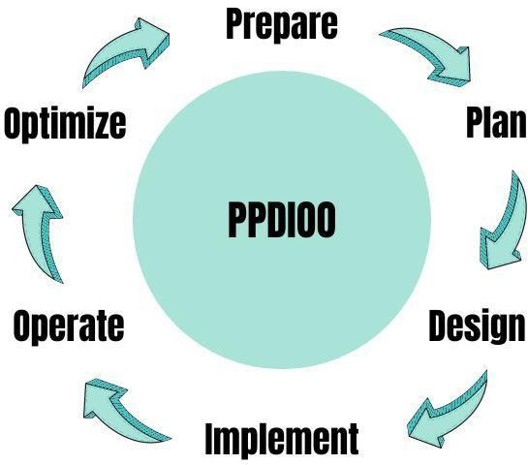

**Figure 2.** *PPDIOO Life Cycle Phases*

The PPDIOO methodology was used as it was the most appropriate methodology for this project and specifically designed by Cisco for network design and implementation that provided a continuous life-cycle of services required for a network. It was composed of six phases: Prepare, Plan, Design, Implement, Operate, and Optimize.

# 

# Prepare Phase

In the preparation phase, Sta. Rita elementary school was visited and solicited critical information, assessed and identified problems within their current existing LAN. Several types of analysis were conducted to better understand the LAN’s state and performance.

**Network Gap Analysis**

Network gap analysis is a technique for evaluating the variations in performance between an organization or institution’s network to ascertain whether business needs are being met and, if not, must think of efforts to be made to ensure what they are.

Table 6

*Network Gap Analysis*

|  |  |  |  |
| --- | --- | --- | --- |
| **Current State** | **Desired State** | **Gap** | **Remedies** |
| LAN with limited cloud data storage, minimal network security, and sufficient bandwidth but unreliable network connection. | LAN with 1TB local data storage alongside the cloud data storage, has appropriate network security and provides a strong and reliable network connection. | Some network devices are outdated and there are only a few network devices that accommodate numerous devices. Lacks a file server and the appropriate network security. | Created and developed  3 network designs considering the cost, design, performance, security, and speed. Implemented a file server with 1TB storage and with ACLs and  server encryption. |

A network gap analysis is conducted to determine if the current existing LAN in Sta. Rita elementary school is performing and meeting expectations accordingly and is effectively using the available resources.

**SWOT Analysis**

A company’s competitive edge can be evaluated using the SWOT analysis, which is also used to develop strategic planning. It represents advantages, dangers, opportunities, and weaknesses. The SWOT analysis analyzes both internal and external factors as well as the current condition and any predicted future events.

Table 7

*SWOT Analysis*

|  |  |  |
| --- | --- | --- |
| ***SWOT*** | ***Helpful*** | ***Harmful*** |
|  | **Strengths** | **Weaknesses** |
| **Internal** | 1. Most network devices are of good quality with sufficient bandwidth. 2. Has enough devices such as tablets, laptops, PCs to accommodate students and teachers. 3. Use of cloud storage. | 1. Lack of a centralized dedicated file server for sufficient data storage and backup. 2. Lacks network devices to accommodate numerous devices. |
|  | **Opportunities** | **Threats** |
| **External** | 1. Cost savings can be gained by upgrading some old network devices and reducing maintenance. 2. Maximize the available bandwidth and provide a stronger and more reliable network connection. 3. Have a more secure network and sufficient local data storage. | 1. Old or already obsolete network devices can lead to potential downtime, increased cost, and loss of productivity. 2. Poorly managed cables can potentially shut down the whole LAN. 3. Not having the appropriate security can lead to network   attacks. |

The researchers conducted a SWOT analysis to better understand the situation of the existing LAN and determined its internal strengths and weaknesses ,identified its potential external opportunities and threats from the environment.

# Analysis of the existing LAN

Figure 3 shows the existing LAN of Sta. Rita elementary school.

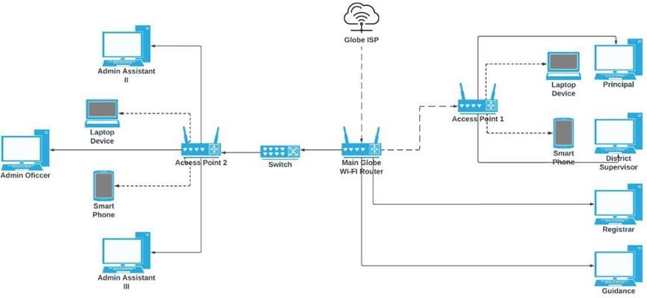

**Figure 3.** *Analysis of existing LAN*

The existing LAN of Sta. Rita elementary school currently lacks a dedicated file server that is necessary for storing and organizing huge amounts of data and files. Some devices are already outdated, and some are of great quality with a large bandwidth but also run short on network devices such as wireless access points to maximize the available bandwidth which compromises the network’s reliability of keeping a stable connection for all the connected devices. On that note, implementing a dedicated file server with 1TB storage, 2 Kingston HyperX Fury DDR4 2400MHz 8GB RAM, and an Intel core i5 10th gen processor is necessary to have sufficient storage for storing files and maximize the efficiency of transferring and moving data.

# Functional and Non-Functional Requirements

Table 8 shows the functional and non-functional requirements based on the specific objectives of the project.

Table 8

*Functional and Non-functional Requirements*

|  |  |  |  |
| --- | --- | --- | --- |
| **Specific Objectives** | **Functional Requirements** | | **Non-Functional Requirements** |
|  | **Main Requirements** | **Sub-Requirements** |  |
| Create 3 network architecture designs by adding and upgrading network hardware devices and comparing them with the existing LAN in terms  of:   1. Cost 2. Design 3. Performance 4. Security 5. Speed | Network Designs | Cost Design  Performance Security Speed | Performance Security Speed Scalability Economical Reliability |
| Network Familiarity |  | Economical Reliability |
| Implement on- premise universal file access and sync platform for data storage management and organization. | Server RAM Upgrade Storage Upgrade | Windows 10 Operating System Kingston HyperX Fury 8GB RAM Seagate BarraCuda 1TB HDD | Usability Availability Performance Security Speed Organizability |
|  | Server Management Skills |  | Manageability and Organizability of data |
| Implement security measures in the LAN and the on- premise universal file access and sync platform using:   1. Access Control List (ACL) 2. Encryption   c. Firewall | Access Control Lists (ACL) Encryption Firewalls | Group Policy Management Cloudflare  Windows Defender Firewall | Performance Security Manageability Reliability Resiliency |
| Server Security Skills |  | Network and User Security |

Functional requirements are composed of the features, components, and functions that enable the system or project to work properly and perform what it is intended to do. Non-functional requirements on the other hand are the qualities or

traits that describe or characterize the system’s functional and non-functional requirements.

# Plan Phase

After gathering all the necessary information and analyzing the existing LAN of Sta. Rita elementary school. All the necessary software and hardware requirements for the implementation were identified and gathered. This phase also shows the total cost of the hardware and software requirements needed to develop the project.

# Hardware Requirements

This part refers to the necessary hardware for the implementation of the file server as well as the necessary hardware for the end users to use and access the system hosted by the server. The researchers highly recommend the hardware specifications in order for the file server to run smoothly and efficiently so that the administrator of the Sta. Rita elementary school avoid issues in operating and managing the server.

Table 9

*Server Implementation Hardware Requirements*

|  |  |
| --- | --- |
| **Hardware** | **Specification** |
| System Unit (CPU) | Intel Core i5 10th Gen or higher |
| Internal Storage (HDD) | 1TB internal storage |
| Random Access Memory (RAM) | 16GB RAM |

Table 9 shows the minimum hardware requirements for the file server to run and function properly in accordance with the required standards, to support the

universal file access and sync platform that is hosted in the file server ensure its running efficiently. This hardware criterion is recommended to ensure that the file server is capable enough of handling the hosted application and provide the administrator with great quality and experience in operating the server.

Table 10

*End User Hardware Requirements*

|  |  |  |
| --- | --- | --- |
| **Device** | **Hardware** | **Specification** |
|  | Processor (CPU) | Intel (R) Pentium Dual Core, 3.00 GHz or higher |
|  | Random Access Memory (RAM) | 2GB+ |
|  | Internal Storage (HDD/SSD) | 500GB (HDD) or 128GB (SSD) |
| Computer/Laptop | Keyboard | Built-in keyboard in laptops or any USB keyboards for computers |
|  | Mouse | Optical mouse for both devices or Trackpad for laptops |
|  | Display/Resolution | 1366x768 to 1920x1080 or higher |
|  | Processor | Qualcomm Snapdragon 425 (Quad- core) or higher |
| Smartphone (or mobile devices such as tablets, iPad, etc.) | CPU speed | 1.4GHz or higher |
| Random Access Memory (RAM) | 4GB+ |
|  | Internal Storage | 32GB+ |
|  | Display | Touch screen display with at least  720x1280 resolution or higher |

Table 10 shows the minimum hardware requirements, both internal and external, for the end users to access the universal file access and sync platform of Sta. Rita elementary school. This hardware criterion is recommended to ensure that end users are provided with a quality experience in accessing the universal file and sync platform with minimal to no issues.

# Software Requirements

This part refers to the necessary software for the implementation of the file server as well as the necessary software for the end users to use and access the system hosted by the server. The researchers highly recommend the software specifications for the set-up and configuration of the universal file access and sync platform as they are suitable for the overall success of the implementation at Sta. Rita elementary school.

Table 11

*Server Implementation Software Requirements*

|  |  |
| --- | --- |
| **Software** | **Specification** |
| Network Design and Simulation | Cisco Packet Tracer |
| Operating System | Windows 10 |
| File Hosting, Sync, and Collaboration Platform | Nextcloud |
| Application Container Platform | Docker |
| Container Management Platform | Portainer |
| Security | Cloudflare |

Table 11 shows the necessary software requirements for the implementation of the universal file access and sync platform at Sta. Rita elementary school. This software criterion ensures that the implemented universal file access and sync platform is configured, deployed, and managed properly and efficiently while having the utmost security. It is recommended that the implementation is done on a Windows 10 operating system as it provides the most stable compatibility for the application to run among other operating systems.

Table 12

*End User Software Requirements*

**Device Software Specification**

Operating System (64bit) Windows 7 or higher macOS

Linux

Computer/Laptop

Web Browser

Mozilla Firefox Microsoft Edge

Google Chrome/Chromium Apple Safari

Smartphone (or mobile devices

Operating System Android 6.0+ (Marshmallow) iOS 14.0+

Mozilla Firefox

such as tablets, iPad, etc.)

Web Browser

Microsoft Edge Google Chrome Apple Safari

Mobile App Nextcloud File App Nextcloud Talk App

Table 12 shows the software requirements for end users to access the universal file access and sync platform of Sta. Rita elementary school. The researchers highly recommend the software criterion to provide the best performance, functionality, and stability in accessing and using the file and sync platform. This ensures the standards are properly met and the platform is supported.

# Network Requirements

The network requirements pertain to how the end users establish connections to the server and access the file and sync platform. In order for the universal file access and sync platform to be accessible, the server must be turned on by the administrator or it should be turned on 24/7 but due to constraints of the school’s policy, it is only accessible during working hours of the school.

Table 13

*Network Requirements*

|  |  |
| --- | --- |
| **Network Component** | **Specification** |
| Network Coverage | 4G Network Coverage |
| Wi-Fi | 802.11b/g/n |

Table 13 shows the network requirements for both the Sta. Rita elementary school and its end users can access the universal file access and sync platform from anywhere they are. This network criterion abides by the standard and ensures that end users can connect to the server with little to no delay or connection issues.

**Hardware Cost and Specifications**

This part discussed the necessary hardware in detail regarding the required quantity of the hardware, its cost, and specifications.

Table 14

*Hardware Cost and Specifications*

|  |  |  |  |  |  |
| --- | --- | --- | --- | --- | --- |
| **Quantity** | **Hardware** | **Classification** | **Specification** | **Estimated Price** | **Total Cost** |
| 1 | Computer Desktop (Provided by the school) | System Unit with Intel Core i5 10th Gen | Dell SFF Desktop System Unit with 19inch LCD Monitor CPU Intel Core i5 Quadcore, 8GB RAM, 320GB HDD Gigabit LAN  Deskless, Internet Shop, Home, School, and office use. | ₱ 19,000.00 | ₱ 19,000.00 |
| 1 | Storage | Seagate BarraCuda 1TB Storage | 7200 RPM spindle speed. Compliant with RoHS requirements. Full track multiple sector transfer capabilities without local processor intervention High instantaneous (burst) data transfer rates (up to 600MB per second). | ₱ 1,500.00 | ₱ 1,500.00 |
| 2 | RAM | Kingston HyperX Fury DDR4 RAM 8GB 2400MHz  Desktop Memory | 8GB DDR4 SDRAM model is manufactured by Kingston. It is compatible with DIMM 288-pin slots and features a 2400MHz clock frequency. performance,  facilitating an optimal computing experience. | ₱ 1,350.00 | ₱ 2,700.00 |
|  |  |  |  | Estimated Total Cost | ₱ 23,200.00 |

Table 14 represents all the hardware requirements for the project along with their classification, specification, and estimated cost. The researchers select affordable yet good-quality products for the hardware requirements of the project.

**Software Cost and Specifications**

This part discussed the necessary software in detail regarding their cost/subscription and specifications.

Table 15

*Software Cost and Specifications*

|  |  |  |  |
| --- | --- | --- | --- |
| **Logo** | **Software** | **Specification** | **Subscription** |
| https://lh6.googleusercontent.com/p2TE-24TaP8-xBLhIWxio9KZ5Cb9LMvj_c2Qy5B0xaVat1czyVeiIX5ruzk3ksjxXYV49qqxtSlKkLIXJgGTxetpdCddW6MPWRnrPpFWzFxulre0a-Vtfy8KT42wVOs04mM4WUhnaPxQ8wIPpi9KzjdxswT9oYkfV5qrJTpvjcIeytZIVlmBEGDbeLrnnA | Windows 10 OS | Provides a more efficient and faster operating system, enables full control that is beneficial for system administrators and is compatible with Windows Subsystem to allow Linux applications to run directly on Windows. | Free. |
| https://lh6.googleusercontent.com/SH2SjCNCHHTwnqfQKauDVy40OlwYci45ZtawYzZH48wCEBzGVf0K7HMRs0rNSlM-gyqMxRSae2s4rAsY_g-pPyOv19Lv_-IcQ5PnVoRrjzhbIeDf-sSWd-F4-lNhyoC-yKp7IuAVUdYpxr9o36YVeBO1wJdCok7W7Fkc_z_0vbcWB4ZGlKDtawqF28N5Kw | Nextcloud | Provides access control, user and role- management, greater file management, and better collaboration between coworkers. | Free |
| https://lh5.googleusercontent.com/yXmRK41oKugXVl4q7PrEGtsTIEGUD_ZzItq1lAJJWJbkQPP5Kn-UXoYjxsRHNH9NoOtsqIHqMUaP69fYe5Yc1fTzKmOKkeQAY4GID8pgcNBM-7YwCyLucFMIb4CxUFW4qDQ0LCAJCO2gbMic3iaYXwegay0IVlV108RVxeyrBkk-fZFCEDWBZwiFu-dAdg | Cloudflare | Provides security and improves the performance and reliability of the websites or applications that a server hosts. | Free |
| https://lh6.googleusercontent.com/KXASMZGcLQnqQBHLb_7voU9eRPgHzvYy71CloH0x1R7DWsVS6xkwxABvfbCu67xLZB72ND05qqqCp42WyX4IkCqH_ez2uf0TGR9-1GTH2_VSee1BWW-pFknc5Kv4iliDqgsSYAPWac7BQ_x9T9Zk6XTM9WmB3Ik763Qn865jPhAKzEcXspkPykXQ7OSjMw | Docker | Provides a platform that allows applications to be built, tested, and deployed. | Free |
| https://lh5.googleusercontent.com/tq0BLfIhaYJ5s_h9Cnc_BpkKohoBKEUhLf0HOv0Gi9-UId-JmzdDwpTuQ5Rm1zXylkRw1q8COeghlvGPRm_5eoomVOfnuqvpHr8DJXbNxn7bDX7omM2TN0-UxVwbQfIjAt0oJjtKC5pcGMhJoC6oqZsh_w1jQySGCEhnP8mwYNG2r2-u_Ob0HpBj-77O7w | Portainer | Provides easy management of containerized apps, simplifies their deployment, and prioritizes performance problems. | Free |

Table 15 shows all the software requirements that are essential for the implementation of the project. It includes Cisco Packet Tracer which is used for the network architecture design and simulation, Nextcloud, Docker, and Portainer for the universal file access and sync platform, and Cloudflare for the security measures. All the software tools that were used to implement the project are free and open-source software that also helps to reduce the cost of the project.

**ISO/IEC 27001 Standard**

ISO 27001 is a premier worldwide standard for information security. It was created to assist businesses of any size or sector in adopting an Information Security Management System to protect their data in a methodical and cost-effective manner.

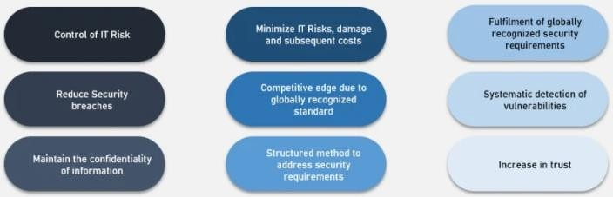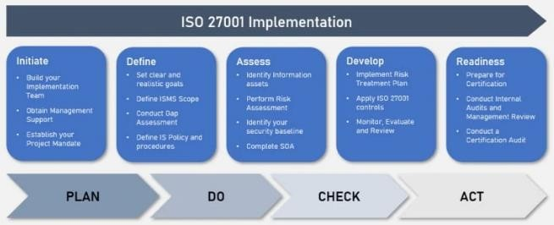

[https://ww](http://www.businesstechweekly.com/legal-and-compliance/iso27001-)w.busi[nesstechweekly.com/legal](http://www.businesstechweekly.com/legal-and-compliance/iso27001-)-[an](http://www.businesstechweekly.com/legal-and-compliance/iso27001-)d[-compliance/iso27001-](http://www.businesstechweekly.com/legal-and-compliance/iso27001-) certification/iso-27001-certification-process-costs/

**Figure 4.** *ISO/IEC 27001*

The confidentiality, integrity, and availability of information in the Sta. Rita Elementary School is ensured and protected by conforming to the ISO/IEC 27001 standard. Its primary goal is to identify the potential risks that can happen to the information and establish the methods to mitigate and prevent such risks from occurring.

# Constraints

This part is where the researchers listed and chose various hardware according to the client’s needs and the most suitable and practical hardware based on their price and specifications.

# Cost Constraints

This part listed and discussed the network devices included in the network design along with their cost and specification.

Table 16

*Access Point*

|  |  |  |
| --- | --- | --- |
| **Access Point** | **Cost** | **Specification** |
| TP-Link TL WR844N AP | ₱ 675.00 | Wi-Fi 4 technology with IEEE 802.11nb/g 2.4 GHz with speeds of up to 300Mbps and the Wi-Fi range encompasses 2 Bedroom Houses. Wi-Fi modes includes legacy, router, access point, range extender mode, and WISP mode. Ethernet Ports are 1x 10/11 Mbps WAN ports, and 4x 10/11 Mbps LAN Ports. |
| TP-Link Archer AX1500 | ₱ 2,460.00 | Wi-Fi 6 technology with up to 1.5 Gbps speeds. Can connect more devices with reliable coverage and reduced power consumption. It provides 1201 Mbps on the 5 GHz band and 300 Mbps on the 2.4 GHz band. |
| Ruijie Reyee RGEW1200G  PRO | ₱ 4,680.00 | Offers a strong signal with its independent signal amplifier. Provides stable connection and better performance with its next-generation chip that has 1300M Dual Band Gigabit. |

The TP-Link TL-WR844N AP is recommended as the access point for the future upgrade of the existing access point. It provides enough features, security, and capabilities suitable for the project and costs way less than the other two access point options. Although the TP-Link Archer AX1500 and Ruijie Reyee RG- EW1200G PRO have newer technology and better features they cost way more and are uneconomical for the project. Thus, TP-Link TL-WR844N AP is the best option,

more economical and has enough to perform the needed capabilities for the project and saves costs. The TP-Link Archer AX1500 and Ruijie Reyee RG-EW1200G PRO are recommended for the upgrades of the access points. The TP-Link TL WR844N AP would generally last for 1-3 years but may vary depending on its frequency of use, while both the TP-Link Archer AX1500 and Ruijie Reyee RG- EW1200G PRO can generally last up to 3-5 years as they are better quality devices.

Table 17

*Switches*

|  |  |  |
| --- | --- | --- |
| **Switch** | **Cost** | **Specification** |
| TP-Link LS1005G 5-  Port | ₱ 500.00 | Provides 5 auto-negotiation RJ45 ports that support 10/100/1000Mbps and also provide auto MDI/MDIX technology. It has IEEE 802.3x flow control that gives dependable transfer of data, plastic casing, desktop, plug and play, and no configuration needed. |
| TL-SG1210P  10 Port | ₱ 4.838.40 | Provides 9 RJ45 ports, 8 of which are PoE+ ports with speeds of up to 10/100/1000Mbps. It has 1 Gigabit SFP port that works with IEEE 802.3af/at compliant PDs and enlarges the network. 802.1p DSCP QoS enables even latency and all of its PoE ports have 63W. It is simple to use as no configuration and installation are needed. |
| TL- SL1218MP  18-Port | ₱ 9,544.55 | Provides 16 PoE+ RJ45 ports with speeds of up to 10/100Mbps. 2 gigabit RJ45 ports and 2 combo Gigabit SFP slots. Has an extended mode specially designed for surveillance system that is capable of 250M of data and power transmission. Guarantees the quality of sensitive applications such as a video monitor with priority mode. All of its PoE ports have 194W. It is simple to use as no configuration and installation is needed. |

It was recommended the TP-Link LS1005G 5-Port as the switch for the future upgrade as it is able to accommodate bandwidths of 10/100/1000Mbps and supports Auto-MDI/MDIX for the cabling. It costs less than the other switch options and has enough features to provide the necessary capabilities on a network. The other two options which are the TL-SG1210P 10-port and TL-SL1218MP 18-Port costs way too much for the current LAN in Sta. Rita elementary school needs and are a much better option for upgrades especially when the school decides to

add more devices in their facilities as these 2 switches can accommodate more devices and provides much better performance. The TP-Link TL WR844N AP generally last for 1-3 years but may vary depending on its frequency of use, while both the TP-Link Archer AX1500 and Ruijie Reyee RG- EW1200G PRO can generally last up to 3-5 years as they are better quality devices.

Table 18

*Storage*

|  |  |  |
| --- | --- | --- |
| **Storage** | **Cost** | **Specification** |
| Seagate BarraCuda 1TB | ₱ 2.195.00 | Provides 7200 RPM spindle speed that is compliant with the RoHS requirements. It features a full-track multiple-sector transfer capability without needing a local processor. It offers high instantaneous data transfer rates that are up to 600MB per second. Increased performance in demanding applications using native command queuing. |
| Western Digital Blue 1TB | ₱ 2,229.00 | Provides IntelliSeek that lowers power consumption, noise, and vibration by calculating optimum seek speeds. It also features Data LifeGuard which continuously monitors the drive so that it stays in optimum health. It has a SATA 6 Gb/s interface, a 7,200 RPM speed, a 64MB buffer size, a 300,000 minimum load/unload cycles, and transfer rates of up to 150 MB/s. |
| Seagate ST2000VX015 2TB | ₱ 2,990.00 | It features Image Perfect firmware. It has a SATA 6Gb/s interface, a 64MB buffer size, a 5900 rpm spindle speed, and is also capable of 180MNps internal data rate and 600MBps drive transfer rate. It also has a connector type of 7-pin serial ATA and a storage interface serial ATA-600. |

The Seagate BarraCuda 1TB is chosen for the storage of the file server. While it has the lowest cost among the three, it provides more reliability and transfer capability. It is capable of data transfer rates that can go up to 600MB per second the same as Seagate ST2000VX015 which is the most expensive one among the three while the Western Digital Blue 1TB can only go up to 150MB/s. The data transfer rate is very important in providing a fast and efficient file transfer. Seagate BarraCuda 1TB has significant features including Native Command Queuing that can increase its performance for demanding applications. The Western Digital Blue 1TB and Seagate ST2000VX015 2TB are the best fit for future upgrades even

though more expensive and provides much more capabilities and features that enhance and improve the performance of the hard drive.

Table 19

*RAM*

|  |  |  |
| --- | --- | --- |
| **RAM** | **Cost** | **Specification** |
| Kingston HyperX Fury 8GB RAM DDR4 2400MHZ | ₱ 1,350.00 | Its capacity is 8GB, has a memory speed of 2400MHz-3200MHz, and is a DDR4 type. It has a 288Pin interface type, and a DIMM memory socket: DIMM, it is capable of single and dual channel. CAS Latency: CL15. Voltage: 1.2V. |
| Crucial 8GB RAM DDR4 2400MHZ | ₱ 1,560.00 | Its capacity is 8GB, has a memory speed of 2400MHz-2600MHz, and is a DDR4 type. It is a Non-ECC function, has a 288Pin interface type, and a memory voltage of 1.2V/1.35V/1.5V. |
| CORSAIR  Vengeance 8GB DDR4 2400MHZ | ₱ 2,674.00 | Designed for high-performance overclocking, provides faster heat dissipation and helps control heat with its eight-layer PCB, It also provides superior overclocking clearance. The heat distributor provides efficient cooling that improves overclocking potential. |

Kingston HyperX Fury 8GB RAM DDR4 2400MHz was chosen as it provides the exact necessary specifications compatible with the system unit in Sta. Rita elementary school that used as a file server. It is the least expensive among the three RAM options but is more reliable, compatible, and provides sufficient features and capabilities to handle the tasks of the file server. The other two options which are crucial are the 8GB RAM DDR4 2400MHz and CORSAIR Vengeance 8GB DDR4 2400MHz that have better features but are too much for the file server implemented. They are better options for future upgrades when the file server needs more resource-heavy software such as the HIDS and SIEM tools for the security of the file server. Thus, Kingston HyperX Fury 8GB RAM DDR4 2400MHz is the best option among the three as it is suitable for the current needs of the system and has enough features.

# Security Constraints

This part listed and discussed the security of each access point included in each network architecture design.

Table 20

*Access Point Security Constraints*

|  |  |
| --- | --- |
| **Access Point** | **Security** |
| TP-Link TL WR844N AP | Wi-Fi encryption includes WEP, WPA, WPA2, WPA/WPA2-Enterprise (802.1x) Provides SPI firewall, access control, IP&MAC binding for the network security. It also provides an application layer gateway and a 1 x 2.4 GHz guest network. |
| Ruijie Reyee RGEW1200G PRO | Provides WPA-PSK/WPA2-PSK encryption for network security, It features IP-MAC binding and SSID hiding for ARP protection. It provides internet access control and prevents rogue devices (Blacklist/whitelist). |
| TP-Link Archer AX1500 | Wi-Fi encryption includes WEP, WPA, WPA2, WPA3, WPA/WPA2-Enterprise (802.1x) Provides SPI firewall, access control, IP&MAC binding for network security. It also provides an application layer gateway and a 1 x 2.4 GHz guest network. |

As shown in table 20, Ruijie Reyee RG-EW1200G PRO has the least capability when it comes to security and is more expensive than TP-Link TL- WR844N AP which is the recommended access point. Both the TP-Link TL- WR844N AP and TP-Link Archer AX1500 have similar security features but the latter has added more security features for newer technology but is unnecessary for the project and is the most expensive among the three. In conclusion, the TP- Link TL-WR844N AP is the best option, it is economical, and saves costs as it is the least expensive but has almost the same security features as TP-Link Archer AX1500 which is the most expensive one.

Table 21

*Longevity of Network Designs and its devices*

|  |  |  |  |
| --- | --- | --- | --- |
| **Network** | **Network Devices** | **Network Lifespan** | **Category** |
| Network Design 1 | TP-Link TL WR844N Access Point  TP-Link LS1005G 5-Port Switch | 1-3 years | Budget-friendly network design with cheap and average quality network devices. |
| Network Design 2 | TP-Link Archer AX1500 Access Point  TL-SG1210P 10 Port Switch | 3-5 years | Affordable network design with good quality network devices. |
| Network Design 3 | Ruijie Reyee RGEW1200G PRO Access Point  TL- SL1218MP 18-Port Switch | 5+ years | Expensive network design with top-quality network devices. |

Table 21 shows the specific access points and switches included in each network design. It indicates the lifespan and specification of the network. Network design 1 is a budget-friendly with average-quality network devices and is expected to last for about 1-3 years but may last shorter, within a few months, or last longer depending on its use and the number of devices it is accommodating. Network design 2 costs a little more than design 1 but is still within the affordable range and includes good-quality network devices that are expected to last for about 3-5 years. Lastly, network design 3 is the most expensive of all three designs but provides top-quality network devices and this design is expected to last about 5+ years as its devices have excellent quality with advanced capabilities and features that can handle and endure heavy use and accommodate more devices.

Table 22

*Number of Users for each Network Design*

|  |  |  |  |  |
| --- | --- | --- | --- | --- |
| **Network** | **Maximum Users/Devices** | **Minimum Recommended Users/Devices** | **Maximum Bandwidth** | **Minimum Required Bandwidth for each User/Device** |
| Network Design 1 | 222 | 111 | 1.7Gbps | 10-15Mbps |
| Network Design 2 | 148 | 74 | 2.3Gbps | 20-30Mbps |
| Network Design 3 | 155 | 77 | 2.5Gbps | 25-32Mbps |

Table 22 shows the maximum number of users/devices and maximum available bandwidth for each network design. 111 is the minimum recommended number of users/devices that network design 1 can accommodate to allow a 10-15Mbps bandwidth allocation for each user/device that provide smooth connection with optimal speeds. While for network design 2, 74 is the minimum recommended amount of users/devices to allow a 20-30Mbps bandwidth allocation for each user/device that provide greater speeds. Lastly, 77 is the minimum recommended amount of users/devices for network design 3 to allow a 25-32Mbps bandwidth allocation for each user/device that would better connection with excellent speeds.

# Trade-Offs

The researchers carefully analyzed, chose, and recommended the best options among the available hardware and software in the market. The various hardware and software were selected based on their cost, specifications, and relevancy of use for the project. The practicality and appropriateness of every option were considered based on how it can be economical and beneficial for future upgrades and long-term use in the network.

In terms of the access point, the TP-Link TL-WR844N AP is the most economical and provides enough security and capabilities that are suitable for the project. For the switch, the TP-Link LS1005G 5-Port is recommended as it provides the necessary features and is a cost-effective option. The Seagate BarraCuda 1TB is recommended for storage as it provides more reliability and transfer capability among the three storage options and also costs less. For the RAM, the Kingston HyperX Fury 8GB RAM DDR4 2400MHz is recommended as it is the least expensive among the three and is more reliable, compatible, and provides sufficient features and capabilities to handle the tasks of the file server.

Network design 1 is a budget-friendly network design consisting of average-quality network devices with a lifespan of 1-3 years. It is able to accommodate 111 users or devices with each having speeds of up to 10-15Mbps. While network design 2 is a little bit more expensive than network design 1 but is still within the affordable range consisting of good quality network devices with a lifespan of about 3-5 years. It is capable of accommodating 74 users or devices with each having speeds of up to 20-30Mbps. Lastly, network design 3 is the most expensive network design among the three but consists of top-quality network devices with a lifespan of 5 years or more. It is able to accommodate 77 users or devices with each having speeds of up to 25-32Mbps.

# Design Phase

The network is built according to design specifications, with the goal of addressing the problems present in the existing LAN and enhancing it by adding a file server, network security, and upgrading network devices without disrupting the existing network or creating security holes or vulnerabilities. The network design is created with the help of software such as packet tracer and lucidchart. The network

was designed with the purpose of meeting the business and technical requirements that provide support for availability, reliability, security, scalability, and performance.

**Vicinity Map**

This part shows the local area of the activity’s location. Figure 5 shows the location of Sta. Rita elementary school.

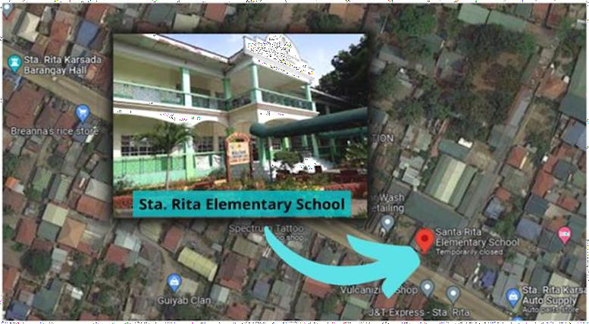

**Figure 5.** *Vicinity Map*

This is the location of Sta. Rita elementary school where the implementation of the project takes place. Specifically, the principal’s office, admin office, guidance, and registrar’s office are involved in this project.

**Network Design**

The researchers developed 3 network architecture designs for the future upgrade of the current LAN in Sta. Rita elementary school. The designs were developed to address the network problems of the existing LAN and improve its

performance by upgrading outdated network devices and providing a neater and clearer LAN layout and infrastructure. Each network design has its own advantages and disadvantages but was created to conform to and suit the needs of the Sta. Rita elementary school.

# Network Design 1

Figure 6 represents the network architecture design 1.

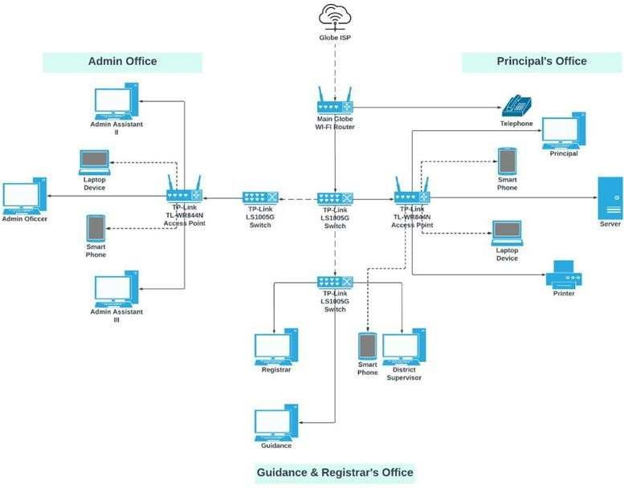

**Figure 6.** *Network Design 1*

Network Design 1 was developed to resolve the network problems present in Sta. Rita elementary school, and is considered to be the best out of the 3 network designs due to it being the most suitable and economical in upgrading the current LAN of the client, hence, it is the recommended network design for the future

upgrade of the current LAN in Sta. Rita Elementary School. Network Design 1

added 2 new switches and upgraded an old switch with the TP-Link LS1005G that provides reliable data transfer and supports Auto-MDI/MDIX. The 2 outdated access points were also upgraded with the TP-Link TL-WR844N which is capable of providing 300 Mbps wireless speeds and supports multiple modes such as access point mode, range extender mode, and more. Upgrading outdated network devices fix a lot of network issues, specifically the slow and unreliable internet connection and the frequent disconnection of devices. A server that hosts the universal file access and sync platform was also implemented in the administrator’s office to provide them with a bigger storage capacity and a centralized database for data storage, management, and easy sharing of files.

# Network Design 2

Figure 7 represents the network architecture design 2.

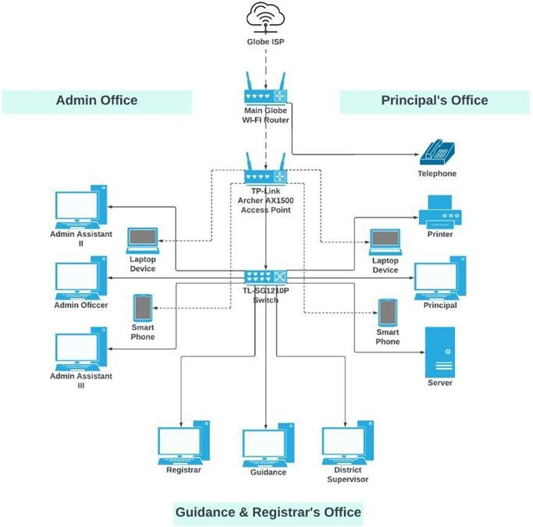

**Figure 7.** *Network Design 2*

Network Design 2 is recommended by the researchers to be the future upgrade of network design 1 as it is more of a neat and simple design but it consists of a much greater quality of network devices, thus, it is also more expensive but beneficial. In this design, the 2 access points were replaced with only one access point which is the TP-Link Archer AX1500, it features numerous capabilities such as Wi-Fi 6 technology, connects more devices, and provides better performance. The 3 switches were also replaced with only 1 switch, which is the TL-SG1210P which is of much greater quality and can accommodate 9 devices as it has 10 ports,

9 of which are RJ45 ports and 1 Gigabit SFP port. It also has 8 ports that are capable of PoE+ that provide up to 30W-63W. The RAM of the file server was also upgraded to 16GB of ram to handle the newer version of Windows Server and the host-based intrusion detection system that is the software integrated with this design to serve as the security measures of the server and the network.

# Network Design 3

Figure 8 represents the network architecture design 3.

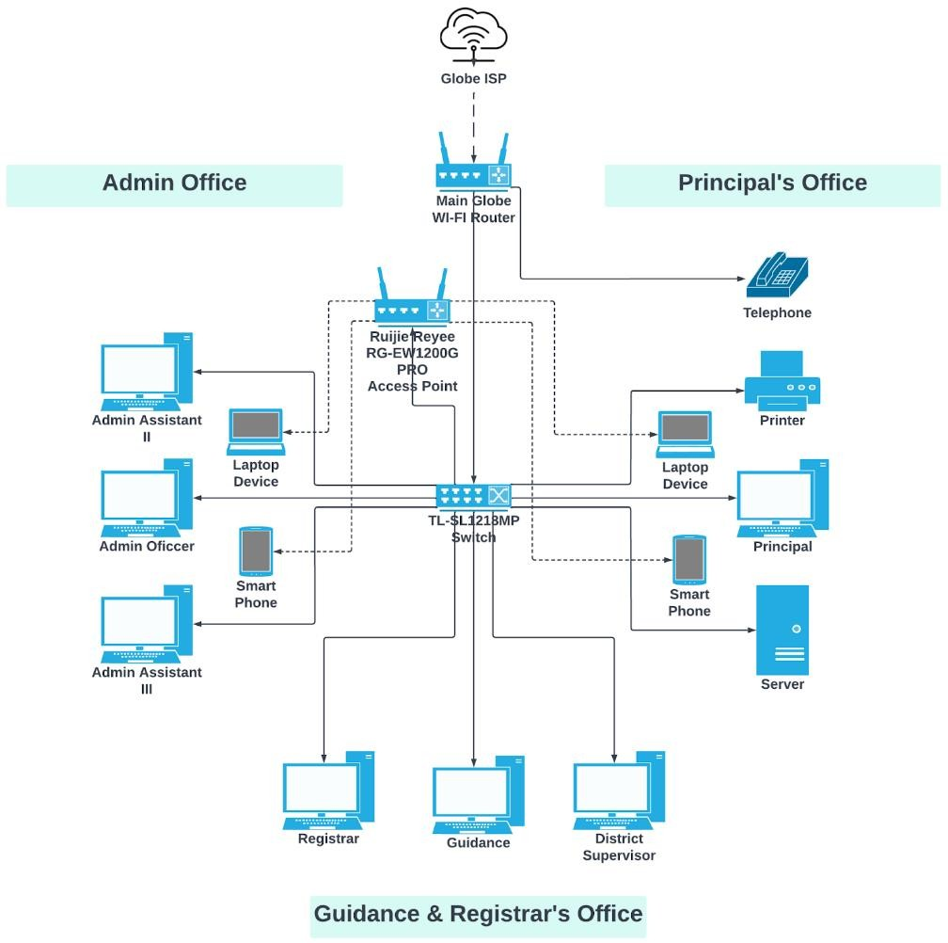

**Figure 8.** *Network Design 3*

Network Design 3 is the recommended upgrade to network design 2. Its design is very similar to network design 2, the only difference is that the new access

point is connected to the main switch instead of being directly connected to the main globe Wi-Fi router. This design consists of network devices and components of very high quality; thus, it is the most expensive of the 3 designs but provides new advanced technology, numerous features, and benefits. This design keeps the LAN in Sta. Rita elementary school, up-to-date with the new trends in technology for several years and prepares the school for cloud adaptability and services.

This design upgraded the TP-Link Archer AX1500 access point from network design 2 to Ruijie Reyee RG-EW1200G PRO has more features including dual-band integration that offers low interference and provides faster internet speeds, has external 6dBi high-gain omnidirectional antennas that boost Wi-Fi range and network performance, and supports beamforming for a stronger and more reliable signal. The switch from network design 2 was also upgraded to TL- SL1218MP which is capable of accommodating more devices as it has 18 ports, 16 of which are fast ethernet PoE ports and 2 Uplink Gigabit ports.

It has a priority mode to ensure the high quality of video applications and an extended mode for surveillance systems. The RAM of the file server is still 16GB but of a much better brand and quality and the storage is upgraded to 2TB to provide more space for newer advanced software. The file server is handling a newer version of Windows Server and a Security Information and Event Management (SIEM) for the security measure of the file server and the network.

# Software Constraints

This part is where the appropriate software requirements according to the hardware requirements of each network architecture design was chosen, consequently improving the capabilities and performance of the previous network design.

Table 23

*Software Constraints*

|  |  |
| --- | --- |
| **Network Design** | **Software Requirements** |
| Network Design 1 | Windows 10, Nextcloud, Cloudflare, Docker, Portainer, Packet Tracer |
| Network Design 2 | Windows Server 2019, OSSEC, Packet Tracer, Packet Sender Testing Tool |
| Network Design 3 | Windows Server 2019, Wazuh, Packet Tracer, Wireshark |

The network design 1 software requirements are the most recommended for the future upgrade and consist of Windows 10, Nextcloud, Cloudflare, Docker, Portainer, and Packet Tracer for the development of the project. Windows 10 operating system provides a more efficient and faster operating system, enables full control that is beneficial for system administrators, and is compatible with Windows Subsystem for Linux applications. Nextcloud is the platform for teachers and faculty staff to access and share files and also provides access control to only give the appropriate access and permissions to the users.

Cloudflare provides security such as a web-application firewall, Cloudflare DNS, and Zero Trust Security to help prevent threat actors from accessing the network and safeguarding against malicious activity. Docker is used for containerizing and deploying the Nextcloud application. Portainer helps in easily managing containerized applications in Docker. Packet Tracer is used for network simulation and network design; this helps to plan the network topology by accessing to graphical representations of various network devices. Most of the software tools that were used are practically free and open-source which provides transparency to the user as the source code is open and available to anyone.

Network design 2 software requirements are composed of Windows Server

2019, OSSEC host-based intrusion detection system, Packet Tracer, and Packet Sender Testing Tool which serves as a recommended future upgrade of network design 1 that is implemented in Sta. Rita elementary school. Windows Server 2019 has added new layers of security to protect businesses and institutions that includes numerous features including Windows Admin Center, Linux integration, which provide increased security to reduce network security risks and Windows Server 2019 achieves greater efficiency and scale for the network.

The OSSEC host-based intrusion detection system provides security measures for the server such as log monitoring, integrity checking, rootkit detection, and more which enables the administrator to check, detect, and monitor any abnormal or malicious activity that is happening in the system. Similar to network design 1, network design 2 also used the Packet Tracer for network design and simulation and the Packet Sender for performing various tests to determine the status and performance of the network.

Network design 3 software requirements are Windows Server 2019, Wazuh, Packet Tracer, and Wireshark, and is recommended as an upgrade to network design 2 if it was implemented successfully and working properly. Network design 3 keeps the LAN of Sta. Rita elementary school with the trending technology especially the cloud. Windows Server 2019 includes numerous features including Windows Admin Center, and Linux integration, which provide increased security to reduce network security risks and Windows Server 2019 achieves greater efficiency and scale for the network. Wazuh is a security monitoring tool that is free and open source that provides numerous security features such as endpoint security which includes file integrity monitoring, extended detection, and response, security operations that include log data analysis, and malware detection.

Lastly, Wazuh is also capable of providing cloud security such as container security and workload protection. Like network designs 1 and 2, network design 3 still used Packet Tracer for the simulation and design of the network. Instead of using Packet Sender for testing the network, Wireshark is used. Wireshark is a broad software application that offers a lot of features including deep inspection of protocols, live capture and offline analysis, and more. It is known for its network traffic analyzer and is an essential tool for any security professional or network administrator as it can be used to troubleshoot network problems.

# Network Design Summary and Comparison

This part summarizes and compares the network designs with each other and in contrast with the existing LAN in Sta. Rita elementary school. The hardware, software, and overall estimated cost of each network design are also included.

Table 24

*Network Design Summary*

|  |  |  |  |
| --- | --- | --- | --- |
| **Network Design** | **Hardware** | **Software** | **Overall Estimated Cost** |
| Network Design 1 | TP-Link TL-WR844N Access Point  TP-Link LS100SG S-Port Switch Seagate BarraCuda 1TB Storage Kingston HyperX Fury DDR4 4GB 2400MHZ RAM | Windows 10 OS Nextcloud Cloudflare Docker Portainer  Packet Tracer | ₱ 6,570.00 |
| Network Design 2 | TP-Link Archer AX1500 Access Point TL-SG1210P 10-port Switch Western Digital Blue 1TB Storage Crucial 8GB DDR4 2400MHz RAM | Windows Server 2019 OSSEC  Packet Tracer  Packet Sender Testing Tool | ₱ 16,967.40 |
| Network Design 3 | Ruijie Reyee RG-EW1200G PRO Access Point  TL-SL1218MP 18-Port Switch Seagate ST2000VX015 2TB  Storage  CORSAIR Vengeance 8GB DDR4  2400MHz RAM | Windows Server 2019  Wazuh Packet Tracer Wireshark | ₱ 25,768.55 |

Table 24 summarizes and compiles all the hardware and software required for each network design as well as their overall estimated cost. The hardware and the overall estimated cost didn’t include the cables, cable tester, and RJ45 for equitability as they are only necessary for network design 1 and is not needed for network designs 2 and 3.

In terms of cost, the least expensive is network design 1 and it is also the most economical to implement in upgrading the existing LAN in Sta. Rita elementary school. Network Design 2 comes in second in cost and is also a good option as it is still within the affordable range but with more high-quality network

devices. Network Design 3 is the most expensive but provides new and advanced technology that would keep the LAN up-to-date with the trend and it also provides numerous features and capabilities that would yield great benefits for the school going forward.

In terms of the design of the network, both network designs 2 and 3 are the clear winner as they provide a much more neat and simple design that improve the existing LAN and make it easier to manage because of the fewer network devices implemented. Making the design simpler was possible because of the much greater quality of network devices that is implemented. Although Network Design 1 is the most suitable in terms of design, it is more crowded and need a lot of work in managing the network devices and making sure that they are all working properly.

In terms of performance, Network Design 1 and all its included hardware and software fit perfectly with the existing LAN in Sta. Rita elementary school but needs an upgrade for solving the network problems. Network Design 2 and 3 provide much better network performance and better security for the server and the network due to better network devices and more advanced and newer versions of the server and software for security but as of now are

unnecessary and are a much better option for future upgrades especially when the school decides to add more devices and wants to migrate to the cloud. Consequently, better network devices and security is necessary.

In terms of security, Network Design 1 implemented ACL and server encryption using Cloudflare and Nextcloud’s security features which are sufficient in protecting against unauthorized access and other malicious activity that can occur in the network. Network Design 2 and 3 definitely provide greater quality and advanced security that is ideal for the upcoming years as network security risks and threats are getting more and more complex and difficult to handle. It is highly recommended that network design 1 is upgraded to either network design 2 or 3 in the future for the Sta. Rita elementary school to have better security that can address and prevent security risks such as DDoS attacks and malware such as ransomware and worms.

In terms of speed, surprisingly enough, all those three designs are not far from each other and may just come down to which network devices provide more features, and capabilities, and which devices have better or more advanced technology that can help maintain the speed and performance in the long run. All three Network Designs are capable of providing sufficient speed and performance to improve the existing LAN but Network Designs 2 and 3 are much better options.

In conclusion, Network Design 1 is what the researchers recommended for the future upgrade and enhancement of the existing LAN in Sta. Rita elementary school as it is the most suitable and economical among the three network designs. The design, hardware, and software included are relevant and are pretty much capable of providing sufficient needs to address and resolve the network problems present in the existing LAN and improve it for the better. The hardware and software chosen for Network Design 1 are the most suitable and practical among their counterparts based on their cost, specifications, and relevancy for the project. Although the counterparts have advanced technology, better features, and capabilities, in return are more expensive, uneconomical, and most of the features are unnecessary for the enhancement of the existing LAN in Sta. Rita elementary school.

**Network Architecture Diagram**

Figure 9 shows the network architecture diagram that provides a visual representation of all the components required to enhance the existing LAN of Sta. Rita elementary school.

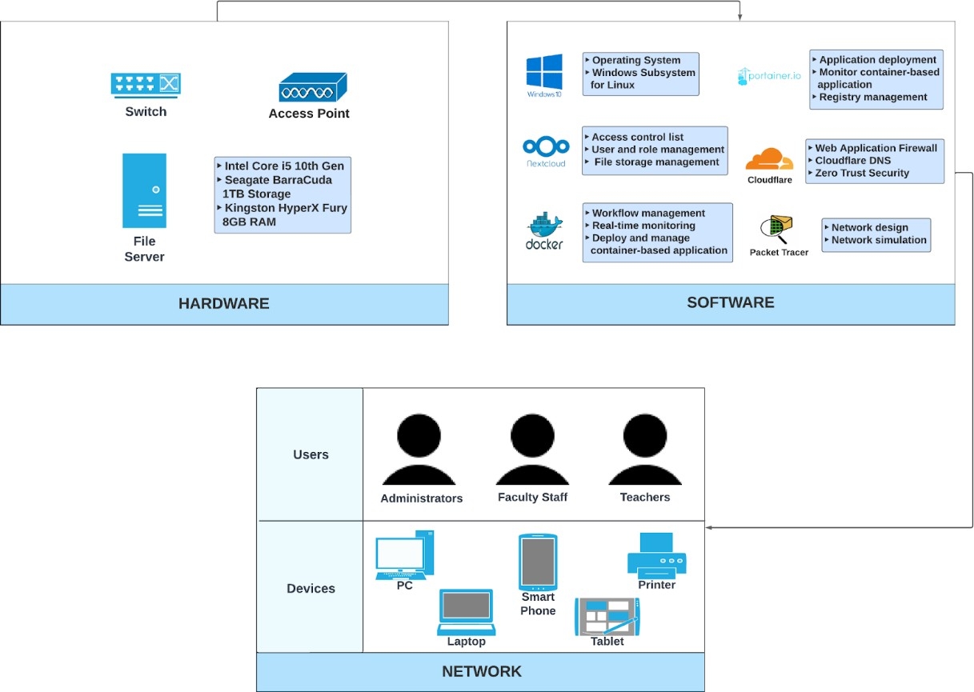

**Figure 9.** *Network Architecture Design*

The network architecture diagram compiles and summarizes the significant components required to enhance the existing LAN of Sta. Rita elementary school. The network layer is where the hardware resides, it comprises the various network devices including a router, a switch, an access point, and a system unit with an Intel core i5 10th gen processor, a 1TB of storage for the file server, and 2 Kingston HyperX Fury DDR4 2400MHz 8GB RAM.

The software layer is required to enable crucial functions and capabilities for the network, it consists of the different software and applications that are used and implemented to enhance the existing LAN. The packet tracer tool is used for the design and simulation of the network, and Windows 10 is used as the operating system for the compatibility of Windows Subsystem for Linux applications that

allows Docker desktop to be installed for containerizing and deploying applications such as Nextcloud. Nextcloud is the platform for teachers and faculty staff to access and share files and it also provides access control to give the right permissions to specific users.

Consequently, Cloudflare provides security including Cloudflare DNS, Zero Trust Security, and Web-Application Firewalls to protect applications from threats such as DoS and DDoS attacks. Portainer goes hand in hand with Docker and helps to easily manage containerized applications. Lastly, the application layer is where the devices and users reside. The devices are the medium for the users to access the internet and the different applications necessary for their work. The devices include PCs, laptops, smartphones, tablets, and a printer while the users consist of teachers, faculty staff, and students.

# Implement Phase

Before the actual implementation of the project, preliminary testing was first conducted on the existing LAN in Sta. Rita elementary school to better analyze the network and determine its current performance and then compare it to the network testing results after the implementation of the project. In the implementation phase, a dedicated server is implemented to host the universal file access and sync platform, the appropriate network security measures are applied to enhance the existing network.

During the implementation phase, enterprises are working to integrate devices and new features after design while maintaining network availability and performance. The implementation phase also describes how to implement the solution based on the design work completed in the previous step. Supporters can continue to test the network at that pace until the network is successfully connected (without interruption). Researchers can integrate devices by redesigning their network topology or adding new components according to design requirements without jeopardizing the current network or creating security vulnerabilities. This phase is important because the designer is able to test the design at various times. When something goes wrong, it is usually easier to fix it before making too many changes.

The following items are the hardware and software tested:

# Server Static Configuration

Figure 10 shows the static configuration of the server in Sta. Rita elementary school.

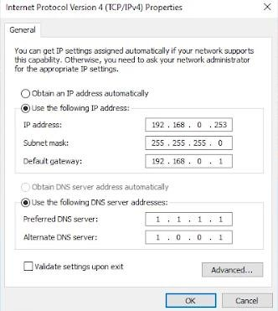

**Figure 10.** *Server Static Configuration*

This is done in the preliminary stages by simply checking and configuring of the devices such as routers, access points, workstations, smartphones, etc. have the right network configuration such as the right default gateway or WLAN settings and test if they have a connection to the network or can transmit files or messages. In some instances, the only reason why certain devices can’t work properly or connect to the network is simply because of wrong or outdated configuration and settings. The DNS server is set to Cloudflare’s DNS service which provides fast response times and advanced security such as DDoS mitigation and DNSSEC. So, this is a very important part before heading into the implementation.

**Ping Test**

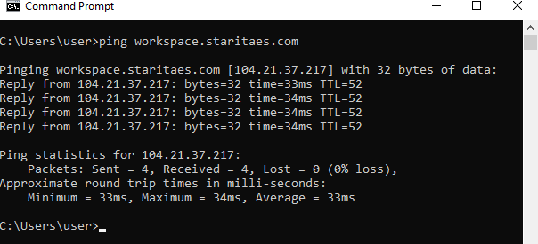Ping tests helped in identifying connection issues between the network and a server, workstation, and websites. Figure 11 shows an example of the ping command on the workspace.staritaes.com website which is the universal file access and sync platform.

**Figure 11.** *Ping Test*

The ping command is used to determine the connection and latency between two connections on the network or between a device and a website. Using ping the researchers determined if workspace.staritaes.com is responsive and reachable even remotely to ensure that users are able to access the file and sync platform without any connection issues.

# Software Configuration

This part shows the step-by-step software configuration of the implementation of the universal file access and sync platform in the server of the Sta. Rita elementary school.

**Prerequisites**

These are the requirements before the actual software configuration of the universal file access and sync platform. This step is crucial in enabling the success of the software configuration and ensures minimal to no issues in the configuration process.

* **Buy a Domain**

The researchers bought a domain in GoDaddy so that users can easily find the website by searching it or by simply clicking on a link that leads to the website. This implementation specifically needs a domain for the Nextcloud application that is customized for Sta. Rita elementary school. The configured domain name is workspace.staritaes.com and is the platform for teachers and faculty staff to mainly upload, access, and share files but do more stuff such as communicate, video chat with others, create documents, share photos, and more.

* **Enable Virtualization for Windows 10**

Enabling virtualization allows the PC to emulate a different operating system like Linux leading to a wide variety of apps to install on a PC.

1. First, check whether your PC has enabled virtualization for Windows 10.
2. Go to the **Task Manager** and click on the **Performance** tab.
3. Check whether the **Virtualization** is Enabled or Disabled.

Figure 12 shows that the Virtualization is Disabled.

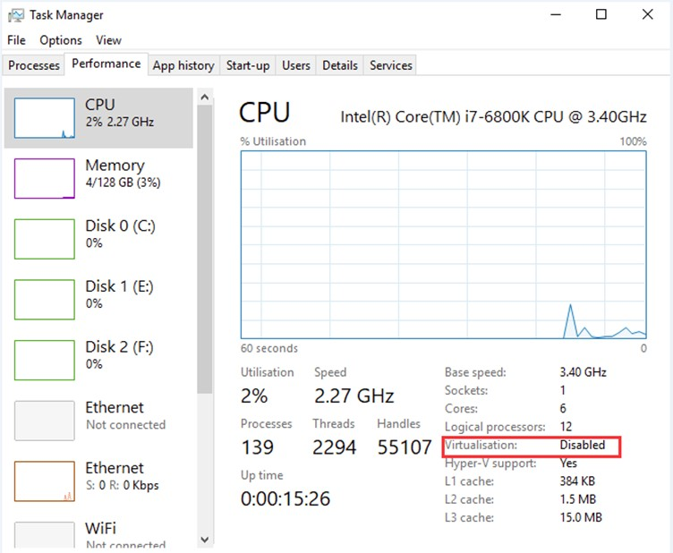

**Figure 12.** *Virtualization*

If the virtualization is disabled, it is not possible to install the Docker desktop and deploy Nextcloud.

1. Go to **Windows Settings** by simply pressing the **Windows key** and **I**

simultaneously.

1. Click on **Update & Security**.
2. Navigate to the **Recovery** tab.
3. In the **Advanced startup** click restart now.
4. In the **Windows Recovery Environment**, click on **Troubleshoot** then

**Advanced options then UEFI Firmware Settings.**

1. Click **Restart now** to continue.
2. In the **BIOS** settings click on **Virtualization** and enable it.

Once all the steps are complete, then enabling Virtualization on Windows 10 is successful.

* **Enable Windows Subsystem for Linux**

Enabling Windows Subsystem for Linux allows Linux applications such as Docker Desktop to run on Windows 10.

1. Go to the **Windows 10 Settings** app.
2. Click on **Apps**.
3. Under **Related settings**, click **Programs and Features** on the right panel.

Figure 13 shows where to navigate the Programs and Features in the Windows settings app.

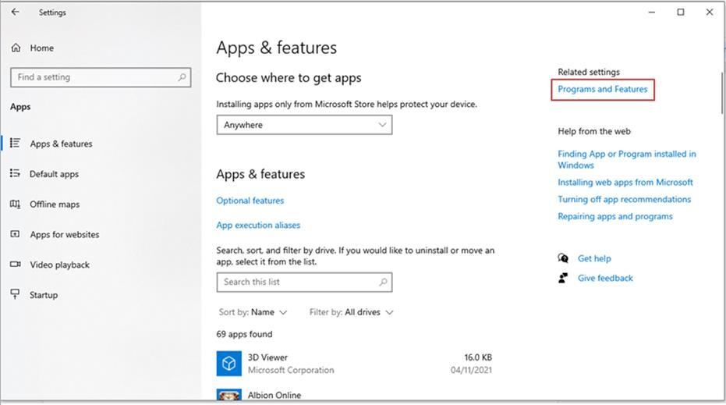

**Figure 13.** *Programs and Features*

Windows Programs and Features are comprised of the various programs and applications installed on a PC. Repairing, changing, and uninstalling programs and applications can be done within this setting.

* **Install Docker Desktop for Windows 10**

Docker Desktop is needed in containerizing and deploying Nextcloud.

* 1. Download **Docker Desktop** for Windows on their official website <https://www.docker.com/>

Figure 14 shows the official Docker website, where Docker Desktop can be installed.

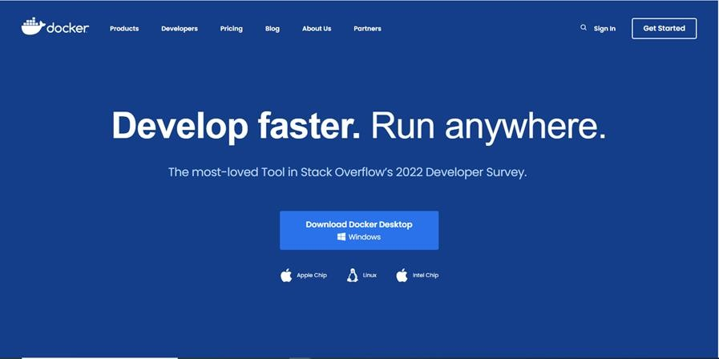

**Figure 14.** *Docker*

Docker Desktop can be installed on numerous operating systems such as Windows, Apple Chip, Linux, and Intel Chip. Docker Desktop simplifies configuration tasks and allows users to containerize and deploy applications.

* 1. After the download has finished, double-click the **Docker Desktop Install.exe**.
  2. When prompted, select **WSL 2** instead of the **Hyper-V** option on the configuration page.
  3. Follow the instructions on the **installation wizard** and proceed to install.
  4. When the installation is finished, **Close** the wizard to complete the installation process.

1. **Procedures:**
   1. Log in to <https://dash.teams.cloudflare.com/>using the **Cloudflare account**.

Figure 15 shows the login page of the Cloudflare website

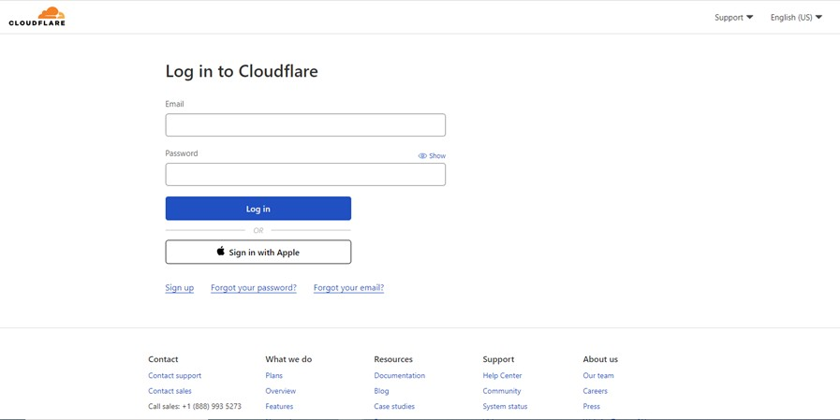

**Figure 15.** *Cloudflare login*

Login to Cloudflare to access its dashboard and navigate through its security settings for the configuration process.

* 1. Navigate to **Access > Tunnels** to configure Network Tunnels.
  2. Click the **Create a Tunnel** button to create a tunnel.

Figure 16 shows the Tunnel page of Cloudflare.

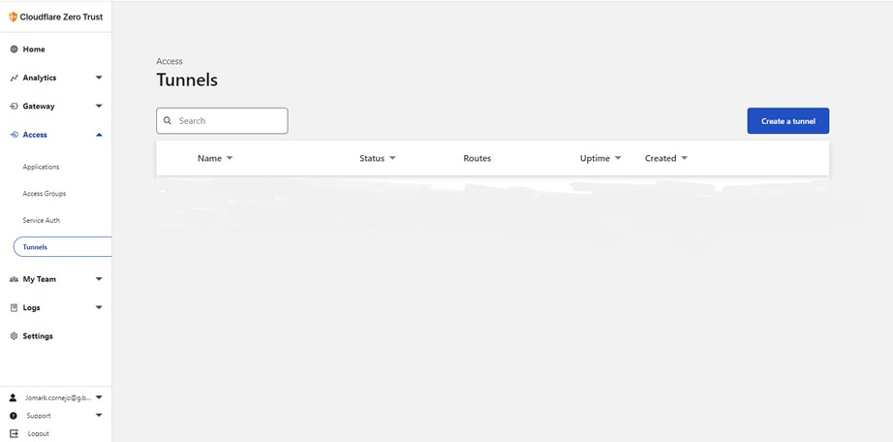

**Figure 16.** Cloudflare Tunnel

Cloudflare Tunnel secures and encrypts application traffic to block attacks and hide web server IP addresses. With Cloudflare Tunnel DDoS attacks, Data breaches or Bruteforce attacks are blocked ultimately allowing for a safe and secure application.

* 1. Name your tunnel (e.g., enterprise-VPC-01), and click the **Save tunnel** button.

Figure 17 shows the page for naming a Cloudflare Tunnel.

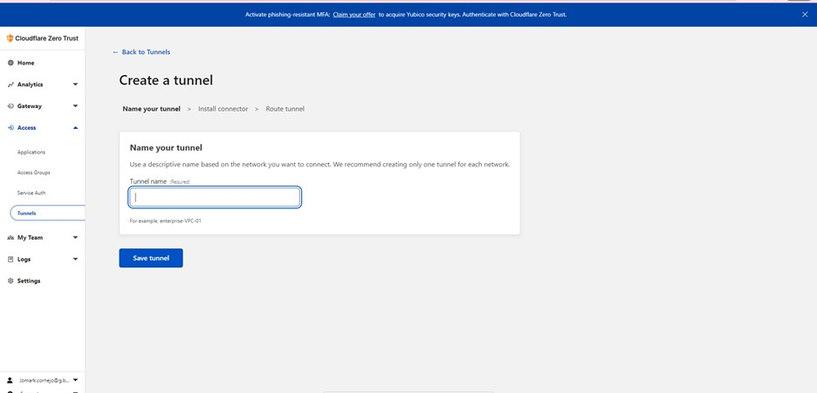

**Figure 17.** *Cloudflare Tunnel Name*

The name of the Cloudflare Tunnel usually represents a particular server, application or network, or the cloud environment it is on. It is advised to name a Cloudflare Tunnel that can be easily referenced when needed.

* 1. Click the Windows icon in **Choose your environment,** and click the **64-bit**

icon in **Choose an architecture.**

Figure 18 shows the configuration of the created Cloudflare Tunnel.

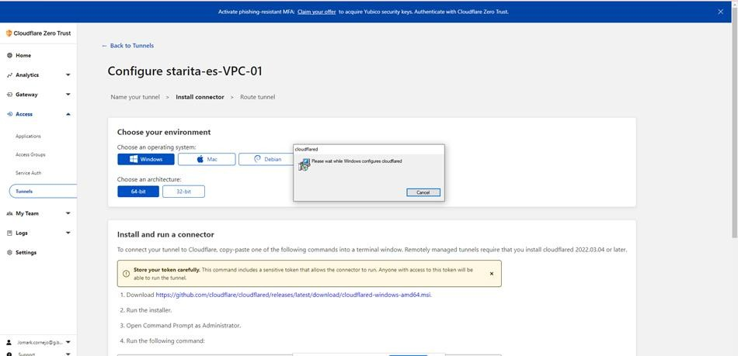

**Figure 18.** *Cloudflare Tunnel Environment*

Choosing the Cloudflare Tunnel Environment depends on the computer’s operating system.

* 1. Download the **Cloudflare installer**

[https://github.com/cloudflare/cloudflared/releases/latest/download/cloudflar](https://github.com/cloudflare/cloudflared/releases/latest/download/cloudflared-windows-amd64.msi)

[ed-windows-amd64.msi](https://github.com/cloudflare/cloudflared/releases/latest/download/cloudflared-windows-amd64.msi) and run the installer.

* 1. Open Command Prompt as **Administrator**.
  2. Copy/paste the **command**. Cloudflare will generate a unique command for you.

Figure 19 shows the unique command generated by Cloudflare.

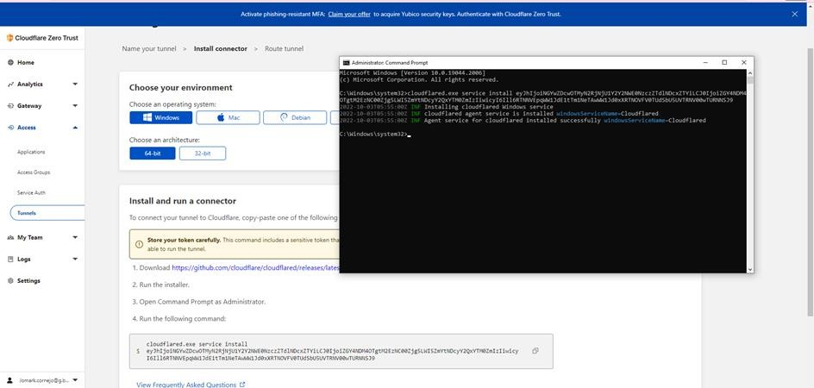

**Figure 19.** *Cloudflare Unique Command*

The generated Cloudflare command is unique for everyone as it depends on the previously configured Cloud Tunnel.

Once all the steps are finished, then the initial configuration of Cloudflare is completed successfully.

1. **Docker Desktop**
   1. Install Portainer with Docker on Windows Container Service <https://docs.portainer.io/start/install/server/docker/wcs>
2. **Portainer**

**Procedures:**

* 1. Open **Command Prompt.**
  2. Copy/paste this **command** into the **Command Prompt.**

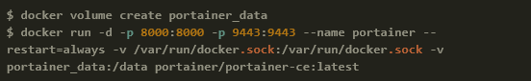Figure 20 shows the command needed to install Portainer.

**Figure 20.** *Portainer Command*

Figure 20 is the command that enables the creation of Portainer volume in Docker and allows Portainer to run on the local machine.

**1.** Visit the Portainer by clicking the link https://localhost:9443

Figure 21 shows the Portainer dashboard.

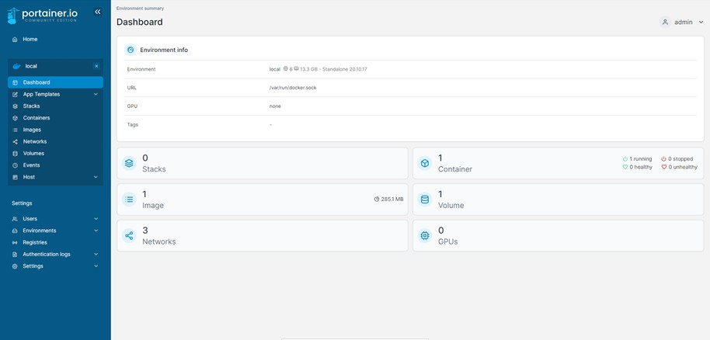

**Figure 21.** *Portainer*

Portainer provides the easy management of containerized applications and in this case, Nextcloud is the containerized application.

1. **Nextcloud Configuration**
   1. Copy and paste the **Nextcloud Docker-Compose** configuration below on the **“Stack”** tab on Portainer.

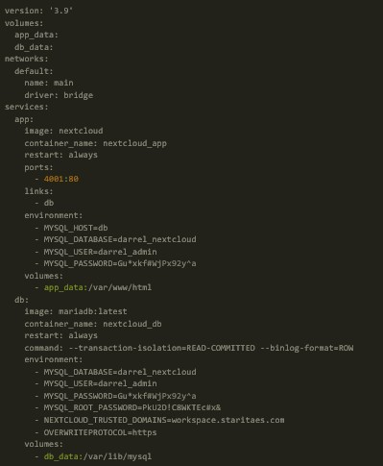Figure 22 shows the command for Nextcloud configuration.

**Figure 22.** *Nextcloud Docker Compose Configuration*

Figure 22 is the command to deploy Nextcloud and enable its installation on the computer. It includes the volumes, networks, the app itself, and its database.

Figure 23 shows the Portainer Stack tab.

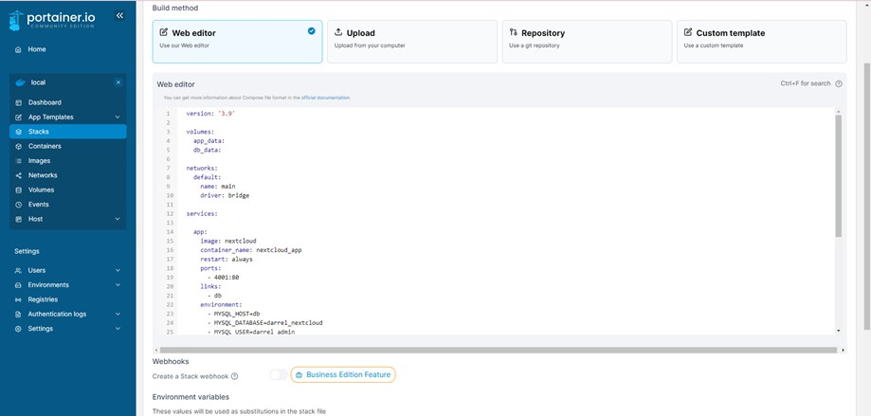

**Figure 23.** *Portainer Stack*

Figure 23 is the Portainer Stack tab where the Nextcloud Docker Compose Configuration is pasted and executed. After it is executed then Nextcloud is deployed and ready to be installed and configured.

Once all the steps have been completed, then the software configuration is finished and successful.

# Operate Phase

This phase involves maintaining the network's health by sustaining the network’s availability and reducing costs. Ensuring hardware and software operability, monitoring network performance, and analyzing the results are included in the operational phase.

As network operations absorb a significant portion of the IT budget, it is important to reduce operating costs while continuously improving performance. During the operational phase, enterprises actively monitor network health and vital

signs to improve service quality, reduce interruptions, mitigate outages, and maintain high availability, reliability, and security. It determines if current technology is still in sync with changing business needs. If there are too many network problems or failures, performance is below expectations, or the study needs new applications that support their organizational and technical needs.

# Server Maintenance

In order to maintain a computer network's seamless operation and prevent downtime or data loss, server maintenance is the process of keeping a server's software updated and functioning. Regular upkeep keeps the server operating as it should and prevent a complete or partial network failure. It entails duties including evaluating the server's performance, making sure automated system monitoring tools are installed and configured correctly, spotting potential security threats, and routinely backing up data.

Table 25

*Steps to maintaining a server*

|  |  |
| --- | --- |
| **Steps** | **Instructions** |
| Update operating system | * Use automated patch management tools. * Set up monitoring to receive alerts when a system needs an update. * Create a schedule for updating the system of a server. |
| Backup data and validate if backups are working | **-** Ensure that backups are functioning properly.   * Backup data before making any changes or updates. * Choose the appropriate backup and location. |
| Monitor Disk Usage | * Delete outdated software versions, emails, and logs. * Regularly monitor disk usage |
| Update Applications | - Regularly update applications when available. |
| Monitor Server Utilization | * Monitor and review the server’s CPU, disk, and RAM. * Consider hardware upgrade if there’s degrading performance. |
| Check for hardware issues | - Routinely check the log for any hardware issues, such as disk read errors or network failure. |
| Change passwords occasionally | - Change and update passwords monthly or annually. |
| Review and update user accounts | - Regularly update, modify, and review user accounts. |
| Test server security | - Perform security tests using security testing tools or software to discover vulnerabilities in the server. |

Maintaining the hardware, software, and network of organizations is beneficial as it can ensure the highest quality of service, performance, and reliability for the organization and its users and ensure their security and protection from threats.

# Optimize Phase

This phase involves identifying and determining the possible improvements of the network to increase its performance and enable continuous scalability and development of the network through its lifetime. This phase also includes the identification of common network risks and their mitigation or solution to be fixed.

After the implementation, network testing, and analysis of the results, the researchers determine and discuss with the client to improve the network, what future plans can be made, and what kind of network disaster recovery plan is to be developed to mitigate and prevent unexpected network interruptions and outages.

# Network Risk Management Plan

Is a documentation of potential risks to an institution’s network and defines the responses and steps the network administrator and other employees should take in order to keep the risks tolerable and to a minimum level?

**Likelihood**

Table 26 shows the rank, level, and definition of likelihood.

Table 26

*Likelihood*

|  |  |  |
| --- | --- | --- |
| **Rank** | **Level** | **Definition** |
| 3 | High | The risk is sufficiently capable of causing serious damage and has a major effect on the network. |
| 2 | Medium | The risk is capable of causing moderate damage and has a tolerable effect on the network. |
| 1 | Low | The risk is capable of causing minimal damage to the network and has little to no effect on the network. |

Table 26 categorizes the risks with rank 3 being the highest and capable enough of doing severe damage to the network, rank 2 being medium level is capable of causing moderate damage to the network, and rank 1 the lowest lacking the capability of doing any serious or relevant damage to the network.

**Risk**

There are various server risks that can potentially damage and harm an institution and its data. It is crucial to create a risk management plan as it enables organizations to identify different risks and threats, and determine their risk level and the likelihood of occurring. The description of the risk is also provided with its corresponding mitigation plan.

Table 27 shows the documentation of the risk management plan.

Table 27

*Risk Management Plan*

|  |  |  |  |  |
| --- | --- | --- | --- | --- |
| **Rank** | **Risk** | **Description** | **Mitigation** | **Likelihood of Occurrence** |
| 2 | Hardware Failure | Malfunctioning PCs, routers, defective cables, etc. | Regularly check the hardware for any faults or damages and test if it is working properly as expected. | Likely |
| 3 | Disk Failure | Stored information cannot be accessed. | Perform disk scan to find errors, reboot the PC, clean the PC for any dust or dirt build- up, and ensure good quality hard drive. | Unlikely |
| 3 | Data Loss File Corruption | Unreadable data or deletion of files. | Always keep a backup for important files and having a second storage such as cloud storage is highly recommended. | Unlikely |
| 2 | Outdated Software | Unsupported software, slow performance, and prone to bugs and security threats. | Regularly check for software updates to keep up with new features and security updates. | Likely |
| 2 | Slow Internet | Slow access to websites, buffering of videos, etc. | Conduct speed tests, upgrade the bandwidth, and ensures appropriate DNS for fast internet access. | Likely |
| 1 | Connection Errors on the Network | Can't connect or have Ho connectivity to the network. | Restart the PC or router, replace the ethernet cable with a new cable, and update the wireless network adapter. | Unlikely |

**Table 27 (cont’d)**

|  |  |  |  |  |
| --- | --- | --- | --- | --- |
| 3 | Power Outage | Loss of power to devices. | Provide an uninterruptible power supply (UPS) to critical devices that require constant power. | Very Unlikely |
| 2 | Duplicate IP Addresses | Two devices attempting to have the same IP address | Configure the router to assign DHCP addresses close to the top end of the subnet and leave the lower addresses for devices that require static IPs. | Very likely |
| 2 | IP Address Exhaustion | No IP address available from the DHCP server. | Have an extra standalone router or access point to create a pool of internal addresses and ensure that the router is the only one connected to the ISP's modem. | Likely |
| 1 | DNS Problems | Unable to connect to an IP address, loss of internet access. | Configure devices to obtain DNS server addresses automatically. | Unlikely |

The risk management plan lists the most common network problems or risks that can potentially occur. Each risk is defined and ranked based on its level of severity; a mitigation plan is provided to know what options or procedures are necessary to address the risks, and the occurrence of each risk is also indicated to determine if the risk is likely to occur or not.

# Network Disaster Recovery Plan

Table 28 summarizes the network discovery plan for the network.

Table 28

*Network Disaster Recovery Plan*

|  |  |
| --- | --- |
| **Plan** | **Description** |
| Data Backup | Backing up data regularly is important to ensure the data's consistency and integrity when a disaster occurs. It is important to identify the data to backup, implement hardware and software backup, schedule backups and validate the data's accuracy. |
| Emergency Contacts | List of emergency team members and their contact details that are responsible for network disaster recovery. A list of network emergency response actions must also be provided. |
| Emergency Network Management Procedures | Develop procedures on how to reconfigure the network, how the data will be accessed, and what kind of outside help is needed. |

**Table 28 (cont’d)**

|  |  |
| --- | --- |
| Hardware and Software Inventory | Create a comprehensive list of critical, important, and unimportant hardware and software. Critical are assets that the network wouldn't be able to operate without. Important are needed in daily operations and unimportant are applications that aren't used frequently and can be easily replaced. |
| Identify Sensitive Data | Determine how to back up sensitive data such as Personally Identifiable Information (PIT), financial data, and other valuable data and identify who should have access to the original and backup copy of the sensitive data on normal operations and when a disaster occurs. |
| Network Recovery | Develop and provide instructions on how to restore normal network operations,  network connectivity, connected devices, and other activities. |

Table 28 listed the significant plans or precautionary measures that are necessary to consider and prepare for when a network disaster occurs. Each plan is defined and has its own steps or procedures to take in case of a network disaster.

The network administrator and other IT personnel are the ones usually involved in developing a network disaster recovery plan according to their organization’s needs.

# CHAPTER IV RESULTS AND DISCUSSIONS

This chapter consisted of the findings, the discussion, and the analysis of the results of the project implementation at Sta. Rita Elementary School. The 3 network architecture designs created in terms of cost, design, performance, security, and speed were discussed here as well as the results of the implemented universal file access and sync platform and its security measures. The existing LAN at Sta. Rita elementary school was also presented in this part for comparison.

**Existing LAN**

Figure 24 shows the existing LAN in Sta. Rita elementary school.

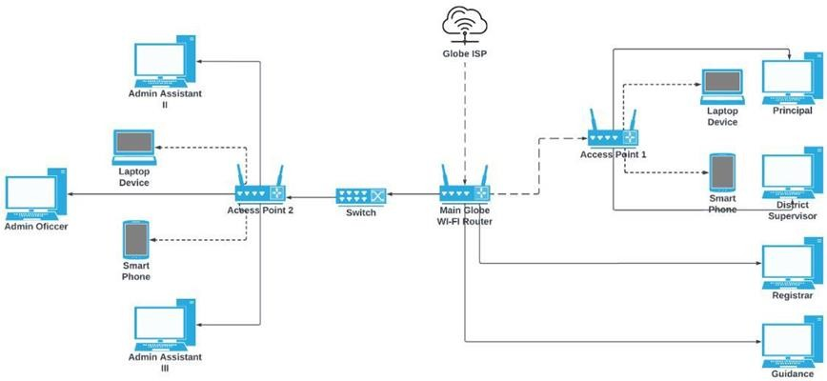

**Figure 24.** *Existing LAN*

The existing LAN of Sta. Rita elementary school currently lacked a dedicated file server that was necessary for storing and organizing huge amounts of data and files. Some devices were already outdated, and some were of great quality with a large bandwidth but they also ran short on network devices such as wireless access

points to maximize the available bandwidth which compromised the network’s reliability of keeping a stable connection for all the connected devices. On that note, implementing a dedicated file server with 1TB storage, 2 Kingston HyperX Fury DDR4 2400MHz 8GB RAM, and an Intel core i5 10th gen processor were necessary to have sufficient storage for storing files and maximize the efficiency of transferring and moving data.

# 3 Network Architecture Designs

The first objective of the project was to create 3 network architecture designs by adding and upgrading network hardware devices and comparing them with the existing LAN in terms of: cost, design performance, security, and speed.

Figure 25 shows the network architecture design 1, was created for the future upgrade of the existing network in Sta. Rita elementary school.

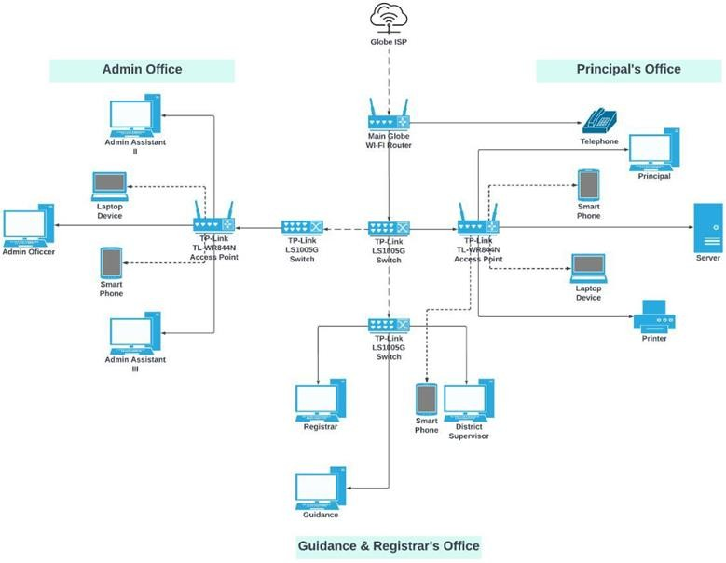

**Figure 25.** *Network Architecture Design 1*

Network Architecture Design 1 was developed to resolve the network problems present in Sta. Rita elementary school, and was considered to be the best out of the 3 network designs due to it being the most suitable and economical in upgrading the current LAN of the client, hence, it was the recommended network design for the future upgrade of the current LAN in Sta. Rita Elementary School. Network Design 1 added 2 new switches and upgraded an old switch with the TP- Link LS1005G that provided reliable data transfer and supports Auto-MDI/MDIX.

The 2 outdated access points were also upgraded with the TP-Link TL- WR844N which was capable of providing 300 Mbps wireless speeds and supports multiple modes such as access point mode, range extender mode, and more.

Upgrading outdated network devices fixed a lot of network issues, specifically the slow and unreliable internet connection and the frequent disconnection of devices. A server that hosted the universal file access and sync platform was also implemented in the administrator’s office and provided them with a bigger storage capacity and a centralized database for data storage, management, and easy sharing of files.

Figure 26 shows the network architecture design 2 created for the future upgrade of the existing network in Sta. Rita elementary school.



**Figure 26.** *Network Architecture Design 2*

Network Architecture Design 2 was developed and recommended to be the future upgrade of the existing LAN in Sta. Rita elementary school as it was more of a neat and simple design but it consisted of a much greater quality of network devices, thus, it was also more expensive but beneficial. In this design, the 2 access points were replaced with only one access point which was the TP-Link Archer AX1500, it featured numerous capabilities such as Wi-Fi 6 technology, connects more devices, and provided better performance.

The 3 switches were also replaced with only 1 switch, which was the TL- SG1210P with of much greater quality and can accommodate 9 devices as it had

10 ports, 9 of which were RJ45 ports and 1 Gigabit SFP port. It also had 8 ports that were capable of PoE+ that provided up to 30W-63W. The RAM of the file server also be upgraded to 16GB of ram to handle the newer version of Windows Server and the host-based intrusion detection system that was the software integrated with this design to serve as the security measures of the server and the network.

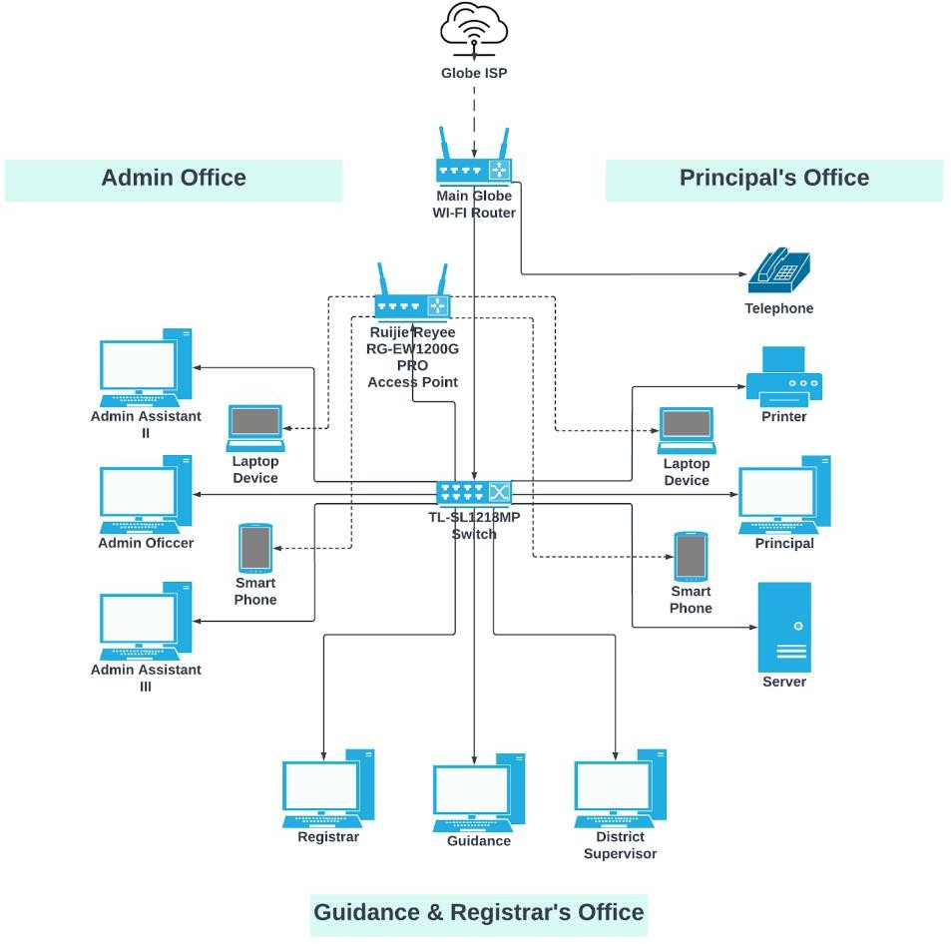Figure 27 shows the network architecture design 3 created for the future upgrade of the existing network in Sta. Rita elementary school.

**Figure 27.** *Network Architecture Design 3*

Network Architecture Design 3 was the recommended future upgrade of the existing LAN in Sta. Rita elementary school. Its design was very similar to network design 2, the only difference was that the new access point is connected to the main switch instead of being directly connected to the main globe Wi-Fi router. This design consisted of network devices and components of very high quality, thus, it was the most expensive of the 3 designs but provided new advanced technology, numerous features, and benefits. This design keeps the LAN in Sta. Rita elementary school, up-to-date with the new trends in technology for several years and preparesd the school for cloud adaptability and services.

This design upgraded the TP-Link Archer AX1500 access point from network design 2 to Ruijie Reyee RG-EW1200G PRO had more features including dual-band integration that offered low interference and provided faster internet speeds, had external 6dBi high-gain omnidirectional antennas that boosted Wi-Fi range and network performance, supported beam forming for a stronger and more reliable signal. The switch from network design 2 was also upgraded to TL- SL1218MP which was capable of accommodating more devices as it had 18 ports, 16 of which were fast ethernet PoE ports and 2 Uplink Gigabit ports.

It had a priority mode to ensure the high quality of video applications and an extended mode for surveillance systems. The RAM of the file server was still 16GB but of a much better brand and quality and the storage was upgraded to 2TB to provide more space for newer advanced software. The file server handled a newer version of Windows Server and a Security Information and Event Management (SIEM) for the security measure of the file server and the network.

# Cost

The 3 network architecture designs as well as the existing LAN were compared with each other in terms of cost to know which design was the most suitable and economical for the upgrade of the existing network in Sta. Rita elementary school.

Figure 28 shows a graph comparing the cost of the 3 network architecture designs.

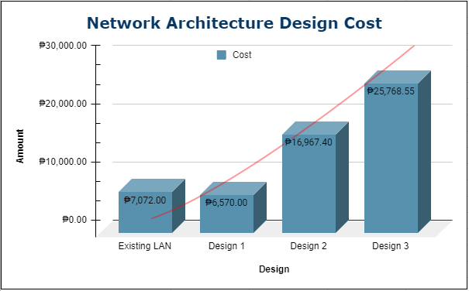

**Figure 28.** *Network Architecture Design Cost*

The network architecture design cost also included the cost of software besides the hardware that was a part of each network design. In terms of cost, the least expensive was the network design 1 and it was also the most appropriate and economical to implement in upgrading the existing LAN in Sta. Rita elementary school. The existing LAN came in second, and had fewer network devices than Network Design 1 but costs a little bit more. Network Design 2 comes in third in cost and was also a good option as it was still within the affordable range but with more high-quality network devices. Network Design 3 was the most expensive but provided new and advanced technology that kept the LAN up-to-date with the trend. It also provided numerous features and capabilities that yielded great benefits for the school going forward.

# Design

The 3 network architecture designs as well as the existing LAN were compared with each other in terms of design to see which of them provided a neater one that allowed for easy management of the network and its network devices.

Referring to the network architecture designs presented, in terms of design the existing LAN had the simplest design and layout out of all the four. Still, the outdated network devices present in the existing LAN proved to be detrimental as they were slowing down the network speed and performance especially when there were too many users connecting to the network.

In contrast, both network designs 2 and 3 had a clear advantage as they provide a much neater and simpler design that improved the existing LAN and made it easier to manage because of the fewer network devices implemented. Making the design simpler was possible because of the much greater quality of network devices that was implemented. Although Network Design 1 was the most suitable, in terms of design it was more crowded and needed a lot of work in managing the network devices and making sure that they were all working properly.

# Speed and Performance

The speed and performance of each network architecture design as well as the existing were measured based on the capabilities and specifications of the network devices, included in them and were also measured by network simulation using Packet Tracer.

Based on each network design's access point specifications, designs 2 and 3 were not far off each other in terms of speed and performance as provided more improved speed and performance than the access point in design 1 and the existing LAN. The access point specification of the existing LAN was the least capable of providing quality speed and performance and was subject to degradation over time due to it being outdated. Although the access point in network design 1 was not on par with the access points in designs 2 and 3, in contrast, it was much more suitable and cheap in replacing the outdated access points present in Sta. Rita elementary school and capable of significantly improving the network.

On the other hand, the switch of all three network designs had similar specifications which are capable of providing sufficient speed and performance for the network, the only difference is that the switches in designs 2 and 3 provide more ports thus accommodating more devices and reducing the need for multiple switches consequently improving the network’s speed and performance.

Figure 29 shows the speed and performance of the existing LAN using ping and simulation of sending packets from one device to another device in the network.

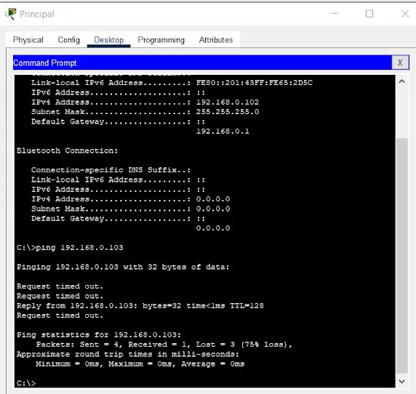

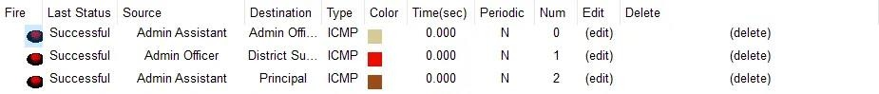

**Figure 29.** *Speed and Performance of the Existing LAN*

As can be seen from the ping simulation on the Principal’s side, there were 4 packets sent, only 1 packet was received and the 3 packets were lost equating to a 75% loss. This may be due to how the network devices were placed and that some network devices were accommodating a lot of users that the devices weren’t capable enough of providing service and weren’t able to keep up with the demand and the network traffic.

Figure 30 shows the speed and performance of the 3 network architecture designs using ping and simulation of sending packets from one device to another device in the network.

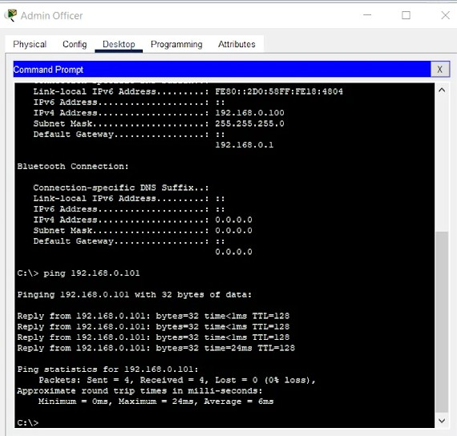

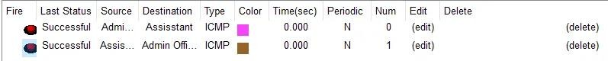

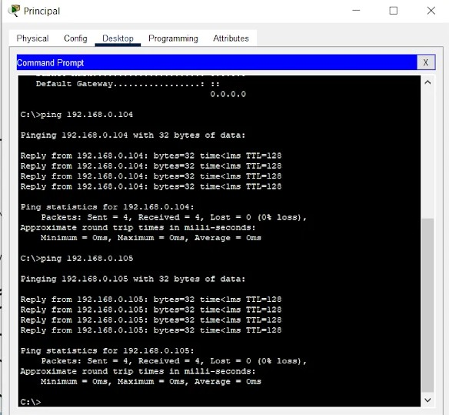

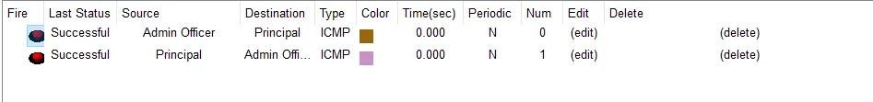

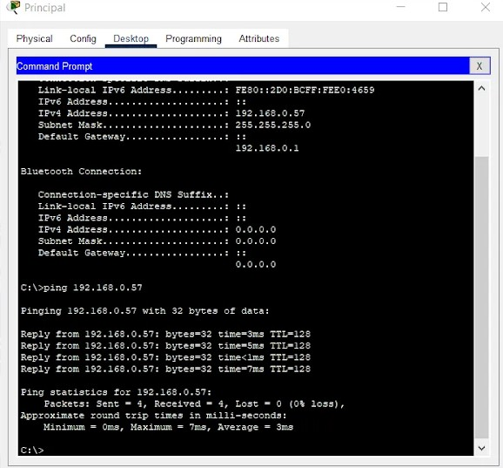

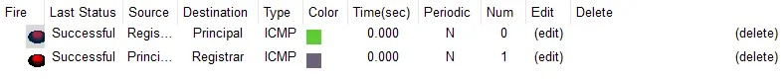

**Figure 30.** *Speed and Performance of Designs 1, 2, and 3*

In terms of speed, the three designs were not far from each other and may just come down to which network devices provided more features and capabilities, and which devices had better or more advanced technology that can help maintain the speed and performance in the long run. In terms of performance, design 1 definitely improves the existing LAN in Sta. Rita elementary school but designs 2 and 3 provided much better network performance and better security for the server and the network due to higher-quality network devices with numerous features. In contrast to the existing LAN, all three network architecture designs were capable of providing sufficient speed and performance to improve the existing LAN in Sta. Rita elementary school.

# Security

The security of each network architecture design was compared based on the security features of the access points included in each of them.

Table 29

*Access Point Security*

|  |  |  |
| --- | --- | --- |
| **Network Design** | **Access Point** | **Security** |
| Existing LAN | TP-Link Archer A6 AC1200 | Wi-Fi encryption includes WEP, WPA, WPA2, WPA3, WPA/WPA2-Enterprise (802.1x) Provides SPI firewall, access control, IP&MAC binding for the network security. It also provides an application layer gateway and a 1 x 2.4 GHz and a 1 x 5 GHz guest network. It also includes a VPN server - OpenVPN, PPTP |
| Design 1 | TP-Link TL WR844N AP | Wi-Fi encryption includes WEP, WPA, WPA2, WPA/WPA2-Enterprise (802.1x) Provides SPI firewall, access control, and IP&MAC binding for the network security. It also provides application layer gateway and a 1 x 2.4 GHz guest network. |
| Design 2 | Ruijie Reyee RGEW1200G PRO | Provides WPA-PSK/WPA2-PSK encryption for network security, It features IP-MAC binding and SSID hiding for ARP protection. It provides internet access control and prevents rogue devices (Blacklist/whitelist). |
| Design 3 | TP-Link Archer AX1500 | Wi-Fi encryption includes WEP, WPA, WPA2, WPA3, WPA/WPA2-Enterprise (802.1x) Provides SPI firewall, access control, IP&MAC binding for network security. It also provides an application layer gateway and a 1 x 2.4 GHz guest network. |

In terms of the security features and capabilities of network devices, Ruijie Reyee RG-EW1200G PRO had the least capability when it came to security and was more expensive than TP-Link TL-WR844N AP which was the recommended access point. The three access points which were the TP-Link Archer A6 AC1200, TP-Link TL-WR844N AP, and TP-Link Archer AX1500 had similar security features but the latter had added more security features for newer technology, but was unnecessary for the project and was the most expensive among the four. So, in conclusion, the TP- Link TL-WR844N AP was the best option, it was economical, and saved costs as it was the least expensive but had almost the same security features as TP-Link Archer AX1500 which was the most expensive one.

# Universal File Access and Sync Platform

The second objective was to implement on-premise universal file access and sync platform for data storage management and organization at Sta. Rita elementary school.

Figure 31 shows the teachers as well as the administrator who can access the universal file and sync platform by inputting workspace.staritaes.com through the web browsers on the desktops/laptops and phones or through the Nextcloud mobile apps which were the Nextcloud File app and Nextcloud Talk app.

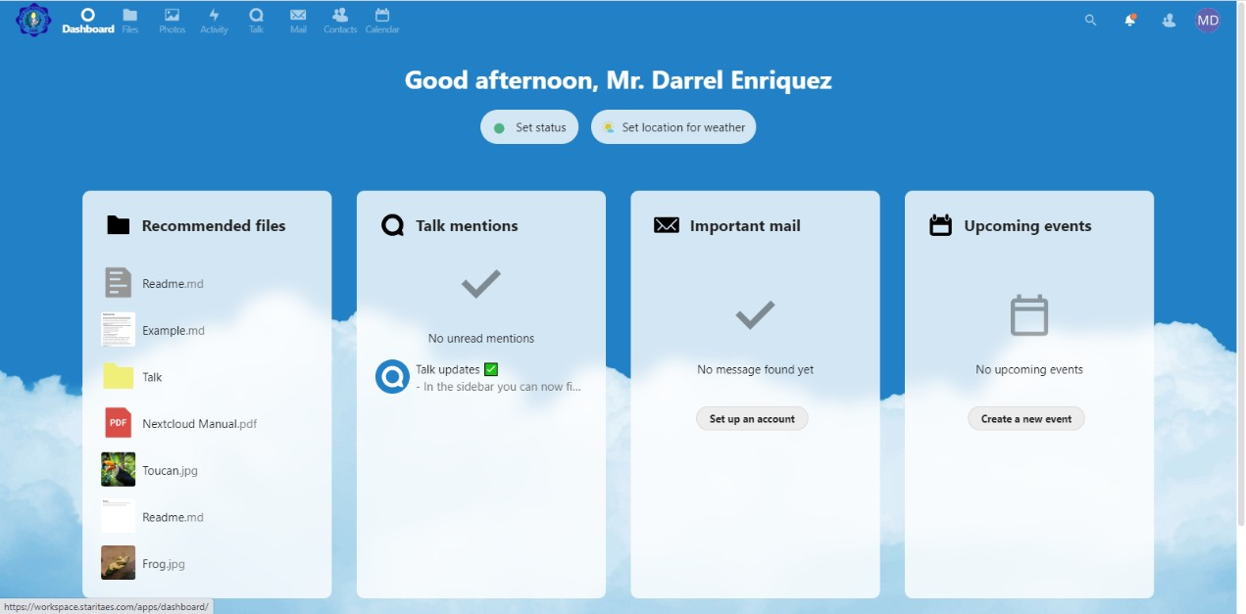

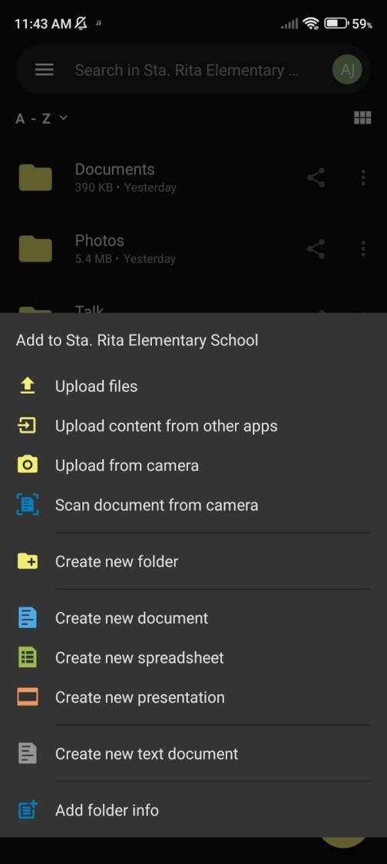 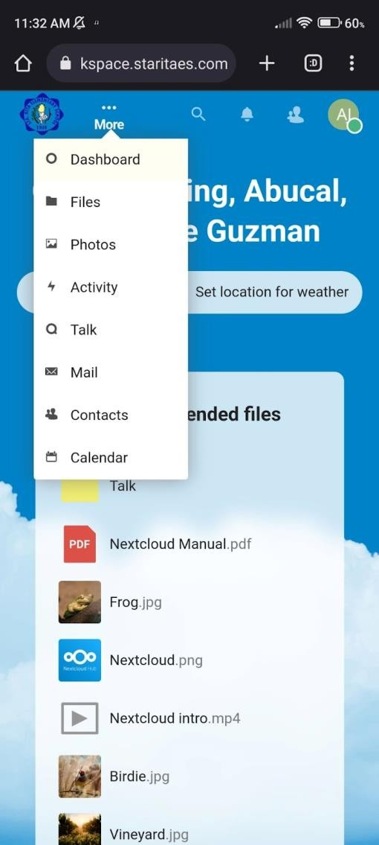

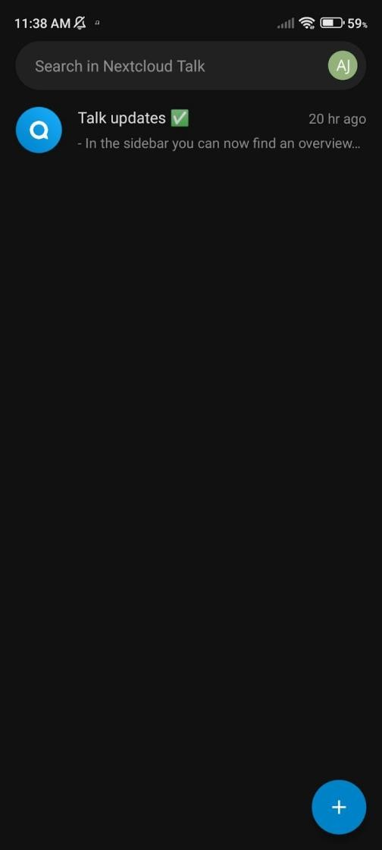

**Figure 31.** *Accessing the workspace.staritaes.com*

The workspace.staritaes.com served as the universal file access and sync platform for the teachers and faculty staff of Sta. Rita elementary school. It was also a collaborative platform that had numerous features such as files, photos, activity, talk, mail, contacts, and calendar tabs. The files and talk feature had its own dedicated mobile app which was the Nextcloud File app and the Nextcloud talk app. With this, the teachers and faculty staff of Sta. Rita elementary school had an exclusive, secure, and easier way of accessing and sharing files, photos, documents, and calendar schedules for meetings and appointments, and a more convenient way of communicating with each other.

Figure 32 shows the files and talk feature being used by the administrator of Sta. Rita elementary school.

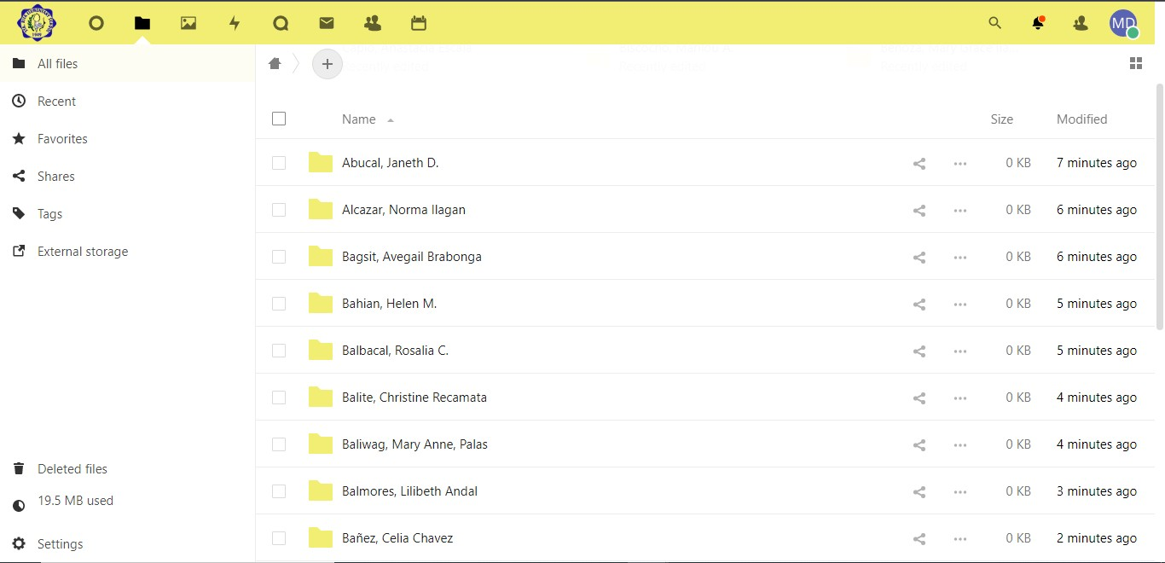

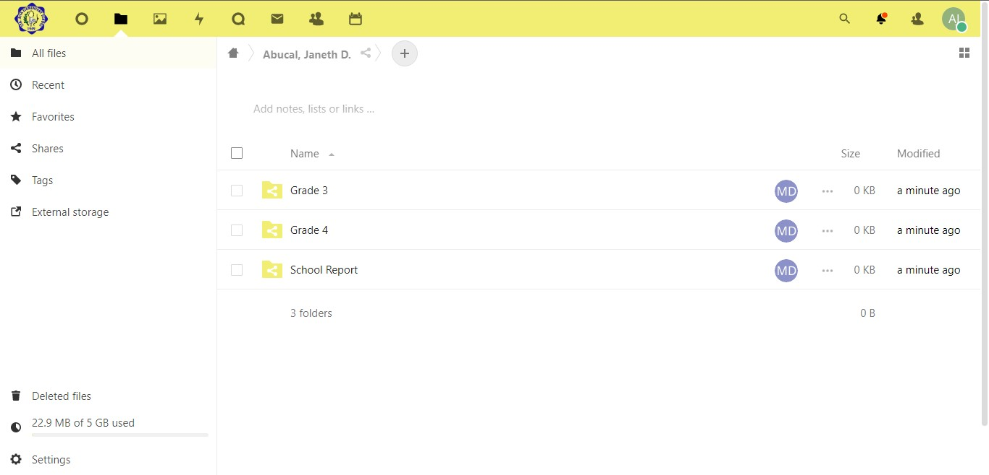

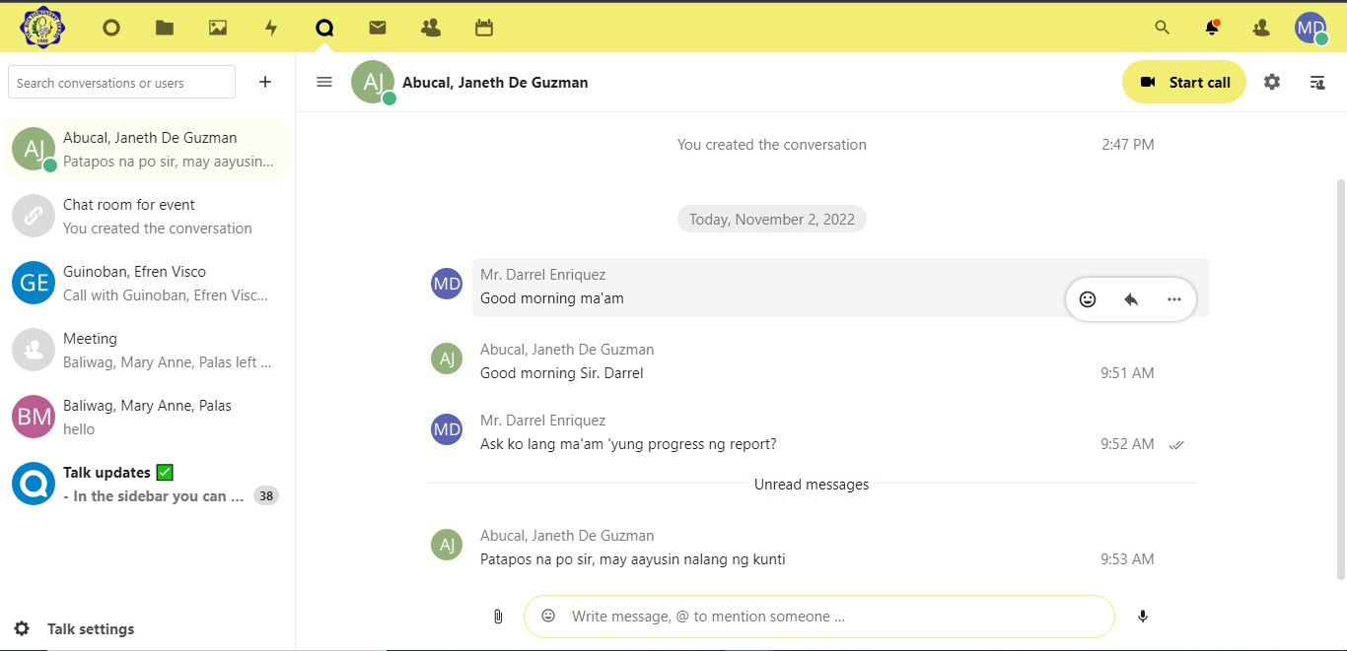

**Figure 32.** *Files and Talk Feature*

Figure 32 shows the administrator having access to the individual folders of the teachers that was capable of modifying the access permission of files to only share them with the necessary users. The administrator also had overseen any changes or modifications to any of the files and had shared with the teachers. On the other hand, the talk features of many capabilities of the teachers and faculty staff of Sta. Rita elementary school produced communication with each other, and shared files such as documents, photos, videos, and audio files, and they can also start a call or host a video meeting just like Zoom or Google Meet.

Figure 33 shows the sync capabilities of workspace.staritaes.com to various platforms and devices.

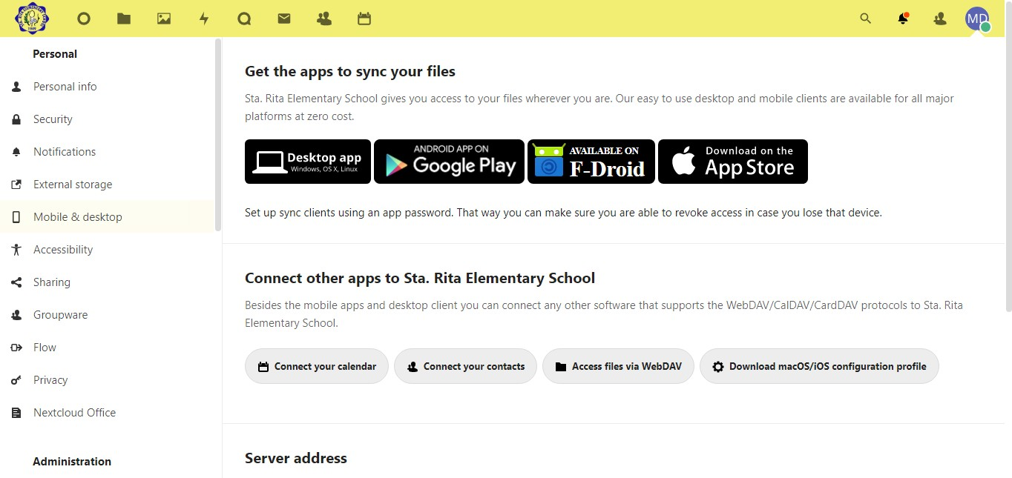

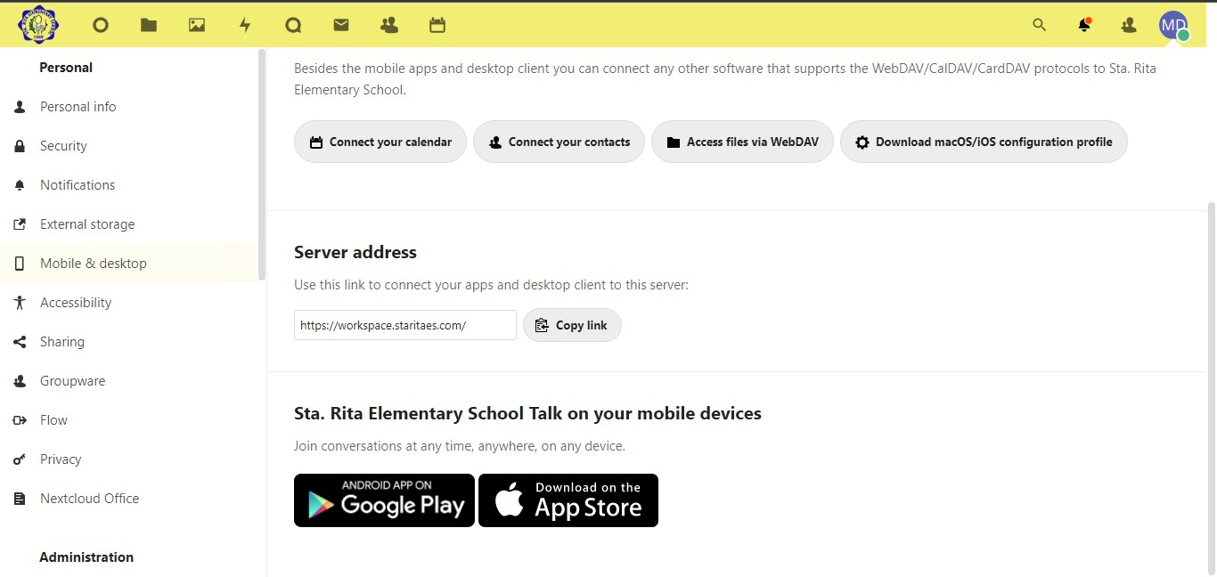

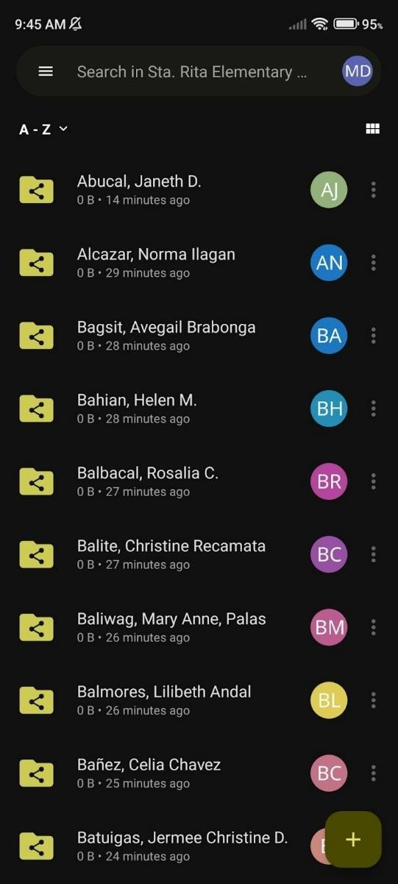 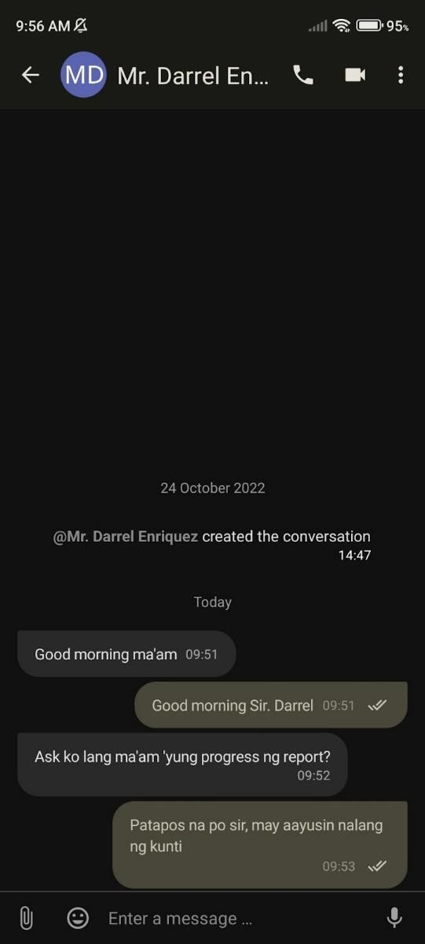

**Figure 33.** *Access and Sync*

The workspace.staritaes.com provided flexibility and availability of data as files and other collaborative features can be accessed and synced through various platforms and devices. The workspace.staritaes.com can be accessed through web browsers of desktops/laptops and phones and the files and talk feature had its own dedicated mobile app which was the Nextcloud File and Nextcloud Talk app. Any progress made on the features of workspace.staritaes.com syncs in real-time through all the platforms and devices was installed or accessed from. This provided

convenience and reliability to the teachers of Sta. Rita elementary school as they were able to access files and do important tasks anywhere, they are.

# Security Measures

The third objective was to implement security measures in the LAN for the on-premise universal file access and sync platform using ACL, encryption, and firewalls.

**Access Control (ACL)**

The implementation of access control guarantees that only the right users had access to the appropriate resources based on their role and level. It was a data security procedure that was crucial in preventing data breaches, phishing attacks, and other threats.

Figure 34 shows that teachers don’t have administrative privileges and that only the administrators were given administrative access. Two-factor authentication was also enabled as another layer of security.

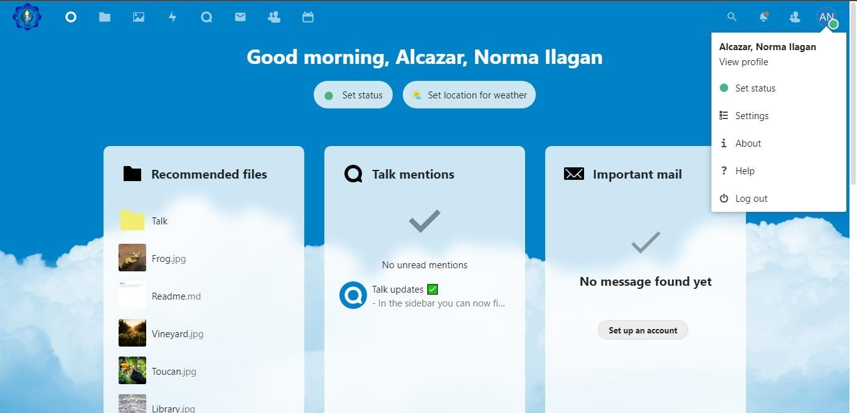

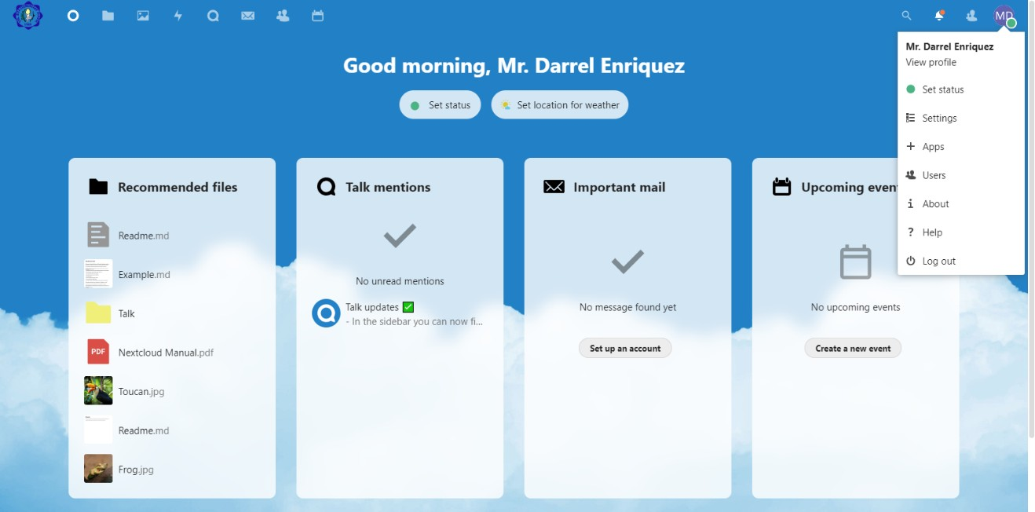

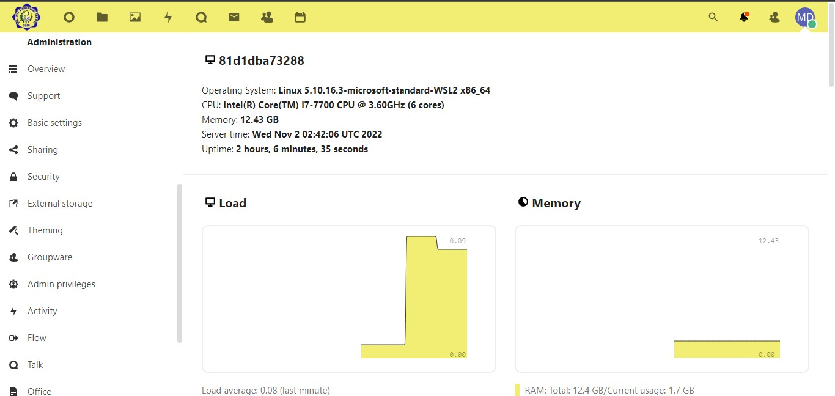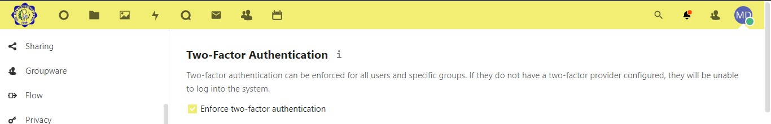

**Figure 34.** *Access Control of Users*

Figure 34 indicates that teachers didn’t have the ability to configure workspace.staritaes.com such as adding or removing some of its features or apps. Moreover, teachers and faculty staff who weren’t administrators didn’t have the ability

to add, modify, and delete user accounts. By contrast, the administrator was given administrative privileges and was able to manage, control, and configure anything that was within the workspace.staritaes.com. The administrator was also capable of installing and removing applications or features that the platform provided and had privileges in managing user accounts such as adding a new user, modifying the user’s information, and removing a user account from the website. Two-factor authentication was also enabled to add another layer of security to ensure that the correct user was given the right access and privileges to resources. It was also important to note that the password convention of every user account was comprised of 12 minimum characters combination of upper- and lower-case letters, numbers, and special characters.

**Encryption**

Encryption provided the privacy, security, and integrity of data. It ensured that no one can access the data except for the rightful owner and ensures that data weren’t modified or tampered with by unauthorized users. Moreover, enabling the encryption of data helped prevent data breaches, unauthorized access, and other malicious attacks.

Figure 35 shows that server-side encryption was enabled within workspace.staritaes.com.

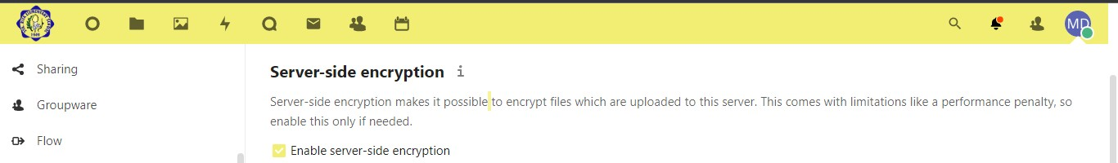

**Figure 35.** *Server-side Encryption*

Enabling server-side encryption allowed all data uploaded on the server had be en crypted at rest on the server and ensured the privacy, security, and integrity of data against unauthorized users and malicious hackers. Backing-up data was an important step in conjunction with encrypting data to ensure its availability in case of unexpected events that damage or harm data.

**Firewall**

A firewall was a type of security system that kept track of and managed network traffic in accordance with a set of security guidelines. It managed the incoming and outgoing traffic and decided whether they were allowed to pass through. Incoming malicious traffic can be stopped by firewalls before it entered the network and served in Sta. Rita elementary school; it also stopped sensitive data from exiting the network.

Figure 36 shows that Cloudflare and its security and website services were implemented on workspace.staritaes.com.

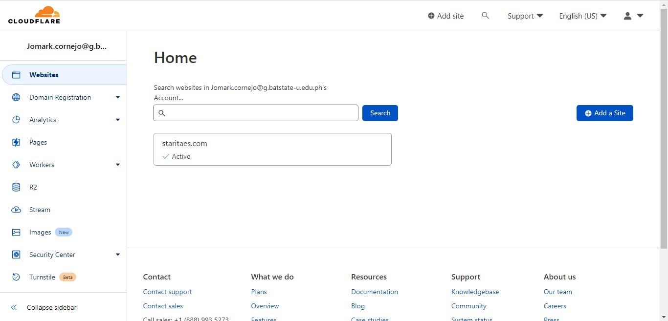

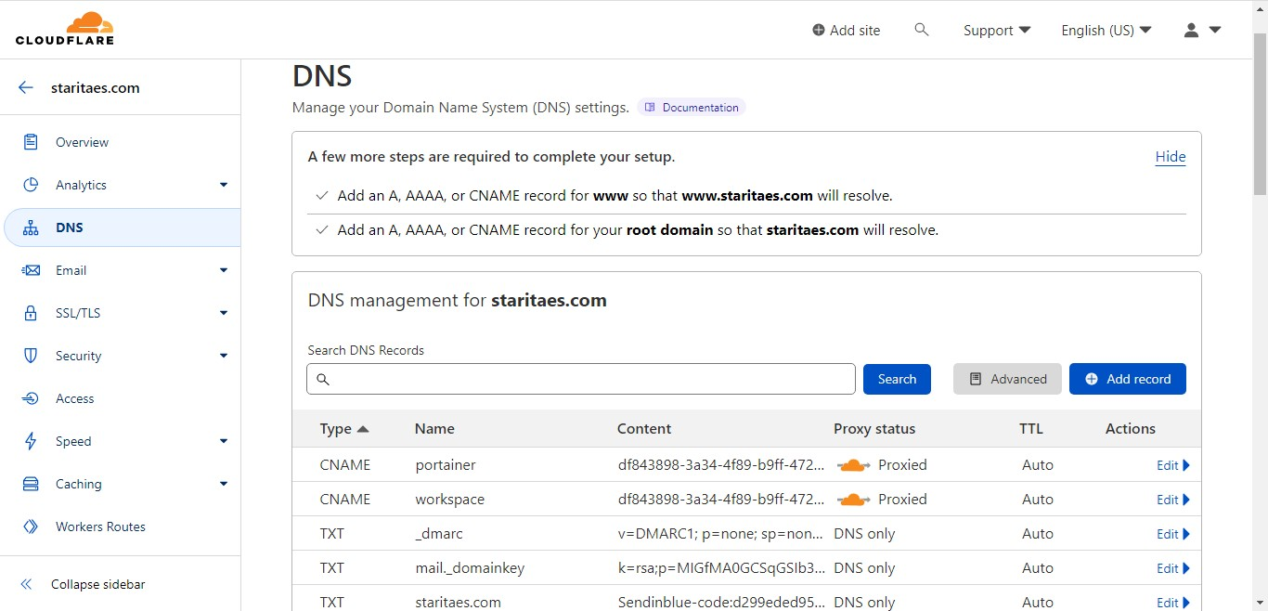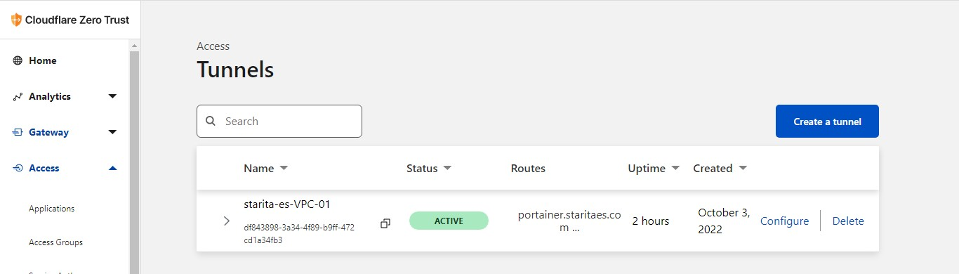

**Figure 36.** *Cloudflare Security*

Enabling Cloudflare on workspace.staritaes.com ensured its security and protection against DDoS attacks, malicious bots, data breaches, brute-force attacks, and other threats. It also optimize and improved the speed and performance of workspace.staritaes.com to provide users with a fast and reliable response and load times. With Cloudflare Zero Trust, every event or request on wroskpace.staritaes.com was logged, offers fast and secured web browsing, phishing and malware were blocked, that helped prevent data loss.

# Security Test

Performing security tests were crucial in discovering vulnerabilities in a website and in other aspects. It gave the administrator insights and valuable information into how the current security was performing and protecting against threats. Furthermore, it allowed the administrator to address what was lacking in terms of security, improve security measures and added new layers of security to reduce vulnerabilities and better secured and protected a website from threats.

**Vulnerability Scanning**

Vulnerability scanning was an automated technique of proactively discovering network, software, and security flaws. In this case, workspace.staritaes.com was subject to the scanning process which included identifying and categorizing system vulnerabilities. The vulnerability scanned not only pinpoint security flaws but also calculated how successful to defend the event of a threat or attack.

Figure 37 shows the vulnerability scanning process of the universal file access and sync platform.

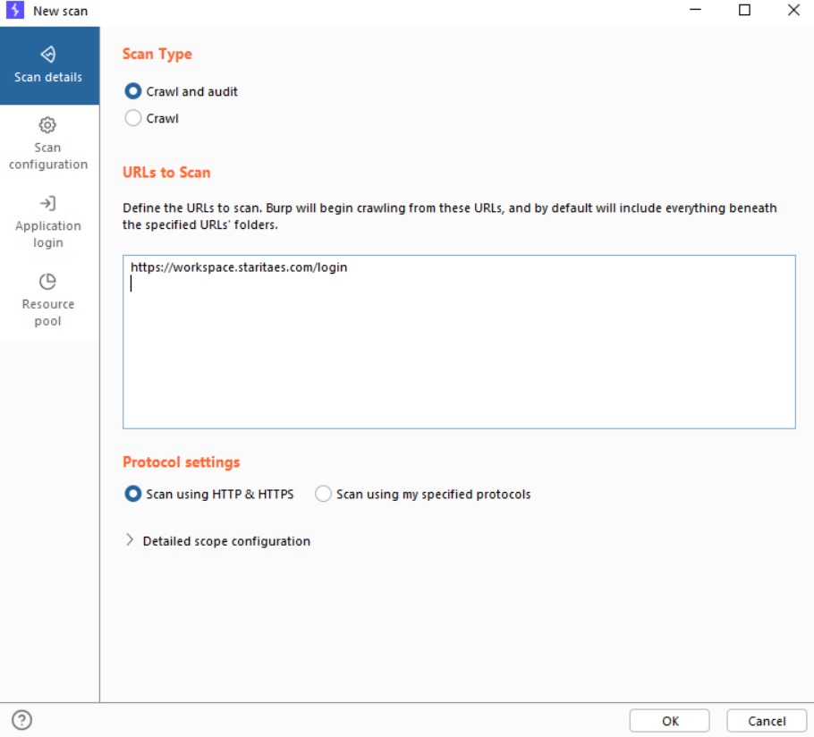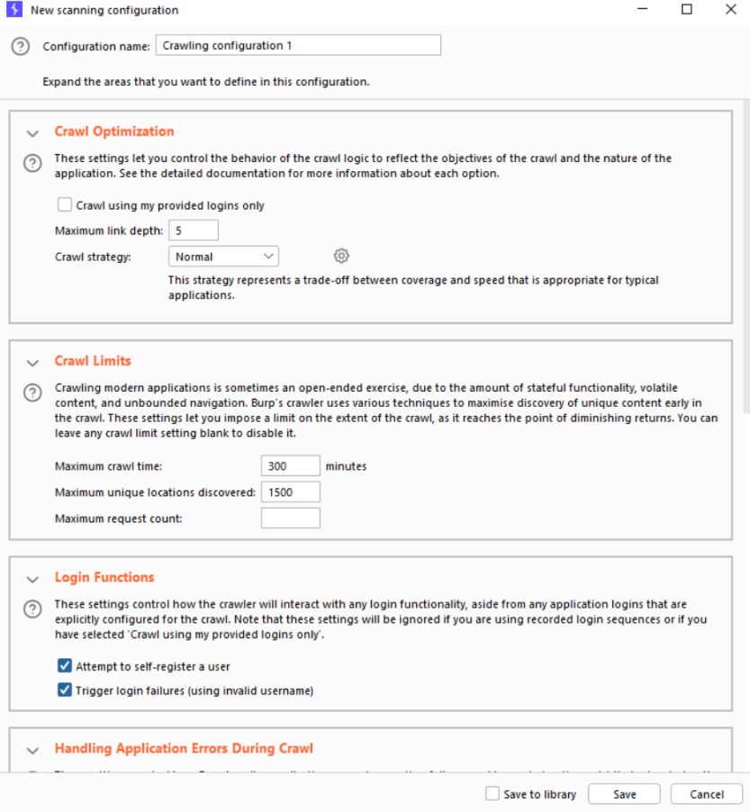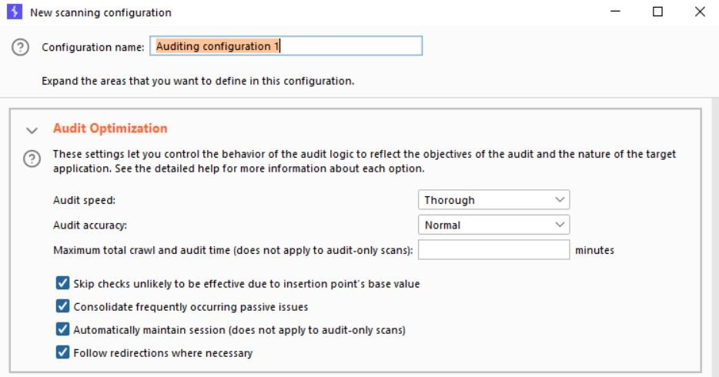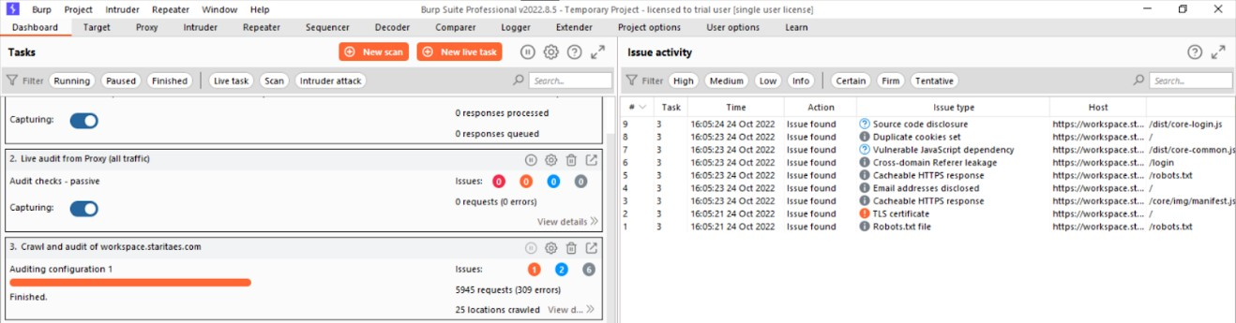

**Figure 37.** *Vulnerability Scan*

After the vulnerability scanning process had finished, it identified 9 potential security vulnerabilities including source code disclosure, duplicate cookies set, cacheable HTTPS response, email addresses disclosed, and more which was proned to security risks and exploits. With this, a corrective response was taken into place to patch vulnerabilities, eliminate security gaps, and maintain strong and resilient security.

**Denial-of-Service Attack (DoS)**

A Denial-of-Service (DoS) attack aimed to bring down a computer system or network that intended users were unable to access its services or resources.

DoS attacks achieved this by flooding the victim with an excessive amount of traffic or information that caused a crash.

Figure 38 shows the 1st trial DoS attack was performed targeting workspace.staritaes.com using Raven Storm DoS/DDoS toolkit.

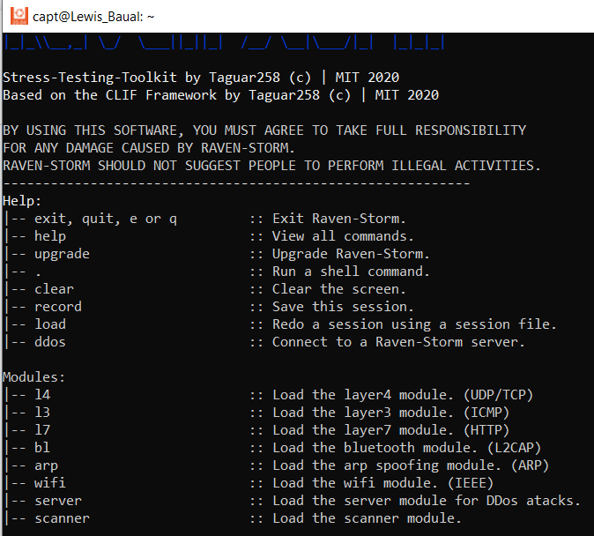

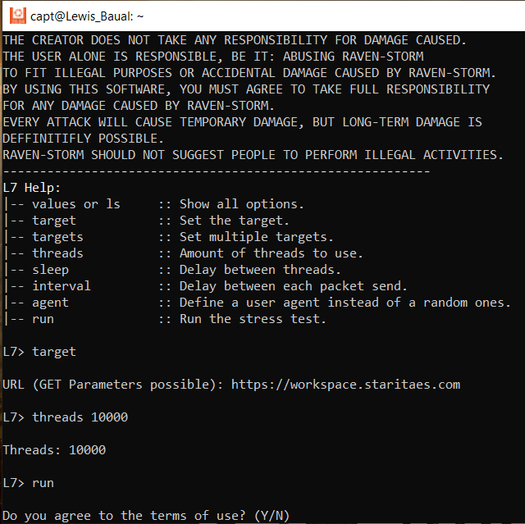

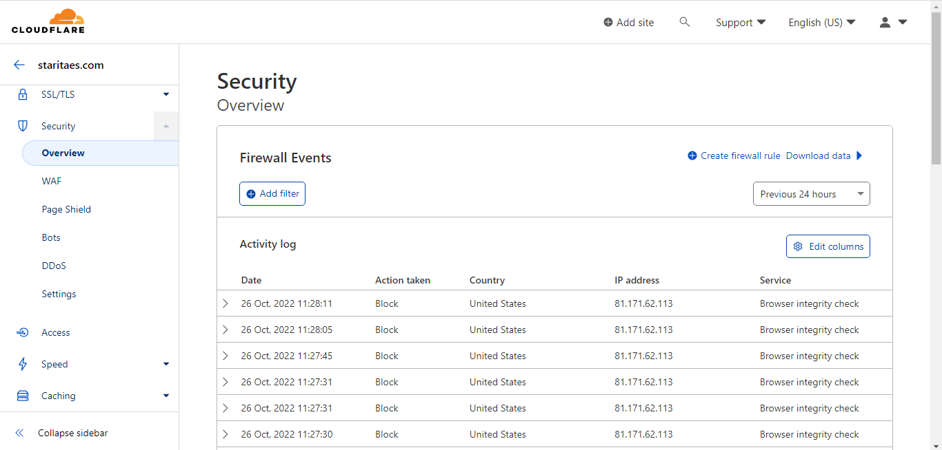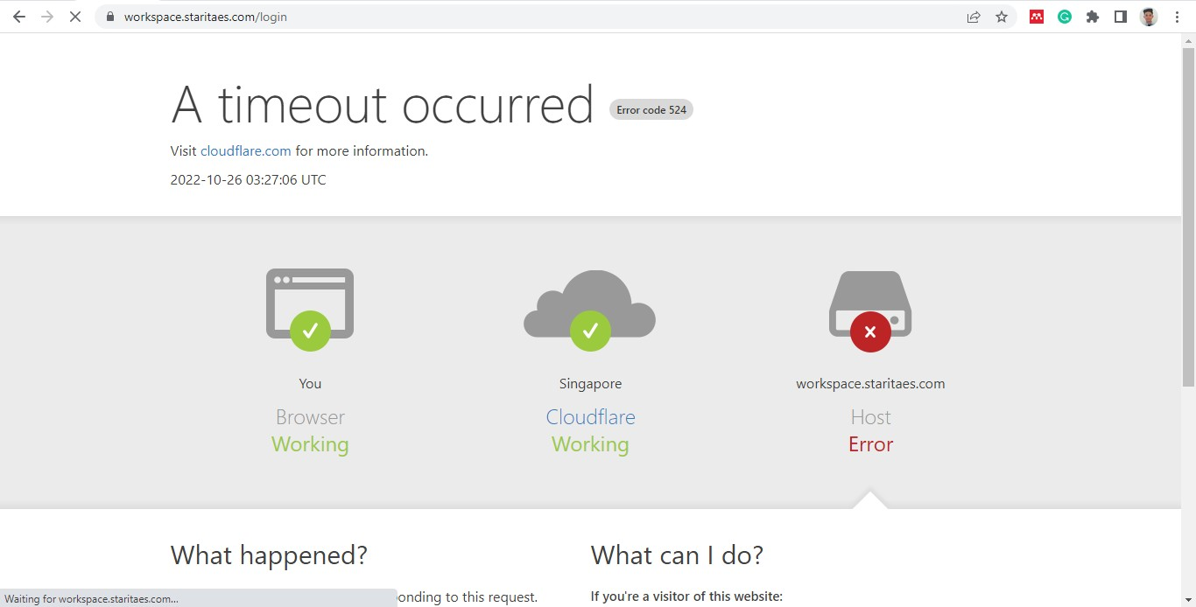

**Figure 38.** *1st Trial DoS Attack*

The first DoS attack was performed with 10,000 threads in under 5 minutes and with the Cloudflare security settings set to default which was low-medium security with Bot-fight mode turned off. As can be seen from the figure, even though the requests were being blocked, workspace.staritaes.com eventually did not handle the attack with the Cloudflare settings set to low-medium security and the result is an error from the host which crashed, rendered inaccessible, and unable to provide service to its users. The recovery time of the file and sync platform was measured and it took between 1 hour and 30 minutes to 2 hours to recover and become accessible again and provide service.

Figure 39 shows the 2nd trial DoS attack performed targeting workspace.staritaes.com using Raven Storm DoS/DDoS toolkit.

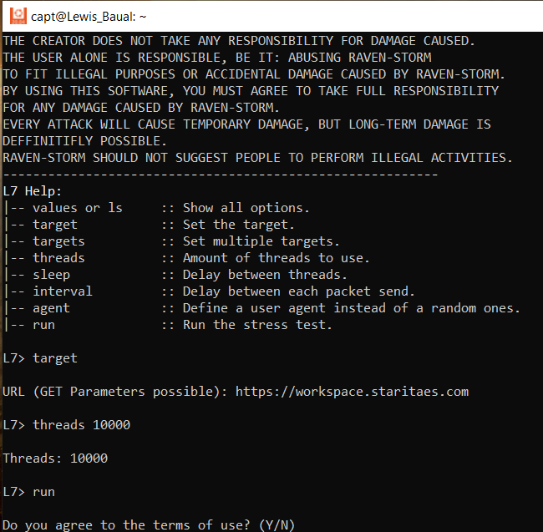

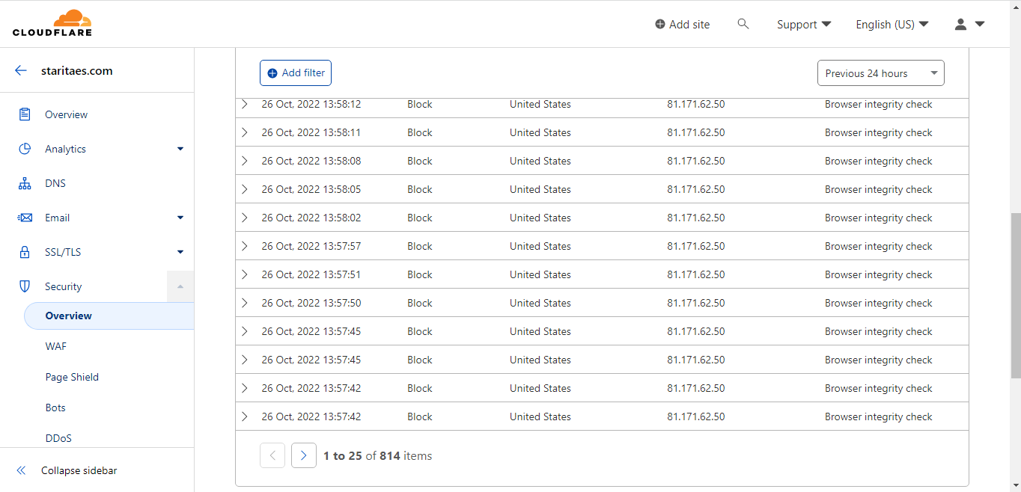

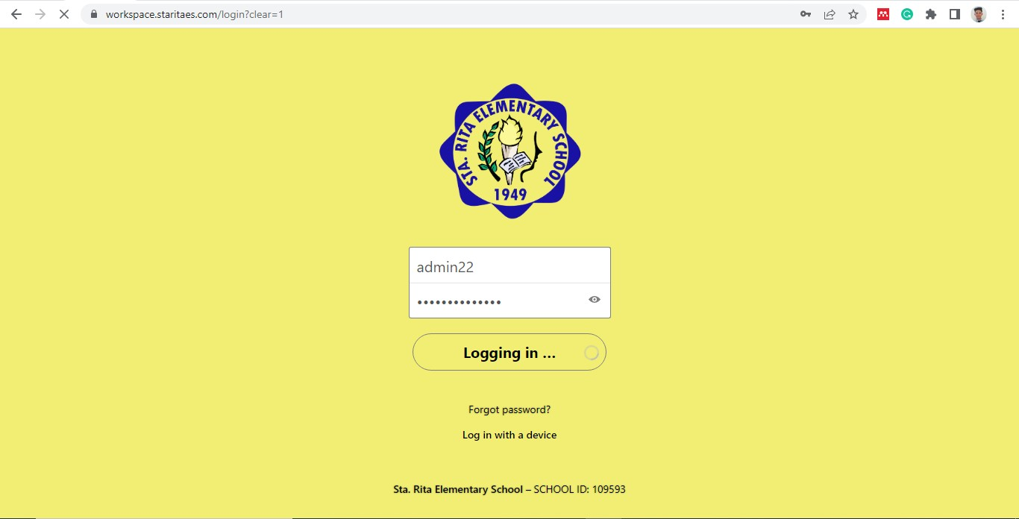

**Figure 39.** *2nd Trial DoS Attack*

The second DoS attack was also performed with 10,000 threads in under 5 minutes but with the Cloudflare security settings set to high and the Bot-fight mode also enabled. This time the file and sync platform were still blocking multiple requests and were successful in mitigating the DoS attack. There was no host error or server downtime after the attack and the file and sync platform was accessible and ready to provide service to its users.

Table 30

*DoS Attack Details*

|  |  |  |
| --- | --- | --- |
| **DoS Attack Type** | **Server Response** | **DoS Attack Request** |
| Layer 7 (L7) | Bad Gateway (Error code 502) | GET request |

The executed DoS attack was an application layer or layer 7 attack towards the server. It forwarded malicious HTTP/S traffic or HTTP GET requests to consume resources and overwhelm the server rendering it inaccessible to users. In this case, the implemented server has reverse proxy enabled by using Cloudflare, meaning it has the capability to accept a request from a client, sends the request to one of many more servers, and then delivers to the client the results from the actual server that handled the request as if the proxy server had processed the request itself. The client does not realize that another server really processed its request because it only talks directly with the reverse proxy server. This improved the server’s performance, security, and reliability.

# CHAPTER V

**SUMMARY, CONCLUSION, RECOMMENDATIONS**

This chapter contained the summary of findings, conclusions, and recommendations from the outcomes of the study. The summary of findings was discussed without going into great depth. The conclusion included generalizations and other interferences, and this chapter also included the recommendations for the outcome of the study.

# Summary of Findings

The Sta. Rita Elementary School possessed some outdated network devices and poorly maintained cabling and other network equipment which resulted in a slow and unreliable network connection causing disruption in the teacher’s and faculty staff’s work and productivity and hindering the student’s learning during lab activities. The school also lacked a platform to centrally store, manage and organize data and was only using Google Drive as their platform for file management, accessing, and sharing files which proved to be inefficient as most of the teachers found it challenging to navigate, access, and share files and remember to submit their work on time.

With this, the study aimed to create network architecture designs and implement on-premise universal file access and sync platform configured with ACL and server encryption using Nextcloud, Cloudflare, and device encryption to address and resolve the problems at Sta. Rita Elementary School.

Numerous related studies were discussed thoroughly and analyzed clearly that focused on network designs and on utilizing Nextcloud as a file access, sync, and collaboration platform and other tools used in the study. The study provided a deep foundation that supports the implementation and development. Various software, analysis tools, and models were used in the implementation, and whole development to achieve its goals and specific objectives.

Specifically, the PPDIOO methodology was used since it was the most appropriate methodology and was specifically designed by Cisco for network and implementation that provided a continuous life-cycle of services required for a network. This ensured the effectiveness of the designed network and managed the problems that could potentially exist in the network architecture designs.

1. The 3 network architecture designs as well as the existing LAN were created using Cisco Packet Tracer with each having different network devices. The

3 network architecture designs were compared with each other and in contrast with the existing LAN in terms of cost, design, performance, security, and speed and were evaluated and analyzed, each having its own advantages and disadvantages for the future upgrade of the existing LAN at Sta. Rita Elementary School.

1. The total estimated cost of each network architecture design comprised both the hardware and software and was compared with

each other through a bar graph to easily differentiate the cost and see which design was realistically attainable and economical.

1. The design and layout of each network architecture design were highly dependent on the added network devices as well as on the structure of the school. The designs were compared with each other based on how simple, neat, or congested they were and how each design can affect network management.
2. The speed and performance of each network architecture design were measured through network simulation, pinging, and sending packets from one device to another using Packet Tracer. The outcome showed the ping statistics to see how many packets were sent, received, and lost; and also showed the status of the connection, if it was successful or not. The specification of the access points of each network design was also considered and discussed for comparison.
3. The security of each network architecture design was measured based on the security features of each access point to see which was and wasn’t capable enough of securing and protecting the network from unauthorized access, threats, and other attacks.
4. The implemented universal file access and sync platform provided the Sta.

Rita Elementary School with a platform to store, access, share files and sync them through multiple devices and operating systems. It also provided the

school with numerous collaborative features such as talk, photos, mail, calendar, and more. Through this, the teachers and faculty staff of the Sta. Rita Elementary School were able to easily store, manage, access, and sync files and documents through various devices from anywhere they were, promoting a better more productive, and collaborative environment within the school.

1. The security features implemented on the universal file access and sync platform were configured to the utmost security settings available for free, tested against DoS attacks, and were capable enough of providing security and protection against DoS attacks, unauthorized access, and other threats.
   1. Nextcloud being the universal file access and sync platform provided access control between the admins, teachers, and faculty staff. It showed that only the administrators had privileged access to managing the platform such as restricting access, adding, updating, and disabling apps and features, and adding, modifying, and removing user accounts. While regular users such as the teachers and faculty staff were only given standard access.
   2. Both Nextcloud and Cloudflare provided encryption for the universal file access and sync platform. Server-side encryption was enabled on

Nextcloud to encrypt important files of the users and the school that contain highly sensitive information while Cloudflare provided free TLS encryption for the platform to secure HTTP requests and responses. Moreover, the password convention of all user accounts was set to 12 minimum characters combining upper, and lowercase letters, numbers, and special characters.

* 1. Vulnerability scanning and DoS attack were performed to test the security of Cloudflare. The outcome showed 9 potential vulnerability risks of the platform that were only of minor concern. When Cloudflare was set to the default security settings, it was vulnerable to DoS attacks and bots but when it was set to the highest security options and other security settings enabled then it was capable enough of protecting against DoS attacks, blocking malicious bots, and other threats.

# Conclusions

The Sta. Rita Elementary School experienced slow and unreliable internet connection where the loss of internet connectivity of devices frequently occurs, which was due to the existing LAN was still possessing some outdated network devices and as a result negatively impacted the faculty staff’s work, the teacher’s way of teaching, and the student's learning. The teachers and faculty staff also experienced difficulties in managing files and submitting their work on time due to the lack of a platform where they can centrally organize, access, and share files.

The study came up with the network architecture design, and an on-premise universal file access and sync platform with ACL and server encryption at Sta. Rita Elementary School. The study helped the school address its problems and promote a more productive and collaborative work environment.

1. The 3 network architecture designs were created and compared with each other and in contrast with the existing LAN in terms of cost, design, speed, performance, and security which showcased the advantages and disadvantages of each design in improving the existing LAN at Sta. Rita Elementary School.
   1. In conclusion in terms of cost, network architecture design 1 was the most suitable and economical for upgrading the existing LAN and was capable enough of addressing and mitigating the problems present at Sta. Rita Elementary School.
   2. In conclusion in terms of design, both network architecture designs 2 and 3 provided a simpler and neater design that improved network management and made it easier.
   3. In conclusion in terms of speed and performance, all three were not far off each other but network architecture design 3 provided the best speed and performance available. All three designs were sufficiently capable of improving the speed and performance of the existing LAN.
   4. In conclusion in terms of security, network architecture designs 1 and 3 were not far off from each other in improving the security of the existing LAN but design 3 provided better security as it had more advanced security features.
2. The study concluded that the teachers and faculty staff of the Sta. Rita Elementary School was able to store, access, share, and sync their files and documents using the implemented universal file access and sync platform. It also provided a more productive and collaborative environment in the school due to its diverse features.
3. The study concluded that the implemented security features were sufficiently capable of securing and protecting the data within the universal file access and sync platform as were configured to the best available security setting and were tested.
   1. The study concluded that only the administrators had privileged access to managing the platform. In contrast, the teachers and faculty staff had standard access to the platform as proper access control was implemented. This helped eliminate unauthorized access to susceptible data and limits any potential human error or modification within the platform.
   2. The study concluded that the security and privacy of the files and connection of the users to the platform were ensured as server-side encryption was enabled together with the encryption of the website or

the platform. The standard for password convention was also met. This provided a strong layer of security and helped prevent data breaches, unauthorized access, and other threats.

* 1. The study concluded that the universal file access and sync platform was able to withstand a DoS attack and the vulnerabilities were minimized when Cloudflare’s security settings were optimized and configured to the best setting available for free. This also improved the speed and performance of the platform and ensured protection against DoS attacks, malicious bots, and other threats.

# Recommendations

Based on the findings and conclusions identified and presented in this study, the following were hereby recommended.

1. Since the network architecture designs were not implemented, it is recommended that future researchers consider implementing possible and thorough testing and improvement of the designs.
2. Consider the redundancy of each network architecture design to eliminate a single point of failure in case of unexpected events that otherwise shut down the connection of devices.
3. Include the configuration of networks such as routing protocols, VLANs, and more.
4. Perform maintenance every end of the month, to maintain security and speed for better service and usage.
5. The user interface and design of the universal file access and sync platform can be further improved and customized more to fit the Sta. Rita Elementary School.

# BIBLIOGRAPHY

**Al-Khaleefa, A. S., Ahmad, M. R., Isa, A. A. M., Al-Saffar, A., Esa, M. R. M., & Malik, R. F. (2019)**. MFA-OSELM Algorithm for WiFi-Based Indoor Positioning System. *Information 2019, Vol. 10, Page 146*, *10*(4), 146. https://doi.org/10.3390/INFO10040146

**Alhamdani, W. A. (2017)**. Resilent Access Control Model. *Journal of Applied Security Research*, *12*(4), 478–496. https://doi.org/10.1080/19361610.2017.1354273

**Angelbert Dulay, M. B., & Kate Manuel, S. J. (2021)**. Emergency remote teaching experience: Challenges, actions and suggested measures of STEM research teachers in Pangasinan Philippines. *International Research Journal of Science*, *1*(2), 150–161. https://doi.org/10.5281/zenodo.5726572

**Arai et al. (2021).** *US8832025*.

**Asenov, S., Raydovska, V., Lyubomirov, S., & Shehova, D. (2019).** USING OF THE NEXTCLOUD TECHNOLOGY IN THE ENGINEER EDUCATION.

*ICERI2019 Proceedings*, *1*, 7087–7095. https://doi.org/10.21125/ICERI.2019.1684

**Aswal, K., Rajmohan, A., Akhil, T. R. C., Mukund, S., Vinitha Panicker, J., & Dhivvya, J. P. (2021).** Kavach: A Machine Learning based approach for enhancing the attack detection capability of firewalls. *2021 12th International Conference on Computing Communication and Networking Technologies, ICCCNT 2021*. https://doi.org/10.1109/ICCCNT51525.2021.9579836

**Ayuban, D., Molina, M. S., Rodrigora, M. J., & San Felipe, L. (2020).** *Establishing Client-Server and Configuration to Bryan John Computer Shop in Bagong Silang, Caloocan City | Ascendens Asia Singapore – Bestlink College of the Philippines Journal of Multidisciplinary Research*. https://ojs.aaresearchindex.com/index.php/aasgbcpjmra/article/view/2411

**Azamuddin, W. M. H., Hassan, R., Mohd Aman, A. H., Hasan, M. K., & Al- Khaleefa, A. S. (2020).** Quality of service (Qos) management for local area network (LAN) using traffic policy technique to secure congestion. *Computers*, *9*(2). https://doi.org/10.3390/computers9020039

**Balogh, Z., Koprda, S., & Francisti, J. (2018).** LAN security analysis and design. *IEEE 12th International Conference on Application of Information and Communication Technologies, AICT 2018 - Proceedings*. https://doi.org/10.1109/ICAICT.2018.8746912

**Bernal, D., Taladro, J., Tabucol, A., & Amba, N. (2020).** *Setting Up Server for Computer Laboratory at Bestlink College of the Philippines, MV Campus | Ascendens Asia Singapore – Bestlink College of the Philippines Journal of Multidisciplinary Research*.

https://ojs.aaresearchindex.com/index.php/aasgbcpjmra/article/view/2378

**Biswas, R., Wu, J., & Chen, Y. (2019).** Optimal Monitor Placement Policy Against Distributed Denial-of-Service Attack in Datacenter. *Proceedings - 2019 Resilience Week, RWS 2019*, 64–70. https://doi.org/10.1109/RWS47064.2019.8972010

**Blancaflor, E. B., Chua, C. C. C., Parallag, V. A. A., Rey, W. P., Tamarauoyerimini, S., & Samonte, M. J. (2020).** A Fault Tolerant and Secured Network Design for File and Application Sharing in a Mid-sized Business Environment. *ACM International Conference Proceeding Series*, 1– 5. https://doi.org/10.1145/3429523.3429528

**Burke, J. (2020, June).** *What is a Network Switch? A definition from WhatIs.com*. [https://ww](http://www.techtarget.com/searchnetworking/definition/switch)w.techta[rget.com/searchnetworking/definition/switch](http://www.techtarget.com/searchnetworking/definition/switch)

**Cadiente, K. A. R., Castro, R. A., Van Gica, E. A., Marie Mora, K. C., & Ternio, J. V. (2020).** APPLYING VULNERABILITY ASSESSMENT AND PENETRATION TESTING (VAPT) AND NETWORK ENHANCEMENT ON THE NETWORK INFRASTRUCTURE OF JOURNEY TECH INC. *INNOVATUS*, *3*, 2651–6993.

**Canja, T. M., Balallo, B., Dela Rosa, R. A., & Fuentes, J. (2020)**. *Establishing Local Area Network in Library at Bestlink College of the Philippines MV Campus | Ascendens Asia Singapore – Bestlink College of the Philippines Journal of Multidisciplinary Research*. https://ojs.aaresearchindex.com/index.php/aasgbcpjmra/article/view/2406

**Cao, Y., & Ai, L. (2022).** Experimental Simulation and Comparative Analysis of an Access Control List at Different Deployment Locations. *2022 IEEE 2nd International Conference on Computer Communication and Artificial Intelligence (CCAI)*, 115–120. https://doi.org/10.1109/CCAI55564.2022.9807771

**Chen, Z., Zhang, W., & Wang, G. (2020).** Design of Algorithm for Verifying Correctness of Firewall Access Control List. *2020 IEEE 3rd International Conference on Computer and Communication Engineering Technology, CCET 2020*, 190–193. https://doi.org/10.1109/CCET50901.2020.9213149

**Christensson, P. (2022).** *Encryption Definition*. https://techterms.com/definition/encryption

**Cisco. (2022).** *What is a LAN? Local Area Network - Cisco*. [https://ww](http://www.cisco.com/c/en/us/products/switches/what-is-a-lan-local-area-)w.cisco[.com/c/en/us/products/switches/what](http://www.cisco.com/c/en/us/products/switches/what-is-a-lan-local-area-)-[is-a-lan-local-area-](http://www.cisco.com/c/en/us/products/switches/what-is-a-lan-local-area-) network.html

**Clark, R., & Rantala, A. (2020).** *Security Automation for Windows Hosts: Hardening of Windows 10 Password Policy Security Automation for Windows Hosts: Hardening of Windows 10 Password Policy Master of Engineering, Cyber Security*.

**da Costa Júnior, E. P., da Silva, C. E., Pinheiro, M., & Sampaio, S. (2018).** A new approach to deploy a self-adaptive distributed firewall. *Journal of Internet Services and Applications*, *9*(1), 1–21. https://doi.org/10.1186/S13174-018- 0083-6/TABLES/4

**De Leon, R., Agawan, A., Anonuevo, E., & Corilla, J. (2020).** *Configuring Basic Setting in Connecting Personal Computer to Switch Hub | Ascendens Asia Singapore – Bestlink College of the Philippines Journal of Multidisciplinary Research*. https://ojs.aaresearchindex.com/index.php/aasgbcpjmra/article/view/2385

**Demeter, R., Kovari, A., Katona, J., Heldal, I., Costescu, C., Rosan, A., Hathazi, A., & Thill, S. (2019).** A quantitative study of using Cisco Packet Tracer simulation software to improve IT students’ creativity and outcomes. *10th IEEE International Conference on Cognitive Infocommunications, CogInfoCom 2019 - Proceedings*, 353–358. https://doi.org/10.1109/COGINFOCOM47531.2019.9089920

**Dewi, E. J., Rusydi, U., & Imam, R. (2019).** *Implementation of Cloudflare Hosting for Speeds and Protection on The Website*.

**Ðuranec, A., Topolcic, D., Hausknecht, K., & Delija, D. (2019).** Investigating file use and knowledge with Windows 10 artifacts. *2019 42nd International Convention on Information and Communication Technology, Electronics and Microelectronics, MIPRO 2019 - Proceedings*, 1213–1218. https://doi.org/10.23919/MIPRO.2019.8756877

**Farooq, A., Hakkala, A., Security, S., & Ibrahim, M. (2022).** *Security comparison of ownCloud, Nextcloud, and Seafile in open source cloud storage solutions Programme: Master’s Degree Programme in Information Security and Cryptography, Networked Title: Security comparison of ownCloud, Nextcloud, and Seafile in open-source cloud storage solutions*.

**Ge, B., & Xu, J. (2020).** Analysis of computer network security technology and preventive measures under the information environment. *Proceedings - 2020 5th International Conference on Mechanical, Control and Computer Engineering, ICMCCE 2020*, 1978–1981. https://doi.org/10.1109/ICMCCE51767.2020.00433

**Haque, M. U., Iwaya, L. H., & Babar, M. A. (2020).** Challenges in Docker Development: A Large-scale Study Using Stack Overflow. *International Symposium on Empirical Software Engineering and Measurement*, *17*. https://doi.org/10.1145/3382494.3410693

**Idar, H. A., Aissaoui, K., Belhadaoui, H., & Hilali, R. F. (2018).** Dynamic Data Sensitivity Access Control in Hadoop Platform. *Colloquium in Information Science and Technology, CIST*, *2018*-*October*, 105–109. https://doi.org/10.1109/CIST.2018.8596381

**Ingalls, S. (2021, July 21).** *What Is a Server? | Complete Guide to Understanding Servers*. htt[ps://w](http://www.serverwatch.com/guides/what-is-a-server/)ww.s[erverwatch.com/guides/what](http://www.serverwatch.com/guides/what-is-a-server/)-[is-a-server/](http://www.serverwatch.com/guides/what-is-a-server/)

**Institute of Electrical and Electronics Engineers. (2017).** *2017 4th International Conference on Advanced Computing and Communication Systems (ICACCS) : 6-7 Jan. 2017.*

**Jayoma, J. M., Moyon, E. S., & Morales, E. M. O. (2020).** OCR Based Document Archiving and Indexing Using PyTesseract: A Record Management System for DSWD Caraga, Philippines. *2020 IEEE 12th International Conference on Humanoid, Nanotechnology, Information Technology, Communication and Control, Environment, and Management, HNICEM 2020*. https://doi.org/10.1109/HNICEM51456.2020.9400000

**Johansen, A. (2022, February).** *What is a router, and how does it work?*

https://us.norton.com/internetsecurity-iot-smarter-home-what-is-router.html

**Kalaskar, A., & Barkade, V. (2018).** FP-Growth Policy Mining for Access Control Policies. *Proceedings - 2018 4th International Conference on Computing, Communication Control and Automation, ICCUBEA 2018*. https://doi.org/10.1109/ICCUBEA.2018.8697508

**Kamalakannan, T., Sharmila, K., Shanthi, M. C., & Devi, M. R. (2019).** *Study on Cloud Storage and its Issues in Cloud Computing*.

**Kariyattin, S., Marru, S., & Pierce, M. (2018).** Evaluating NextCloud as a file storage for apache airavata. *ACM International Conference Proceeding Series*. https://doi.org/10.1145/3219104.3229270

**Kaspersky. (2021).** *What is a Firewall?* [https://ww](http://www.kaspersky.com/resource-)w.kaspe[rsky.com/resourc](http://www.kaspersky.com/resource-)e[-](http://www.kaspersky.com/resource-) center/definitions/firewall

**Khashan, O. A. (2020).** Secure Outsourcing and Sharing of Cloud Data using a User-side Encrypted File System. *IEEE Access*. https://doi.org/10.1109/ACCESS.2020.3039163

**Kim, B. S., Lee, S. H., Lee, Y. R., Park, Y. H., & Jeong, J. (2022).** Design and Implementation of Cloud Docker Application Architecture Based on Machine Learning in Container Management for Smart Manufacturing. *Applied Sciences 2022, Vol. 12, Page 6737*, *12*(13), 6737. https://doi.org/10.3390/APP12136737

**Kithulwatta, W. M. C. J. T., Jayasena, K. P. N., Kumara, B. T. G. S., & Rathnayaka, R. M. K. T. (2022).** Docker Containerized Infrastructure Orchestration with Portainer Container-native Approach. *2022 3rd International Conference for Emerging Technology, INCET 2022*. https://doi.org/10.1109/INCET54531.2022.9825257

**Liu, L. (2020).** Discussion and practice of computer network information and network security protection strategy. *Proceedings - 2020 5th International Conference on Mechanical, Control and Computer Engineering, ICMCCE 2020*, 1810–1813. https://doi.org/10.1109/ICMCCE51767.2020.00397

**Liu, T., Shi, D., & Yang, G. (2020).** Research on an Active Wireless Local Area Network Access Management Model. *Proceedings - 2020 5th International Conference on Information Science, Computer Technology and Transportation, ISCTT 2020*, 168–171. https://doi.org/10.1109/ISCTT51595.2020.00037

**Liu, W., & Li, D. (2019).** A File Protection Scheme based on the Transparent Encryption Technology. *Proceedings of 2018 IEEE International Conference of Safety Produce Informatization, IICSPI 2018*, 793–795. https://doi.org/10.1109/IICSPI.2018.8690414

**Liu, X., Holden, B., & Wu, D. (2018).** Automated Synthesis of Access Control Lists. *Proceedings - 2017 International Conference on Software Security and Assurance, ICSSA 2017*, 104–109. https://doi.org/10.1109/ICSSA.2017.26

**Luan, G., Bai, Y., Yu, C., Zhang, X., Wang, R., & Huo, L. (2018).** Multi-level virtual desktop security enhancement technology based on Docker and X server. *ACM International Conference Proceeding Series*, 163–168. https://doi.org/10.1145/3220228.3220252

**Maakoul, O., Tajioue, M. A., Hsaini, S., Azzouzi, S., & El Hassan Charaf, M. (2020).** Testing Access Control List Policies in a Hadoop Environment. *7th*

*International Conference on Control, Decision and Information Technologies, CoDIT 2020*, 831–836. https://doi.org/10.1109/CODIT49905.2020.9263817

**Matel, E., Vahdatikhaki, F., Hosseinyalamdary, S., Evers, T., & Voordijk, H. (2019).** An artificial neural network approach for cost estimation of engineering services. *Https://Doi.Org/10.1080/15623599.2019.1692400*, *22*(7), 1274–

1287. https://doi.org/10.1080/15623599.2019.1692400

**Mufadhol, M., Aryotejo, G., & Kurniawan, D. E. (2019).** The Network Planning Concept for Increase Quality of Service using Packet Tracer. *Proceedings of the 2019 2nd International Conference on Applied Engineering, ICAE 2019*. https://doi.org/10.1109/ICAE47758.2019.9221675

**Naz, M., Al-zahrani, F. A., Khalid, R., Javaid, N., Qamar, A. M., Afzal, M. K., & Shafiq, M. (2019).** A Secure Data Sharing Platform Using Blockchain and Interplanetary File System. *Sustainability 2019, Vol. 11, Page 7054*, *11*(24),

7054. https://doi.org/10.3390/SU11247054

**Negi, V. S., & Kar, N. (2020).** Security and Anonymity Aspects in Tails and Windows 10 Operating Systems. *Communications in Computer and Information Science*, *1358*, 188–199. https://doi.org/10.1007/978-3-030- 66763-4_17/COVER

**Nurdin, J. B., Mulyana, E., & Hendrawan. (2019).** NextCeph: Nextcloud Platform Based Application for Ceph Cluster Management. *TSSA 2019 - 13th International Conference on Telecommunication Systems, Services, and Applications, Proceedings*, 25–30. https://doi.org/10.1109/TSSA48701.2019.8985460

**Osias, R., Delapena, M., Ayan, G. D., & Soler, P. (2020).** *Setting Up Local AreaNetwork in ICT Faculty for Bestlink College of the Philippines | Ascendens Asia Singapore – Bestlink College of the Philippines Journal of Multidisciplinary Research*.

https://ojs.aaresearchindex.com/index.php/aasgbcpjmra/article/view/2437

**Penaflor Rey, W., & Dugang Rey, K. W. J. (2022).** Designing Secure and Scalable end-to-end Private Network Connections between sites via Overlay Tunnels. *The 2022 5th International Conference on Electronics, Communications and Control Engineering*, 50–56. https://doi.org/10.1145/3531028.3531036

**Pongsrisomchai, S., & Ngamsuriyaroj, S. (2019).** Automated IT Audit of Windows Server Access Control. *International Conference on Advanced Communication Technology, ICACT*, *2019*-*February*, 539–544. https://doi.org/10.23919/ICACT.2019.8701931

**Rochim, A. F., Mochtar, F. M., & Fauzi, A. (2021).** Design and Implementation of Post-Detection of Denial of Service (DoS) as a Mitigation System (PDDMS) Based on Dynamic Access Control List Algorithm. *2021 4th International Seminar on Research of Information Technology and Intelligent Systems, ISRITI 2021*, 29–34. https://doi.org/10.1109/ISRITI54043.2021.9702881

**Samir, A., Ratkoceri, J., & Batagelj, B. (2018).** Multi-core optical fiber in a passive optical local area network. *Proceedings of 2018 International Conference on Innovative Trends in Computer Engineering, ITCE 2018*, *2018*- *March*, 77–82. https://doi.org/10.1109/ITCE.2018.8316603

**Singh, N., Bui, K., & Mailewa, A. B. (2021).** Robust Efficiency Evaluation of NextCloud and GoogleCloud. *Advances in Technology*, *2021*(3), 536–545. https://doi.org/10.31357/ait.v1i2.5392

**Softic, J., & Vejzovic, Z. (2022).** Windows 10 Operating System: Vulnerability Assessment and Exploitation. *2022 21st International Symposium INFOTEH- JAHORINA, INFOTEH 2022 - Proceedings*. https://doi.org/10.1109/INFOTEH53737.2022.9751274

**Srikanth Reddy, P., Saleem Akram, P., Ramana, T. V., Aditya Sai Ram, P., Pruthvi Raj, R., & Adarsh Sharma, M. (2020).** Configuration of firewalls in educational organisation LAB setup by using cisco packet tracer. *Proceedings*

*- 2020 IEEE International Symposium on Sustainable Energy, Signal Processing and Cyber Security, ISSSC 2020*.

https://doi.org/10.1109/ISSSC50941.2020.9358818

**Takei, Y., Nakatsukasa, S., Nishiguchi, M., & Ohnishi, H. (2021).** POSTER: Fine-grained Network Identification and Control Combining Routers and Programmable Switches. *IEEE Workshop on Local and Metropolitan Area Networks*, *2021*-*July*. https://doi.org/10.1109/LANMAN52105.2021.9478800

**Techopedia. (2020).** *What is Storage? - Definition from Techopedia*. [https://ww](http://www.techopedia.com/definition/1115/storage)w.techo[pedia.com/definition/1115/storage](http://www.techopedia.com/definition/1115/storage)

**Thai-Nichi Institute of Technology. Faculty of Information Technology, IEEE Thailand Section, & Institute of Electrical and Electronics Engineers. (2019).** *Proceedings of 2019 4th International Conference on Information Technology (InCIT) : Encompassing intelligent technology and innovation towards the new era of human life : 24-25 October, 2019, Thai-Nichi Institute of Technology, Bangkok, Thailand*.

**Tong, J., Long, Y., & Liu, Q. (2021).** A File Encryption System Based on Attribute Based Encryption. *Proceedings - 2021 17th International Conference on*

*Computational Intelligence and Security, CIS 2021*, 454–458. https://doi.org/10.1109/CIS54983.2021.00100

**Wakabayashi, K., Kotani, D., & Okabe, Y. (2020).** Traffic-aware Access Control List Reconstruction. *International Conference on Information Networking*, *2020*-*January*, 616–621. https://doi.org/10.1109/ICOIN48656.2020.9016512

**Whitton, C. H. (2021).** *Using Docker in an Educational Environment*.

**Wright, G. (2021, August).** *What is a file server and how does it work?*

[https://ww](http://www.techtarget.com/searchnetworking/definition/file-server)w.techta[rget.com/searchnetworking/definition/file-server](http://www.techtarget.com/searchnetworking/definition/file-server)

# APPENDICES

# APPENDIX A

# SCHEDULE AND TIMELINE

|  |  |  |  |  |  |  |  |  |  |  |  |  |  |  |  |  |
| --- | --- | --- | --- | --- | --- | --- | --- | --- | --- | --- | --- | --- | --- | --- | --- | --- |
| **Task Phase** | **March** | | | | **April** | | | | **May** | | | | **June** | | | |
| W1 | W2 | W3 | W4 | W1 | W2 | W3 | W4 | W1 | W2 | W3 | W4 | W1 | W2 | W3 | W4 |
| **1 Preparing** |  | | |  |  |  |  |  |  |  |  |  |  |  |  |  |
| **1.1 Initiate Meeting** |  |  |  |  |  |  |  |  |  |  |  |  |  |
| **1.2 Site Visit** |  |  |  |  |  |  |  |  |  |  |  |  |  |
| **1.3 Data collection and analysis of existing LAN** |  |  |  |  |  |  |  |  |  |  |  |  |  |
| **2 Planning** |  |  |  |  | | |  |  |  |  |  |  |  |  |  |  |
| **2.1 Hardware Requirements** |  |  |  |  |  |  |  |  |  |  |  |  |  |
| **2.2 Software Requirements** |  |  |  |  |  |  |  | | |  |  |  |  |  |  |  |
| **2.3 Cost Planning** |  |  |  |  |  |  |  |  |  |  |  |  |  |
| **3 Design** |  |  |  |  |  |  |  |  |  |  | | |  |  |  |  |
| **3.1 Network Design Construction** |  |  |  |  |  |  |  |  |  |  |  |  |  |
| **3.2 System Architecture** |  |  |  |  |  |  |  |  |  |  |  |  |  | | | |

|  |  |  |  |  |  |  |  |  |  |  |  |  |  |  |  |  |  |  |  |  |
| --- | --- | --- | --- | --- | --- | --- | --- | --- | --- | --- | --- | --- | --- | --- | --- | --- | --- | --- | --- | --- |
| **Task Phase** | **July** | | | | **August** | | | | **September** | | | | **October** | | | | **November** | | | |
| W1 | W2 | W3 | W4 | W1 | W2 | W3 | W4 | W1 | W2 | W3 | W4 | W1 | W2 | W3 | W4 | W1 | W2 | W3 | W4 |
| **4**  **Implementation** |  | | | | | | | |  |  |  |  |  |  |  |  |  |  |  |  |
| **4.1 Installation of Hardware Requirements** |  | | | | | | | |  |  |  |  |  |  |  |  |  |  |  |  |
| **4.2**  **Configuration**  **of Software Requirements** |  |  |  |  |  |  |  |  |  | | | |  |  |  |  |  |  |  |  |
| **5 Operate** |  |  |  |  |  |  |  |  |  |  |  |  |  |  |  |  |
| **5.1 Speed and Performance**  **Testing** |  |  |  |  |  |  |  |  |  |  |  |  |  |  |  |  |
| **5.2 Security Testing** |  |  |  |  |  |  |  |  |  |  |  |  |  |  |  |  |  |  |  |  |
| **6 Optimizing** |  |  |  |  |  |  |  |  |  |  |  |  |  |  |  |  |  |  |  |  |
| **6.1 Server Maintenance** |  |  |  |  |  |  |  |  |  |  |  |  |  |  |  |  |  | | | |

# APPENDIX B

# PROJECT TEAMS AND RESPONSIBILITIES

|  |  |  |
| --- | --- | --- |
| **Project Team** | **Roles** | **Responsibilities** |
| Jomark L. Cornejo | Project Manager | Responsible for the overall completion and success of the project and ensures that sufficient time, budget, and resources are given to achieve the objectives of the project. The project manager should lead and manage the project team, develop a project plan, assign tasks to project team members, and monitor the progress of the project. |
| Lewis Minch D. Baual | Project Analyst | Supports the project manager in overseeing and coordinating the project. Responsible for information gathering and data analysis. The project analyst should assist the project manager in leading and managing the project team, provide expertise, manage and organize the development of the project, and determine the necessary hardware and software requirements of the project. |
| Cycerille Jane R. Lorzano | Project Organizer | Assist the project manager and project analyst by organizing the project and documenting the whole project’s development and process. The project organizer should communicate with the client, contribute to overall project objectives, complete individual deliverables, and document the process. |
| Abegail P. Driz | Project Team Member | Works on one or more phases of the project and helps in the project’s development and success. A project team member contributes to the overall project objectives and completes individual deliverables. |

# APPENDIX C

# BUDGET COST AND MANAGEMENT PLAN

|  |  |
| --- | --- |
| **Project Title:** | Network Architecture Designs and an On-premise Universal File Access and Sync Platform with ACL and Server Encryption at Sta. Rita Elementary School. |
| **Document Name:** | Budget Cost Management Plan |
| **Prepared By:** | Lewis Minch D. Baual, Jomark L. Cornejo, Abegail P. Driz, Cycerille Jane R. Lorzano |

|  |  |  |  |  |  |
| --- | --- | --- | --- | --- | --- |
| **Description** | **#Units/Hrs.** | **Cost/Units/Hr** | **Subtotal** | **Total** | **% of Total** |
| **Hardware** |  |  |  |  |  |
| HDD -  Barracuda 1TB storage | 1 | ₱ 1,500.00 | ₱ 1,500.00 | ₱ 1,500.00 | 25% |
| RAM -  Kingston HyperX Fury DDR4 RAM 4GB  2400MHz | 2 | ₱ 1,350.00 | ₱ 2,700.00 | ₱ 2,700.00 | 44% |
| **Software** |  |  |  |  |  |
| GoDaddy | 1 | ₱ 900.00 | ₱ 900.00 | ₱ 900.00 | 15% |
| Other Expenses (food, commuting expenses |  | ₱ 1,000.00 | ₱ 1,000.00 | ₱ 1,000.00 | 16% |
| Total Project Cost Estimate |  |  |  | ₱ 6,100.00 | 100% |

# APPENDIX D

# SERVER CONFIGURATION

**Install Docker Desktop for Windows 10**

Docker Desktop is needed in containerizing and deploying Nextcloud.

1. Download **Docker Desktop** for Windows on their official website <https://www.docker.com/>



Docker Desktop can be installed on numerous operating systems such as Windows, Apple Chip, Linux, and Intel Chip. Docker Desktop simplifies configuration tasks and allows users to containerize and deploy applications.

1. After the download has finished, double-click the **Docker Desktop Install.exe**.
2. When prompted, select **WSL 2** instead of the **Hyper-V** option on the configuration page.
3. Follow the instructions on the **installation wizard** and proceed to install.
4. When the installation is finished, **Close** the wizard to complete the installation process.

**1 . Cloudflare Zero Trust Dashboard**

Procedures:

* 1. Log in to <https://dash.teams.cloudflare.com/>using the **Cloudflare account**.



Login to Cloudflare to access its dashboard and navigate through its security settings for the configuration process.

* 1. Navigate to **Access > Tunnels** to configure Network Tunnels.
  2. Click the **Create a Tunnel** button to create a tunnel.



Cloudflare Tunnel secures and encrypts application traffic to block attacks and hide web server IP addresses. With Cloudflare Tunnel DDoS attacks, Data breaches or Bruteforce attacks are blocked ultimately allowing for a safe and secure application.

* 1. Name your tunnel (e.g., enterprise-VPC-01), and click the **Save tunnel**

button.



The name of the Cloudflare Tunnel usually represents a particular server, application or network, or the cloud environment it is on. It is advised to name a Cloudflare Tunnel that can be easily referenced when needed.

* 1. Click the Windows icon in **Choose your environment,** and click the **64-bit**

icon in **Choose an architecture.**



Choosing the Cloudflare Tunnel Environment depends on the computer’s operating system.

* 1. Download the **Cloudflare installer**

[https://github.com/cloudflare/cloudflared/releases/latest/download/cloudflar](https://github.com/cloudflare/cloudflared/releases/latest/download/cloudflared-windows-amd64.msi)

[ed-windows-amd64.msi](https://github.com/cloudflare/cloudflared/releases/latest/download/cloudflared-windows-amd64.msi) and run the installer.

* 1. Open Command Prompt as **Administrator**.
  2. Copy/paste the **command**. Cloudflare will generate a unique command for you.



The generated Cloudflare command is unique for everyone as it depends on the previously configured Cloud Tunnel.

Once all the steps are finished, then the initial configuration of Cloudflare is completed successfully.

1. **Docker Desktop**
   1. Install Portainer with Docker on Windows Container Service <https://docs.portainer.io/start/install/server/docker/wcs>
2. **Portainer**

Procedures:

* 1. Open **Command Prompt.**
  2. Copy/paste this **command** into the **Command Prompt.**



This is the command that enables the creation of Portainer volume in Docker and allows Portainer to run on the local machine.

**2.** Visit the Portainer by clicking the link https://localhost:9443



Portainer provides the easy management of containerized applications and in this case, Nextcloud is the containerized application.

1. **Nextcloud Configuration**
   1. Copy and paste the **Nextcloud Docker-Compose** configuration below on the **“Stack”** tab on Portainer.



This is the command to deploy Nextcloud and enable its installation on the computer. It includes the volumes, networks, the app itself, and its database.



This is the Portainer Stack tab where the Nextcloud Docker Compose Configuration is pasted and executed. After it is executed then Nextcloud is deployed and ready to be installed and configured.

Once all the steps have been completed, then the software configuration is finished and successful.

# 

# APPENDIX E

# DoS ATTACK MAIN SCRIPT

# 

# 

# 

# 

# 

# 

# 

**DoS ATTACK FRAMEWORK SCRIPT**

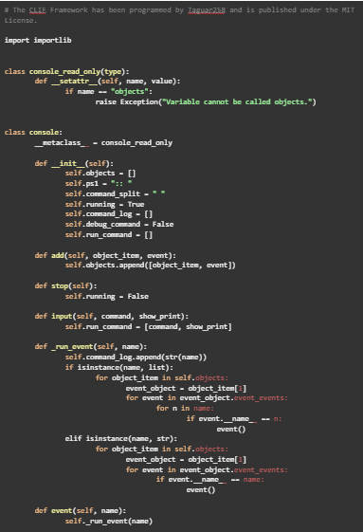

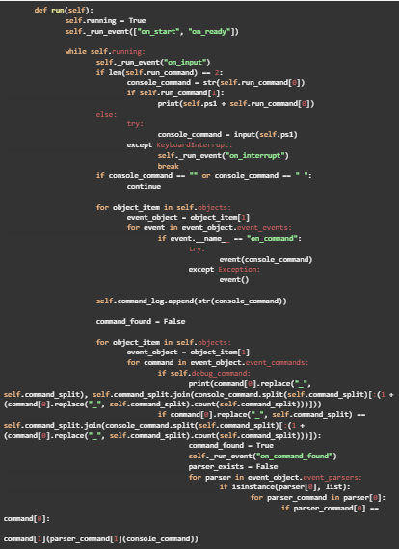

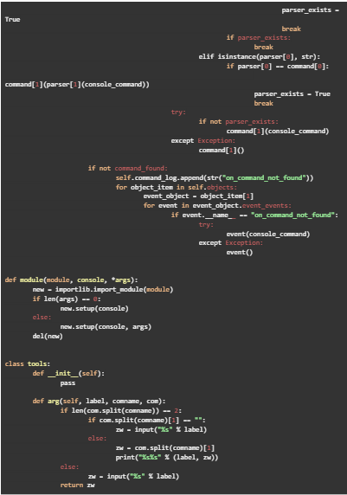

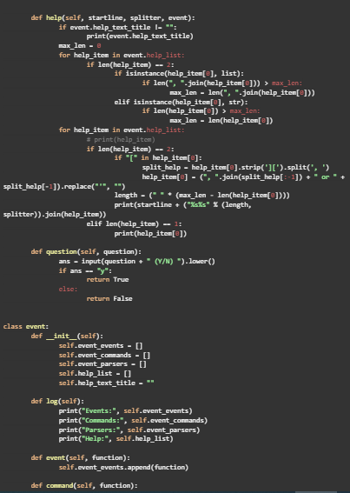

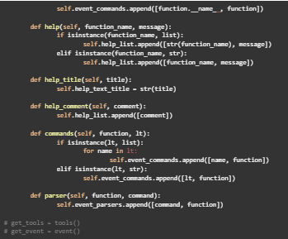

# APPENDIX F

# USER MANUAL

**Dashboard**

1. Open the link workspace.staritaes.com in your web browser.
2. On the **Login page**, enter your default **Username (ID number)** and **Password.**
3. On the **Dashboard tab**, is where you can see the notification from recommended files, important mail, and upcoming events.
4. The dashboard is **customizable**, aside from the administrator other users can also customize the dashboard from what they wanted to see first or prioritize.
5. On the **status bar**, you can change your status online, away, do not disturb, and invisible.
6. On the **upper right side** of the screen, is where you can see the **search icon**, **notification**, **contacts**, and the **menu** for the user profile.
7. At the **search bar**, users can search for files, contacts, comments, messages, emails, and documents that are part of the platform.
8. The **notification bar** is where users can find **real-time notifications**, this covers all the aspects of the platform whether message notifications, meetings, and uploaded files.
9. On the **contact bar** is where users can find all the **contacts** that are added within the organization whether it is **teaching** or **non-teaching**.

**Profile**

1. Under the **profile menu**, users can view their profile, edit their personal information, change their passwords and navigate their settings from security, notifications, storage, accessibility, sharing, groupware, flow, privacy, and lastly from the office.
2. On the **Files tab**, you can upload files by clicking the **plus button** and adding a new folder, text file, document, presentation, and more. On the **left side panel**, there are the Recent, Favorites, Shares, and Tags options.
3. On the **Photos tab**, is where you can navigate the recently uploaded photos, and on the **left side panel** you can choose other options such as Your videos, Favorites, On this day, Your folders, Shared with you, and Tagged photos.
4. On the **Activities tab**, is where you can see the notifications or recent changes on options in the left side panel.
5. Under the **talk panel** you can create a group chat by simply clicking on the **plus icon** at the left side corner of the screen there are options whether to add individually or by group (teaching or non-teaching).

There is also a **search panel** at the left-side corner so you can easily connect to which faculty member you wanted to message.

Under the search panel, there is an option to allow guests to join via a link or to open a conversation to register the user.

Like any other platform next cloud allows users to have **video calls**, you can also view the **profile** of the member you wish to view.

1. On the **mail icon**, users can automatically or manually connect their **accounts** to their **personal email**.
2. Under the **contact icon** you are able to view all the contacts, not grouped, you can also add **new contacts** and be able to group them or put them in a circle. Contacts are **downloadable**, they can generate **QR Codes**, and lastly, contacts can also be deleted.
3. On the **calendar icon** users from teaching to non-teaching are allowed and able to set appointments or meetings. They can set **venue**, **time**, and **date**, and add notes or descriptions of the meeting to be held, one of the features of this is it allows the user to choose who will only participate in the said meeting and all of the chosen participants will be notified.

**ADMINISTRATOR MANUAL**

**Dashboard**

1. Open the link workspace.staritaes.com in your web browser.
2. On the **Login page**, enter your default **Username (ID number)** and **Password.**
3. On the **Dashboard tab**, is where you can see the notification from recommended files, important mail, and upcoming events.
4. The dashboard is **customizable**, aside from the administrator other users can also customize the dashboard from what they wanted to see first or prioritize.
5. On the **status bar**, you can change your status online, away, do not disturb, and invisible.
6. On the **upper right side** of the screen, is where you can see the **search icon**, **notification**, **contacts**, and the **menu** for the user profile.
7. At the **search bar**, users can search for files, contacts, comments, messages, emails, and documents that are part of the platform.
8. The **notification bar** is where users can find **real-time notifications**, this covers all the aspects of the platform whether message notifications, meetings, and uploaded files.
9. On the **contact bar** is where users can find all the **contacts** that are added within the organization whether it is **teaching** or **non-teaching**.

**Profile**

1. Under the **profile menu**, users can view their profile, edit their personal information, change their passwords and navigate their settings from security, notifications, storage, accessibility, sharing, groupware, flow, privacy, and lastly from the office.
2. Under the **administrator account**, the administrator is **authorized** to **enable** or

**disable** all the **functioning features**.

1. The **Administrator** can **modify** the information of the **user** by clicking the **pencil icon** and filling in the **field** that needs modification or change. Like the **password** of a user, the administrator must first enter the user’s **default password** before **changing** it to a new one.
2. A **form** will show up where the administrator can **add** a **new account** and set user whether he/she is under the **teaching** or **non-teaching** sector.
3. After setting and creating the account the **administrator** is **prompted** to enter his **password** to successfully create the account.
4. On the **Files tab**, you can upload files by clicking the **plus button** and adding a new folder, text file, document, presentation, and more. On the **left side panel**, there are the Recent, Favorites, Shares, and Tags options.
5. On the **Photos tab**, is where you can navigate the recently uploaded photos, and on the **left side panel** you can choose other options such as Your videos, Favorites, on this day, your folders, shared with you, and Tagged photos.
6. On the **Activities tab**, is where you can see the notifications or recent changes on options in the left side panel.
7. Under the **talk panel** you can create a group chat by simply clicking on the **plus icon** at the left side corner of the screen there are options whether to add individually or by group (teaching or non-teaching).

There is also a **search panel** at the left-side corner so you can easily connect to which faculty member you wanted to message.

Under the search panel, there is an option to allow guests to join via a link or to open a conversation to register the user.

Like any other platform next cloud allows users to have **video calls**, you can also view the **profile** of the member you wish to view.

1. On the **mail icon**, users can automatically or manually connect their **accounts**

to their **personal email**.

1. Under the **contact icon** you are able to view all the contacts, not grouped, you can also add **new contacts** and be able to group them or put them in a circle. Contacts are **downloadable**, they can generate **QR Codes**, and lastly, contacts can also be deleted.
2. On the **calendar icon** users from teaching to non-teaching are allowed and able to set appointments or meetings. They can set **venue**, **time**, and **date**, and add notes or descriptions of the meeting to be held, one of the features of this is it allows the user to choose who will only participate in the said meeting and all of the chosen participants will be notified.

# 

# APPENDIX G

# GRAMMARIAN’S CERTIFICATION

|  |  |  |  |
| --- | --- | --- | --- |
| C:\Users\KC Tejada\Desktop\bsu seal.png | Reference No.: BatStateU-CE-04 | Effectivity Date: January 3, 2017 | Revision No.: 00 |

Republic of the Philippines

**BATANGAS STATE UNIVERSITY**

Batangas City

**CERTIFICATE OF EDITING OF THESIS**

This is to certify that this Thesis/Dissertation entitled “**Network Architecture Design and an On-premise Universal File Access and Sync Platform with ACL and Server Encryption at Sta. Rita Elementary School”** in partial fulfillment of the requirements for the degree BACHELOR OF SCIENCE IN INFORMATION TECHNOLOGY MAJOR IN NETWORK TECHNOLOGY has been reviewed and edited by the undersigned based on the minutes of the Final Defense.



It now follows the standard format of the University and conventions of research writing.

Assoc. Prof. Ninfa M. Vergara, MAED

**Signature over Printed Name**

**Editor**

Date Signed: January 13, 2022

# 

# APPENDIX H

# CURRICULUM VITAE

**BAUAL, LEWIS MINCH D.**

P4-140 Velasquez Rd. Sta. Rita Karsada Batangas

09995619545

[l.baual88@gmail.com](mailto:l.baual88@gmail.com)

**PERSONAL INFORMATION**

Date of Birth : January 10, 2001 Civil Status : Single

Age : 21

Citizenship : Filipino

Sex : Male

Religion : Roman Catholic

Language : Filipino

**EDUCATIONAL BACKGROUND**

**Tertiary Level Bachelor of Science in Information Technology**

**Major in Network Technology**

**Batangas State University Alangilan Campus**

Alangilan, Batangas City

2019-2023

**Senior High School** **ICT- Information & Communication Technology**

**University Of Batangas**

Hilltop, Batangas City

2017-2019

**Junior High School** **Sta. Teresa College**

San Jose, Batangas 2013-2017

**Primary Level** **Sta. Rita Elementary School**

San Jose, Batangas 2007-2013

**CURRICULUM VITAE**

**CORNEJO, JOMARK L.**

0760 ME Sitio Santolan Alangilan Batangas

09977364621

[jomarkcornejo12@gmail.com](mailto:jomarkcornejo12@gmail.com)

**PERSONAL INFORMATION**

Date of Birth : January 26, 2001 Civil Status : Single

Age : 21

Citizenship : Filipino

Sex : Male

Religion : Roman Catholic

Language : Filipino

**EDUCATIONAL BACKGROUND**

**Tertiary Level Bachelor of Science in Information Technology**

**Major in Network Technology**

**Batangas State University Alangilan Campus** Alangilan, Batangas City

2019-2023

**Senior High School** **STEM – Science, Technology, Engineering and Mathematics**

**St. Bridget College**

M.H. Del Pilar St. Batangas City 2017-2019

**Junior High School** **St. Bridget College**

M.H. Del Pilar St. Batangas City 2013-2017

**Primary Level** **St. Bridget College**

M.H. Del Pilar St. Batangas City 2007-2013

**CURRICULUM VITAE**

**DRIZ, ABEGAIL P.**

0135 Diversion Road Purok 1, Bolbok Batangas City, Batangas 09451173632

[abegail.driz@g.batstate-u.edu.ph](mailto:abegail.driz@g.batstate-u.edu.ph)

**PERSONAL INFORMATION**

Date of Birth : October 05, 1999 Civil Status : Single

Age : 23

Citizenship : Filipino

Sex : Female

Religion : Roman Catholic

Language : Filipino

**EDUCATIONAL BACKGROUND**

**Tertiary Level Bachelor of Science in Information Technology**

**Major in Network Technology**

Batangas State University Alangilan Campus Alangilan, Batangas City

2019-2023

**Senior High School** **TVL- Information & Communication Technology**

**IT in Computer System Servicing**

**University of Batangas**

Hilltop, Batangas City

2017-2019

**Junior High School** **University of Batangas**

Hilltop, Batangas City 2013-2017

**Primary Level** **University of Batangas**

M.H.Del Pilar, Poblacion, Batangas 2007-2013

**CURRICULUM VITAE**

**LORZANO, CYCERILLE JANE R.**

075, Banay banay II, San Jose Batangas

09569311035

[cjanelorzano@gmail.com](mailto:cjanelorzano@gmail.com)

**PERSONAL INFORMATION**

Date of Birth : October 07, 2000 Civil Status : Single

Age : 22

Citizenship : Filipino

Sex : Female

Religion : Roman Catholic

Language : Filipino

**EDUCATIONAL BACKGROUND**

**Tertiary Level Bachelor of Science in Information Technology**

**Major in Network Technology**

**Batangas State University Alangilan Campus** Alangilan, Batangas City

2019-2023

**Senior High School** **ICT- Information & Communication Technology**

**AMA**

Balintawak, Lipa City 2017-2019

**Junior High School** **St. Joseph Academy**

San Jose, Batangas 2013-2017

**Primary Level** **Padre Imo Luna Memorial Elementary School**

**(PILMES)**

San Jose, Batangas 2007-2013